Equipment | Description | Image
Gigli Wire Saw | Gigli wire is a flexible cutting wire with a toothed edge used to cut hard materials such as Fibreglass casts, bone and horn. It is a standard grade stainless steel saw wire, with a loop at each end for ease of use when attaching to Gigli handles.  https://www.youtube.com/watch?v=yZp6xizR0yU  This video shows how the Gigli wire can be used to dehorn an adult goat. However, it is not a good example of how the procedure is done. The video clearly lacked proper surgical protocol as no anaesthesia was given to numb the area by blocking the nerve. Also, the animal was not properly restrained. After removing the horns nothing was used to stop the bleeding and no bandage was placed to keep the area closed/ prevent infection.  This video was only chosen to show how the wire can be used to cut off the horn. | 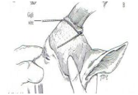  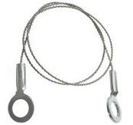
Dehorning Wire saw | Similar to Gigli Wire saw. This is for removing horns from mature goats. It’s a fast-cutting veterinary obstetrical wire to do a quick, neat job. Also useful to remove horn scurs and to cut small horns from kids before burning the root with hot iron. Some surgeons prefer to use this because it is less likely to break and leave a protuberance in the middle that can cause the horn to grow back | 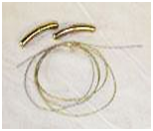
Hemostats | This is used to control bleeding by ligating the blood vessels. | Electrocautery-Hot iron  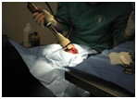 Hemostatic forceps eg mosquito forceps
Sterile gauze | This is to place in the exposed frontal sinuses before placing bandages. | 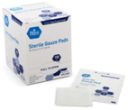
Bandages | When frontal sinuses are exposed the bandage is placed to prevent myiasis and the accumulation of foreign material in the sinuses. | 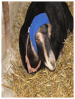
Clippers | To remove the hair on the top of the head around the horns to prepare the surgical site | 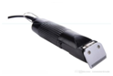
General Surgery pack | To prepare the surgical sterile area. It contains the scalpel, blade, hemostatic forceps, towel clamps, drapes, scissors, needle holder and dressing forceps. | 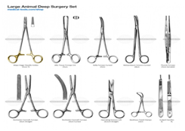
Guillotine/Keystone Dehorner | A keystone dehorner has two handles that move a blade downward against a plate or another blade, slicing through the base of the horn and surrounding skin.  Advantages: Can be used in older cattle with large horns.  Disadvantages: Greater risk of exposed sinus, infection and blood loss; painful; may lead to set-backs in overall health and performance, including weight loss; requires follow-up care; poses risk of injury to the animal and handler. | 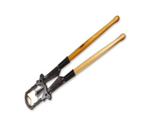
Callicrate Bander | This can be used to remove different size horns in cattle and goats of different ages. The animal’s head must be properly restrained during this procedure. The end of the loop should be inserted with the clip, seam side up into the nose of the bander.  Reach across the top of the animal’s head and place the loop over the horn furthest from you. Do not drag the loop along the bottom side of the horn.  Dragging the loop along the bottom of the horn as you pull it toward the head will cause the loop to roll. If the loop rolls on the horn, it will tend to return to its original shape and roll back toward the tip of the horn.The bander loop should be pulled and loop towards you. This will keep the loop close to the head and in the hairline at the horn base. Tighten the loop until the tension peg on the bander touches the back of the slot. Press the crimping lever until it will go no further. Cut the loop as close to the spool as possible using the Callicrate Cutter.  Place a Figure eight duct tape around the horns ,over the loops.  Repeat procedure on other horn.  Expect the horns to fall off in 20 to 30 days for small to medium sized horns. Horns with large bases may take up to 50 days as experienced by some producers.  Ligation allows the horns to drop slowly, giving the holes at the base of the horn time to fill with tissue and thus no open hole into the sinus. Flies and maggots are not a problem, plus dirt and debris cannot get into the sinus, reducing chances of infection. | 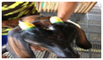 In this image the green bands were placed by the callicrate bander at the base of the horns. The yellow adhesive tape was used to hold the bands in place. After a few weeks the banded horns will fall off. The image below shows the banded horns after they feel off.  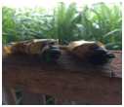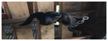 This image shows the goat after the horns above fell off. This is a cosmetically appealing procedure.  Callicrate bander:  