Drugs used in post-op
Ketoprofen V
Concentration: 100mg/ml
dosage: 3 mg/kg (1.5 mL/50 kg body weight) by intravenous or intramuscular injection.
L-Arginine, citric acid and benzyl alcohol are the active ingredients of this drug
Uses: Used to manage mild to moderate pain in dehorning, arthritis, musculoskeletal injuries, fever, mastitis, udder oedema and mastitis. It is also known to reduce inflammation.
Contraindication: Don’t use on animals that are hypersensitive to ketoprofen as well as animals that have poor renal function
Side effects: Can mask the signs of gastrointestinal issues since it is a potent analgesic. It can affect antimicrobial. Overdosing cattle may cause inappetance, depression, icterus, recumbency and abdominal swelling
Calculations: Weight of calf- 120kg
Volume= dosage x weight/concentration
= 3mg/kg x 120kg/100mg/ml= 3.6ml

NOTE: This drug can also be used with lidocaine in pre-operative care which eliminates the need for using this drug in post-operative care due to the increase of analgesic effects the drug combination has
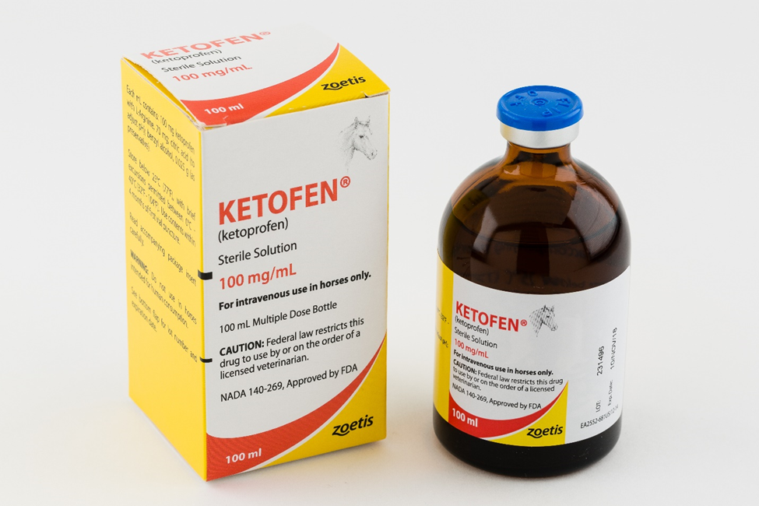

Meloxicam
Active ingredients: Mannitol, Sorbitol, Aspartame
Use: Primarily used to treat pain after dehorning and castration
Contraindication: Not recommended in animals with gastrointestinal disorders, hypersensitivity, renal function and haemorrhagic disorders. Don’t use on animals that have been severely dehydrated, hypovolemic or hypotensive
Concentration: 0.5mg/ml
Dosage: 0.5 mg/kg (Subcutaneous or intravenous drug administration routes are utilized)
Calculations: Weight of calf-120kg
Volume=dosage x weight/concentration
= 0.5mg/ml x 120kg/0.5mg/ml= 120ml
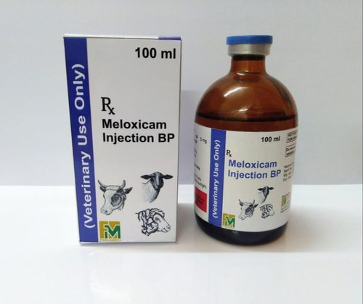

Tetanus antitoxin
This can be administered to prevent the occurrence of tetanus which is a common complication of dehorning. The dosage can range from 500-1,500IU with the effects lasting between 10-14 days; the drug can be administered in the subcutaneous layer.

