A short list of Surgical Therapy for Equine Lameness

Deep solar penetration
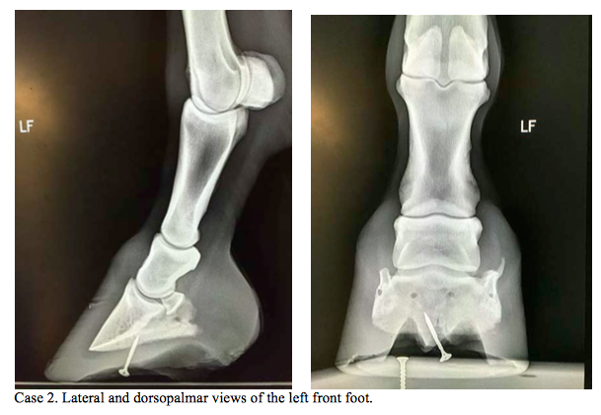
Wounds to the solar surface of the foot most often occur when the horse steps on a sharp objects, such as a nail. These wound can be superficial or deep. Superficial wounds penetrate cornified tissue deep wounds penetrate the germinal layer of the hoof. Wound in the sole can reach a depth of 1 cm before reaching the germinal layer and wounds of the frog 1.5 cm. superficial wounds may be more common but deep wound areas more serious.
- Type I wounds penetrate to the sole and may damage the distal phalanx (P3).
- Type II wounds can penetrate the frog and heel as well as the deep digital flexor tendon, distal sesamoidean im par ligament, navicular bursa, distal interphalangeal joint, digital flexor tendon sheath, and digital cushion.
- Type III injuries penetrate the coronary band and can cause septic osteitis of P3, septic chondritis of the collateral cartilages, or septic arthritis of the distal interphalangeal joint.
Deep wounds have more serious consequences and need quick identification and aggressive therapy which may involve surgical debridement and drainage which is necessary for wound healing. The horse should be placed on systemic antibiotics and anti-inflammatories before surgery. An area of sole 1–2 cm in diameter should be removed from around the puncture site so that the tract can be completely explored. Radiographs may suggest that a wider diameter is needed if a sequestrum is present. If there is no draining tract, then a radiograph with radio-opaque markers can be used to pinpoint the affected bone.
A tourniquet can be placed at the fetlock and proximal sesamoid bones to minimize bleeding. Antibiotics can also be used to flush the wound. Wounds that may have affected the corium should be debrided by sharp dissection and suspect bone should be removed by curettage. A sample can be used for culture and sensitive to ensure the correct antibiotic therapy is used. Bandages place on after surgery should be changed daily. Surgical Maggots can be used to help with debridement if the infection is extensive and can decrease healing time.

Pedal bone fracture
Options for treating horses with P3 fractures include confinement, confinement with corrective shoeing or foot casts, lag screw fixation (types II and III), and surgical removal of the fracture/fragment (type IV only).
Treatment depends on
- the age
- use of the horse,
- the fracture, and
- financial constraints of the owner.
Most horses with P3 fractures are treated with confinement and corrective shoeing, the goal of which is to stabilize the fracture and prevent expansion of the hoof wall
Types of Pedal Bone Fractures
- Type I-a non-articular fracture. Usually treated with confinement and methods to prevent hoof expansion (shoe or foot cast). Confinement and rest alone may also prove successful.
- Type II - Foals less than 6 months of age are treated with stall confinement. Adult horses can be treated with confinement and prevention of hoof expansion or surgically by placing a lag screw. Most type II fractures are treated non-surgically because screw placement can be very difficult with this fracture type. Surgery is usually only considered in horses with large wing fractures.
- Type III- Acute type III fractures in adult horses are usually the best candidates for surgical repair using lag screw fixation. The correct site for screw placement is midway between the articular surface and solar canal through a hole in the side of the hoof wall. Screw placement for type III fractures is usually less difficult than for type II fractures because the bone is essentially divided in half and there is less risk of splitting the fracture when the screw is tightened.
Major risks include
- infection developing around the implant,
- the inability to compress the fracture,
- incorrect screw placement leading to continued lameness, and
- overriding of the fracture fragments during compression.
Complete fracture healing can be expected in 6–12 months and the screw may have to be removed if lameness persists or infection around the implant is evident. A computer‐assisted surgery technique and CT scans can be used to improve accurate screw insertion into sagittal P3 fractures.
- Type IV - Surgical removal of the fracture/fragment is usually the preferred treatment for type IV P3 fractures. Conservative treatment usually does not work. Lag screws are not be uses in chronic fractures. Arthroscopy using a dorsal approach is the preferred technique for removal of small extensor process fractures.
- Type V This fracture may be articular or non-articular. It is usually treated with confinement and methods to prevent hoof expansion.
- Type VI - Treatment of solar margin fractures depends on whether the condition is primary or secondary to a chronic foot disorder. Primary causes of solar margin fractures are usually treated with corrective shoeing and rest.
- Type VII Affected foals with this fracture are usually treated with confinement alone for 6–8 weeks.

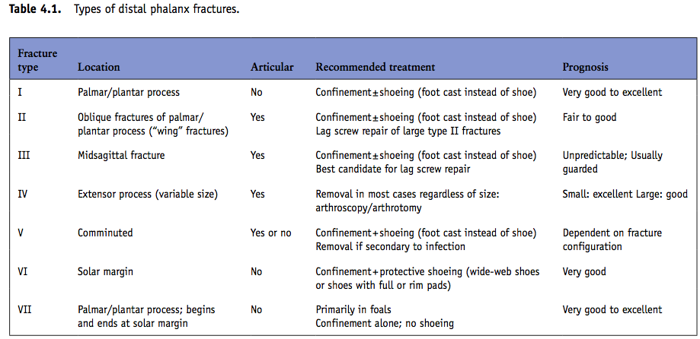

P1 fractures
Noncomminuted P1 Fractures
Treatment usually depends on the fracture type, location, length, degree of displacement, and use of the horse. Options include confinement with bandaging, confinement and casting, internal fixation with lag screws and/or bone plates, external skeletal fixation alone, or internal fixation combined with external skeletal fixation. In general, most noncomminuted P1 fractures involve an articular surface and are treated lag screws.
Comminuted P1 Fractures
The goal is usually to preserve the horse for breeding purposes or pasture soundness.
Methods for treatment of comminuted P1 fractures include:
- External coaptation alone
- External skeletal fixation alone
- Lag screw fixation through stab incision with or without external skeletal transfixation
- Open reduction with lag screws and external coaptation
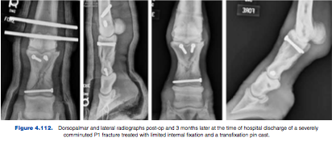
- Open reduction with plates and screws and external coaptation
- Reduction combined with transfixation pin casts

Stress fractures of the Dorsal 3rd Metacarpus
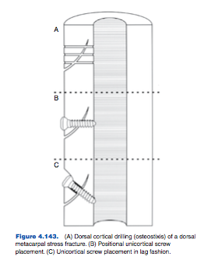
Treatment
There is no specific medical treatment for dorsal metacarpal disease. Several surgical procedures have been recommended for treatment of dorsal cortical metacarpal fractures, including placement of a unicortical screw in lag fashion, placement of a neutral unicortical positional screw, and dorsal cortical drilling or osteostixis. For screw fixation, cortical bone screws (4.5 or 3.5 mm) are used.
Postoperative management includes stall rest and bandaging for 2 weeks, followed by 6 weeks of rest with hand walking. Screw removal is usually performed at 8 weeks, followed by an additional 2 weeks of hand walking. Track walking and light jogging can be introduced 2 weeks after screw removal; however, more intense race training should 4 months after surgery.

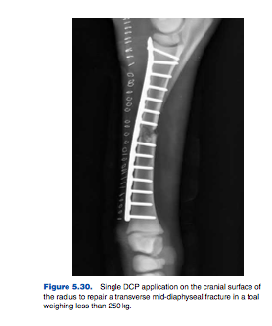
Displaced Radial Fractures
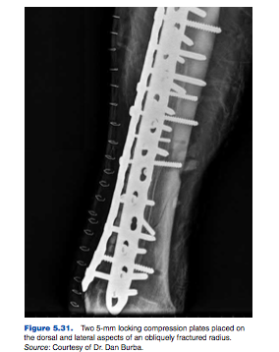
Internal fixation is used to treat complete displaced fractures of the radius. Transfixation casts can be used for open contaminated fractures due to the risk of infection and poor plate fixation. A full‐limb cast alone for displaced fractures of the radius may not work because the humeroradial joint cannot be adequately immobilized.
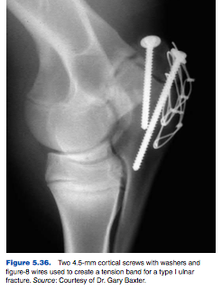

Elbow Treatment Fracture cases that include nondisplaced, non-articular ulna fractures or severely comminuted are candidates for conservative treatment. In horses younger than 6 months, a combination of screws, pins, and tension band wires, or plating can be used.
Humerus may be difficult to stabilize however, intramedullary pinning, bone plating, and interlocking intramedullary nailing or rush pins have been used to successfully treat foals and ponies with humeral fractures.
Arthroscopy
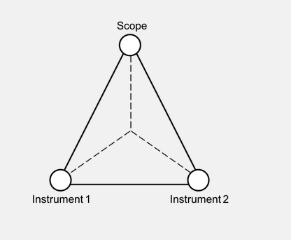
- Arthroscopy involves the surgical exploration of a joint using a small telescope. Tenoscopy and bursoscopy involves the surgical exploration of tendon sheaths and bursae using the same surgical method. Triangulation can be used to allow surgical instruments to be placed within the synovial structure.
- Arthroscopy is common used for fragment removal. Carpal and fetlock joints are common area of osteochondral chipping which may lead to fragmentation. Although the fragmentation may be acute, it may be secondary to subchondral bone disease. Exercise can put stress on the joints and cause damage leading to small cracks and sclerosis. Eventually bone may begin to chip away.
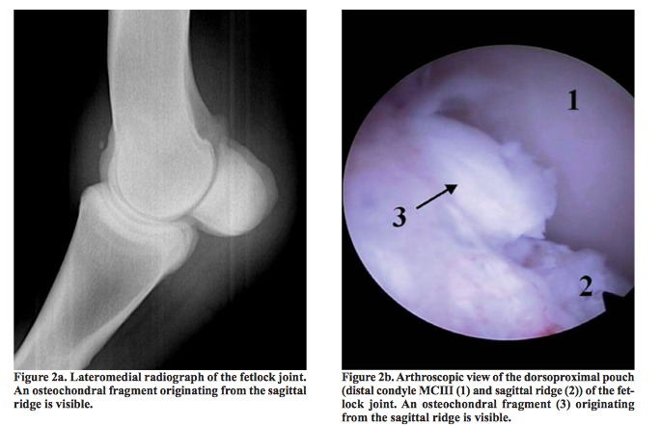
- Fast race horses may present with lameness, joint effusion, and pain upon flexion. Arthroscopy is usually use to remove the fragments once present. Inflammation due the presence of the fragment can cause further damage therefore, these case should be treated quickly. However there are cases where the fragment does not cause any clinical signs and the fragment may be an incidental finding.
- Chip fragments in low motion joints rarely cause lameness. These fragments are usually left in place unless there further investigation states that it is the source of lameness.
- Chip fragments in pastern joint may be left alone whereas chips within the fetlock joint should be removed, even if there are no clinical signs.
- Palmar or plantar osteochondral fragmentation off of the proximal palmar or plantar eminence of the first phalanx are also common incidental findings. These fragments once found however are removed in high speed horses. In order to perform this surgery, fragments must be confirmed radiographically. This is due to the location of the joint and the ligaments present there, such as the distal sesamoidean ligaments
- Chips within the carpal hock and stile joints are usually removed especially lameness and joint effusion are present, because it is usually a traumatic case,.
- In some cases joint effusion may be the only sign (no lameness), however the fragment should still be removed to avoid inflammatory destruction. If there is not joint effusion, surgery is not recommended.
- Other indications for arthroscopic, tenoscopic, or bursoscopic surgical intervention include debridement, internal fixation, lavage and decontamination of the joint (septic arthritis), and removal of soft tissue masses.

Neuroectomy for navicular disease
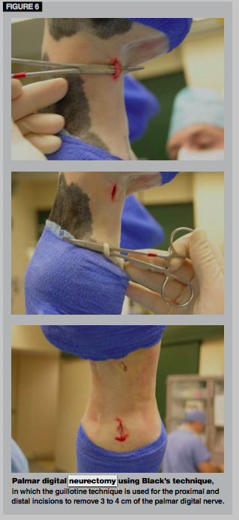
Palmar digital neurectomy is one of the las options to treat end stage navicular disease, it can be unilateral or bilateral.

- Palmar digital neurectomy is the surgical severing of the lateral and medial palmar digital nerves to remove neural sensation to the heel. Removing a section of the nerve, can prolong nerve regeneration.
- A guillotine technique can be used in which a 2-3 cm section of nerve is removed by sharp severing of the nerve.
- The nerve is stretched over the scalpel blade. Tension of the nerve is used to sever its fibers. The proximal and distal nerve stumps can fall beneath the soft tissues away from the incision.
- A neuroma at the cut end of the nerve can cause pain and lameness. This should be done as atraumatically as possible with the use of good surgical skills.
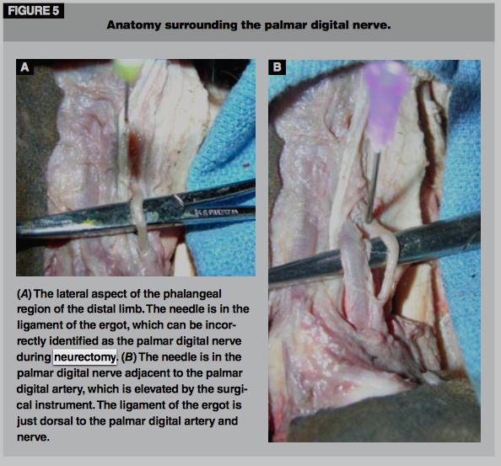

Proximal suspensory desmitis
- Proximal suspensory desmitis of the rear limb is a particularly challenging cause of lameness in the athletic horse. The proximal part of the suspensory in the rear limb is located within a confined tunnel that is made up of the plantar part of the third metatarsal, the axial parts of the second and fourth metatarsal bones, and an inelastic band of connective tissue or retinaculum around the plantar part. Injury to this area can cause leading to pain due to pressure around the inelastic structure. This can be a chronic cycle of pain and swelling.
- This area also make it difficult to reach. Initial treatment involves anti-inflammatories, shock wave therapy and rest. If conservative treatment fails, surgical transection of the plantar fascia or retinaculum may be indicated. Surgery is also indicated if there is enlarged area of the proximal suspensory as seen on ultrasound.
- The horse is placed in dorsal recumbency, and a 4-6 cm incision is made in the proximal medial metatarsus just distal to the chestnut.
- The subcutaneous fascia is incised to expose the tendons and proximal suspensory ligament.
- Using curved kelly hemostats, the plantar fascia can be separated from the proximal suspensory ligament and incised.
- Incision of the most proximal and distal part of the plantar fascia can be completed with surgical scissors without extending the skin incision. The proximal suspensory ligament will usually bulge out of the fascial incision once the plantar fascia is incised. A number 11 scalpel blade is used to spilt the ligament longitudinally. The subcutaneous fascia is closed followed by a subcuticular skin closure.

Surgical arthrodesis
- Arthrodesis of the proximal interphalangeal joint is generally performed in cases of osteoarthritis, osteochondrosis, or fracture. Low motion joints can be fused together and can still preserve athletic soundness. Osteoarthritis of the pastern joint is a common cause of lameness in both the fore and hindlimb. Conservative treatment with anti-inflammatories are used first, however if it fails surgery maybe indicated.
- Surgical approach to the dorsal aspect of the proximal interphalangeal joint is made using an inverted incision. The foot should be draped properly
- This incision must be made in close proximity to the hoof capsule. The joint is subluxated dorsally by incising the lateral and medial collateral ligaments. Debridement of the articular surface is performed. In severe cases of osteoarthritis, excess bone may need to be removed due proliferation of bone. This provides a smooth dorsal surface of the first and second phalanx. The arthrodesis is completed using a combination of dynamic compression plate and screws. In cases of second phalanx fracture, 2 dynamic compression plates may have to be used. The leg is placed in a distal limb cast following the surgical procedure.

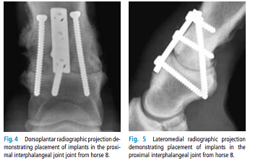
The typical time frame necessary for complete joint fusion is approximately 4 months, however clinical soundness may take 6-12 months to occur.

Osteoarthritis of the distal intertarsal and tarsometatarsal joints are one of the most common causes of rear limb lameness in athletic horses. Initially anti-infammatories are used, but if they fail, ankylosis is indicated. Some joints will ankylose on their own however it may be incomplete. The intra-articular or intra-osseous pressure may cause a lameness that will not respond to medical treatment.
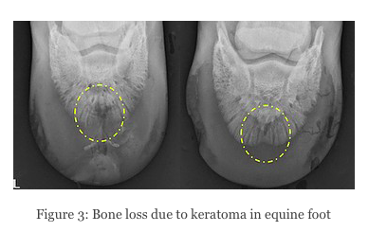
Surgery involves the used of 3 divergent drill tracts through the articular surfaces of both the distal intertarsal and tarsometatarsal joints. Intra-operative imaging is used to control positioning of the drill bit. Implants are usually not needed as the drill tracts will eventually fill in with osseous and fibrous tissue completing the ankylosis. Which takes about 6-12 months. Relief in pressure can improve lameness.
Keratoma
Treatment usually involves complete surgical removal of the abnormal growth. If it is not removed properly it is believed that it will grow back. General anesthesia or regional anesthesia and sedation can be used to perform this surgery.
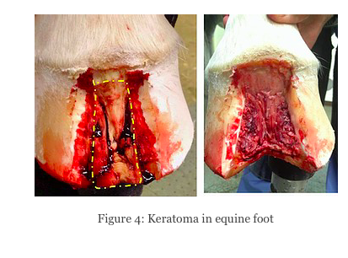
Resection of the hoof wall directly over the location of the keratoma is the usually the preferred technique. Ct scan can be used to improve the accuracy of hoof wall removal ensuring complete removal. Windows within the hoof wall can be made with a motorized burr, a cast cutting saw, oscillating saw, or an osteotome. Trephinations can also be used to expose the lesion. As little hoof wall as possible should be remove with complete removal of the keratoma is the goal.

References
Videos
- Case Study: Fetlock Bone Chip- https://www.youtube.com/watch?v=HMi03-45J9Y

Watch Now - Surgical Horse Neurectomy - Marc Smith, DVM-https://www.youtube.com/watch?v=Nz9rQRNkX_w

Keratoma removal on horse’s hoof- https://www.youtube.com/watch?v=3RKDwKgLP4o

Surgical Fusion of the Distal Hock Joints in a Horse due to severe bone spavin, arthritis
- https://www.youtube.com/watch?v=s-0-jhKfYV4

Equine Arthroscopic Surgery https://www.youtube.com/watch?v=fZSKCARoLvc

Websites:

Arthroscopy in Equine Lameness https://www.msdvetmanual.com/musculoskeletal-system/lameness-in-horses/arthroscopy-in-equine-lameness

Surgical management of specific equine lameness disorders (Proceedings)-https://www.dvm360.com/view/surgical-management-specific-equine-lameness-disorders-proceedings
- Keratoma in a horse! https://www.phdveterinaryservices.com/post/keratoma-in-a-horse
- Paint horse undergoes Arthrodesis in Hopes for New Lease on Life-http://www.equinechronicle.com/paint-horse-undergoes-pastern-arthrodesis-in-hopes-for-new-lease-on-life/
Articles
- Osteochondral fragments in the metacarpo- and metatarsophalangeal joint and their clinical importance https://vdt.ugent.be/sites/default/files/art80402.pdf
- A limited surgical approach for pastern arthrodesis in horses with severe osteoarthritis https://www.researchgate.net/publication/26666274_A_limited_surgical_approach_for_pastern_arthrodesis_in_horses_with_severe_osteoarthritis/link/5509a6d90cf26ff55f86b9f0/download
- Treating Navicular Syndrome in Equine Patients- https://pdfs.semanticscholar.org/d1db/f7122c6cbca37544466b188e600c39ce4dc5.pdf?_ga=2.76985621.1078598949.1601814002-1777239251.1600380457
- Nailed it!!! Direct Penetrating Wounds to the Horse’s Foot- https://www.newenglandequine.com/Articles/NEEMSC-Street-Nails.pdf

Text books
- ADAMS AND STASHAK’S LAMENESS IN HORSES
- DIAGNOSIS AND MANAGEMENT OF LAMENESS IN THE HORSE

