JOINT BLOCKS
Joint blocks

- Navicular bursa block/ podotrochlear bursa block
- Using a 20g 2inch needle, inject 5ml anaesthetic solution via a subcutaneous injection on the midline just above the bulb of the heel.
- Predisposes to deep infection
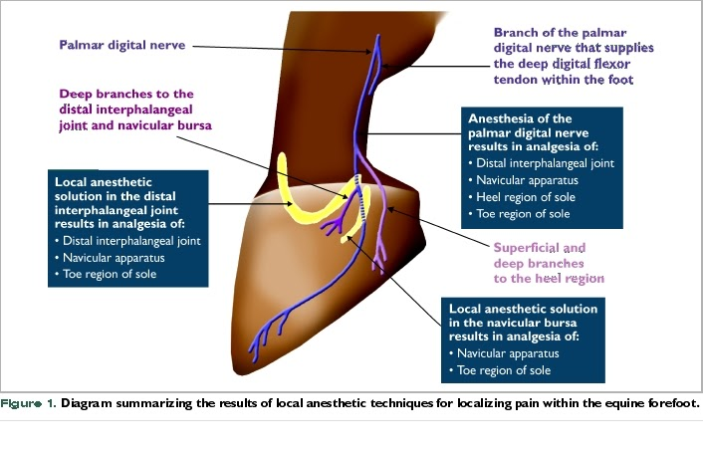
- Dorsal approach to fetlock, pastern and coffin joints
- Using a 20g 1 ½ inch needle, inject 5ml anaesthetic solution proximal to the joint, under the common/long digital extensor tendon laterally while passing obliquely into the dorsal pouch.
- Same procedure for all 3 joints except coffin joint, needle is inserted above the coronet, laterally to and under the extensor tendons.

- Palmar approach to fetlock joint
- Boundaries-
a) dorsal pouches: proximal to the joint and obliquely under the extensor tendon.
b) palmar pouch of fetlock; proximal- button of splint bone
Dorsal-cannon bone
Distal- proximal sesamoid bone
Palmar- suspensory lig.
- Begin by flexing the fetlock and palpating the boundaries of the palmar pouch. Inject 5ml anaesthetic solution dorsal to suspensory lig. and palmar to the cannon bone using an 18g 1-inch needle.

- Carpal joint injection- dorsal and palmar approach
3 joints - antebrachiocephalic, middle carpal and carpometacarpal
Dorsal approach, antebrachiocephalic and middle carpal.
- Flex the carpus to open the joint. Palpate the depression of both joints on either side of the tendon of the extensor carpi radialis muscle.
- Using a 20g 1 inch needle, remove 10ml synovial fluid and inject 10 more anaesthetic solution medially or laterally to the tendon and into the depression.
Palmar/ palmarolateral pouch approach
- Insert the 20g 1 ½ inch needle perpendicular into the depression and joint space located between the accessory carpal bone, ulnaris lateralis muscle and lateral digital extensor muscle. Remove synovial fluid and inject 10mls anesthetic solution.

- Elbow joint block
- Lateral approach- A 2 ½ inch 18g needle is directed into the space either cranial or caudal to the collateral ligament. The collateral lig. is located between the palpable lateral epicondyle proximally and the origin of the lateral digital extensor distally. Aspirate and inject 10mls anesthetic solution at the site.
- Caudolateral approach- insert 18g 3 ½ inch needle from the caudolateral side proximal to the elbow joint. The needle is directed between the olecranon process of the ulnar and the lateral epicondyle of the humerus into the caudal pouch over the olecranon fossa.

- Shoulder joint block
- Using a 3 ½ inch 18g spinal needle, direct it through the notch present on the greater tubercle at an angle caudal, distal and medial. Then aspirate a liberal amount of synovial fluid and inject 10-20mls anesthetic solution.

- Distal intertarsal joint block
- Using a 22g 1 inch needle, inject 5ml anesthetic solution subcutaneously in the gap between the 1st, 2nd, 3rd and central tarsal bone on the medial side of the hock.
- Tarsometatarsal joint block
- Inject anesthetic solution using a 20g 1 inch needle between the distal row of the tarsal bones.
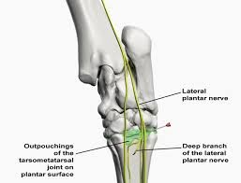
- Hip block
- Palpate the summit of the greater trochanter ⅔rds of the way from the tuber coxae to the ischiatic tuberosity. Palpate the convexity and estimate the location of the notch between the 2. Use a 16g 6 inch needle through the notch and walk the needle up the neck of the femur into the joint. Aspirate synovial fluid and inject 10-15ml anesthetic solution.

- Trochanteric block
- Locate the greater trochanter cranial part and insert a 18g 3 inch needle 2inches distal to the convexity and it is directed proximomedially over the convexity into the bursa. Inject 10ml anesthetic solution.
- Stifle blocks
- Medial femorotibial pouch block
- 3 inch 18g needle is inserted between the medial collateral and medial patellar ligaments at the level of the joint. Synovial fluid is aspirated and 10-20 mls anesthetic solution is injected at the site.
- Lateral femorotibial pouch block
- Visualize where the long digital and peroneus tertius extensor muscle runs between the 2 prominence of the extensor groove of the tibia.
- Palpate the lateral collateral lig. between the lateral epicondyle of the femur and the origin of the lateral digital extensor.
- Using a 3 inch 20g needle, aspirate synovial fluid and inject 10-20 mls anesthetic solution caudal to the tendons pointing proximally.
- Femoropatellar pouch block- lateral approach
- Stifle is extended and the patellar is grasped and pulled to widen the joint space. A 2 inch 18g needle is inserted on either side of the intermediate patellar lig.
- The needle is then advanced 2 inches between the patellar and patellar surface of the femur where synovial fluid is aspirated and 20ml anesthetic solution is injected.

VIDEO LINKS
https://youtu.be/D4hQ5VX95EE
https://youtu.be/owfRyDQhfWk
https://youtu.be/S0dv9GsR4-I
https://youtu.be/PJlCew5UM6M
https://youtu.be/X3rLRgyKFrU

