Tools for Castrating Goat
https://www.youtube.com/watch?v=CWcrFwnTp7U
This video gives a description of the Burdizzo tool used in castration of goat

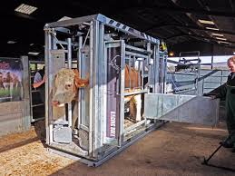

This is a crush cage that is used for the restraining of animals such as bulls and water buffalo for procedures such as castration.

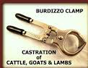

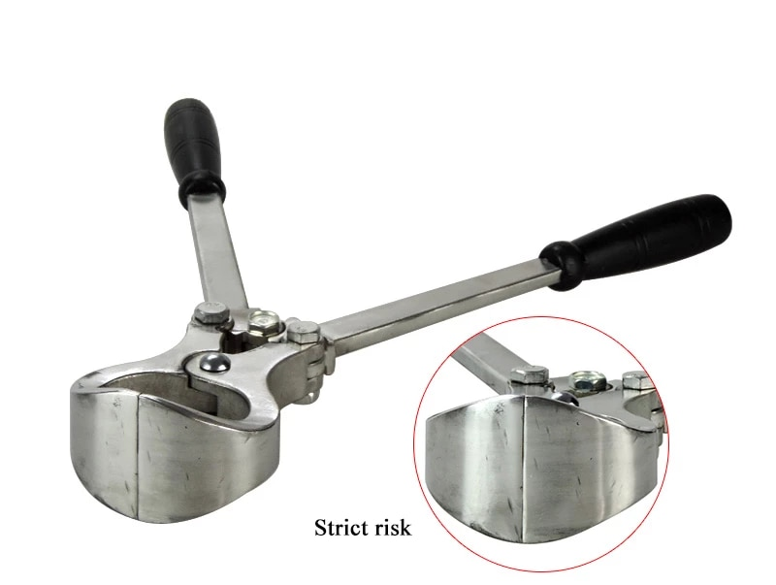

Another quick, bloodless method of castration is to use a Burdizzo clamp, or emasculatome, to crush and rupture the spermatic cords. This method can be used on older animals, however, it is best to castrate goats when young.

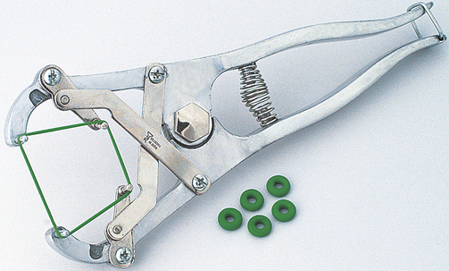
Using an elastrator is an inexpensive, quick and bloodless method of castration. It involves putting a heavy rubber ring around the scrotum near the body. The ring stops blood circulation to the scrotum and testicle and these will dry, shrivel and slough off in 10 to 14 days. It must be done while the scrotum is still very small; from three days to three weeks of age depending on breed size, before the scrotal muscles and associated tissues develop.

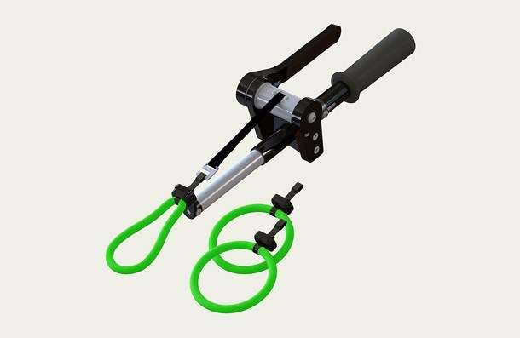
Callicrate Bander used for bloodless, closed castration. The Callicrate Bander may be used for delayed castration and horn removal for cattle, goats, sheep and water buffalo to name a few. The same tool and loop is used for both castration and horn removal. Callicrate Loops are made from a specific latex formulation that is over three times stronger than surgical tubing or pre made latex rings
https://www.youtube.com/watch?v=vthCZJEPIRA
This video demonstrates use of callicrate bander as well as care for the equipment

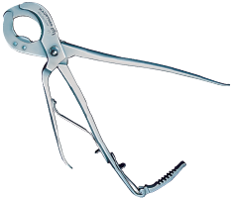
The Reimer emasculator has a double crushing part. The cutting lever works independently, allowing extra time for crushing action and diminishes bleeding.

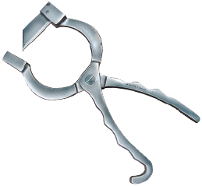
Newberry-style castration knife is used to make an incision in the scrotum for removal of the testicles in young bulls. To use, force the testicles up and insert the blade through the scrotum below the testicles. When the knife is closed pull downward slicing the scrotum. The testicles can then be removed using an emasculator or Henderson castration tool.

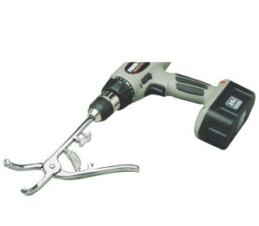
This instrument and technique minimizes blood loss and risk of hemorrhage through the severed cord. It utilizes twisting action which effectively closes the severed cord. It is used with a standard, variable-speed drill. This may be used on any age bull, but is an especially effective method to use on older, heavier bulls; 500 to 900 lbs, where it is important to minimize the risk of blood loss, swelling, and infection.

https://www.youtube.com/watch?v=NirjTncYmVM
This video explains the use of various tools used in castration of bulls in particular.
Emasculator
Newberry Knife
Burdizzo
Callicrate bander

