Castration Methods

Castration methods can be broadly classified as either Surgical or Bloodless (Non-surgical). The goal of castration is to remove the two testicles while causing minimal pain and discomfort to the animal.

Surgical
The principle behind Surgical Castration is the removal of the testicles from the scrotal sac. The scrotum is opened (using a Scalpel or a Newberry Knife) and the testicle is removed either by:
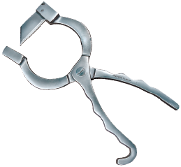Newberry Knife
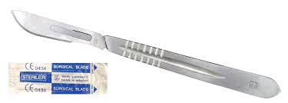 Scalpel

- Traction (slow and gentle pulling)
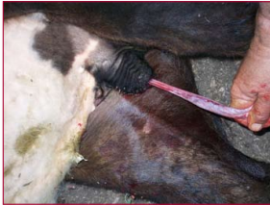

- Henderson Castration Tool (Emasculator)
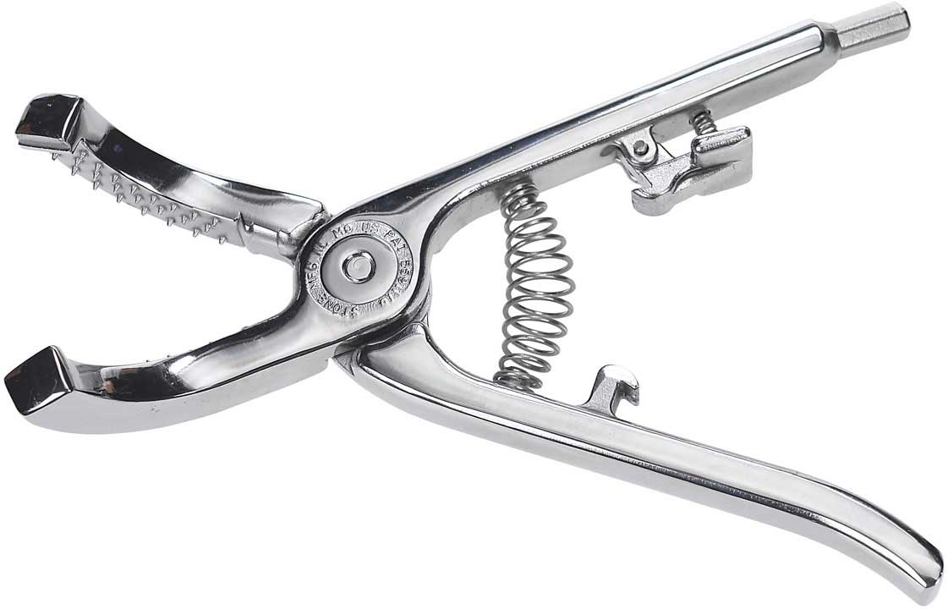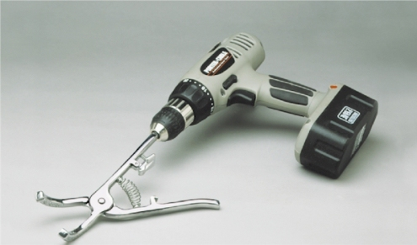
It is clamped on to the Spermatic Cord after the scrotum has been incised and it takes approximately 20 spins of the drill to twist out the testicle. The twisting action is sufficient to close off the blood supply to the testes.

- Emasculator (different from Emasculatome, as Emasculator crushes and cuts. Also the Emasculatome is used with the testes inside the scrotum)

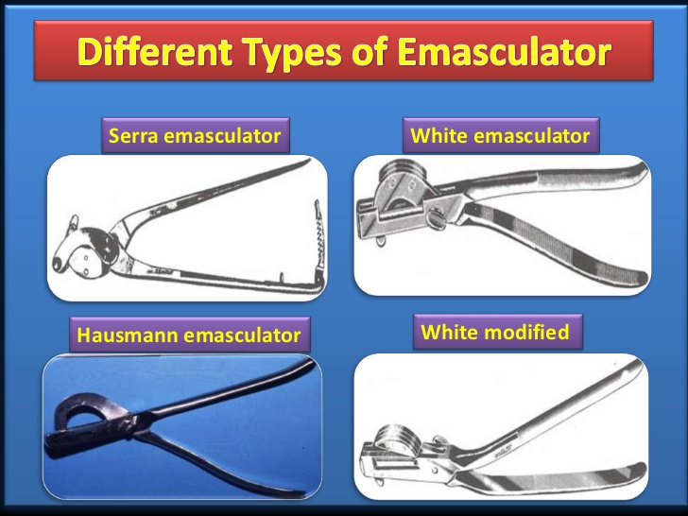

- Ligature - Material used to tie off blood vessels in spermatic cord before severing and removing testes.

Bloodless
Bloodless removal of the testes is usually done without incising the scrotum. There are multiple ways to achieve this using a variety of tools. Tools used in Bloodless Castration include:
- Elastrator Banding Tool
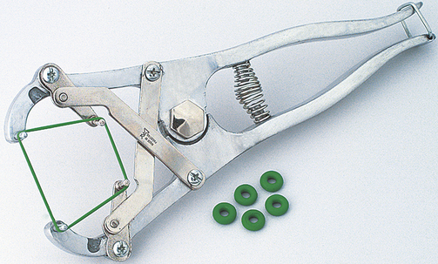 Jeffers Band

- Callicrate Bander
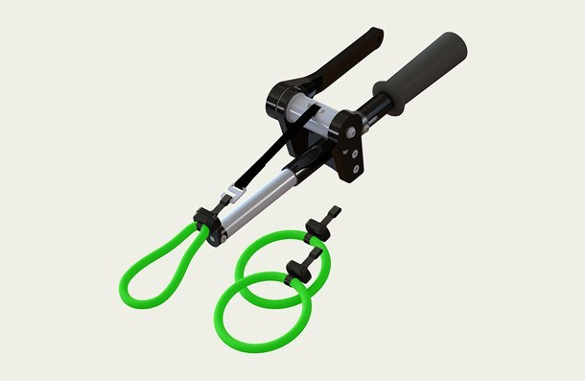

- Burdizzo (Emasculatome)
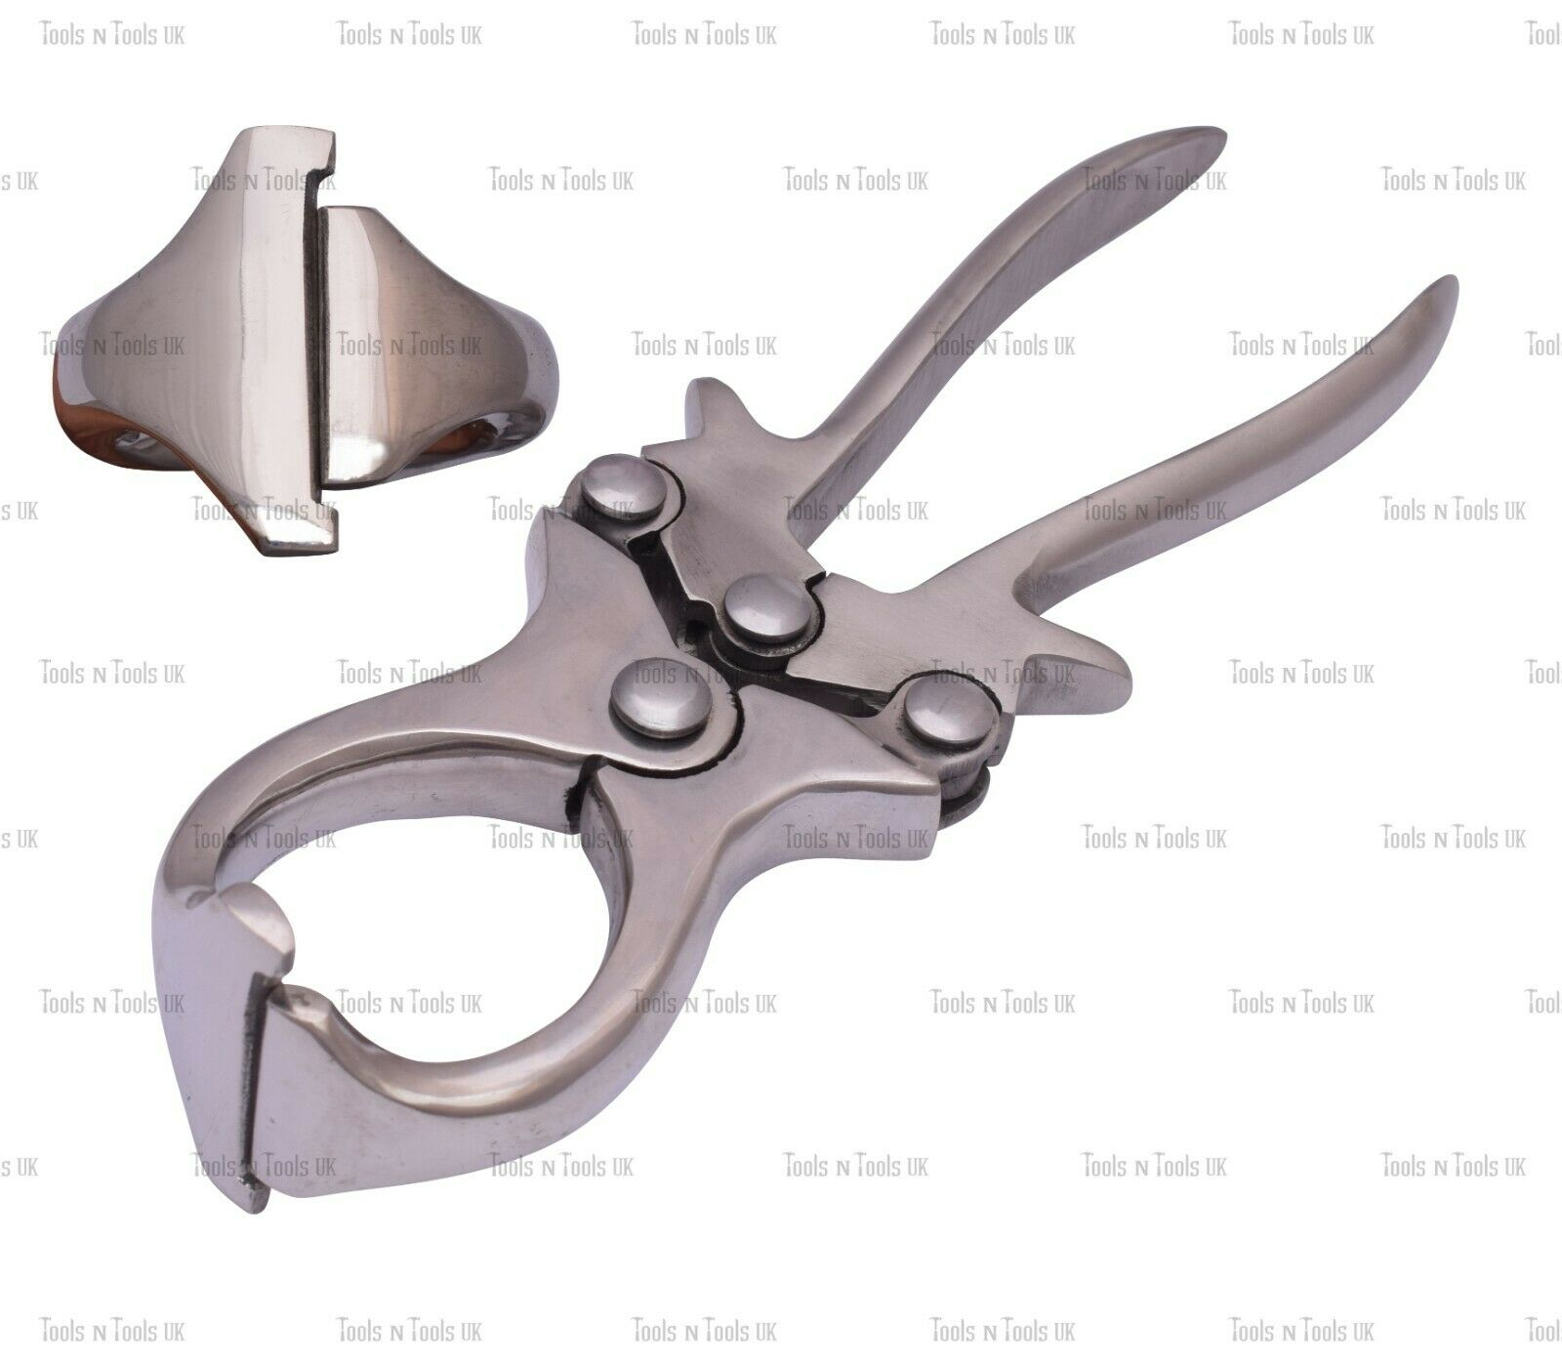

- Ritchey Nipper (Emasculatome) – Variation of Burdizzo (Vertical “Clamp”)
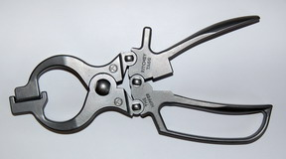 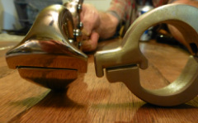 Burdizzo (Left), Ritchey Nipper (Right)

- Short Scrotum Method – Scrotum is banded after testicle pushed close to body
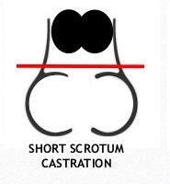 Band placed at Red Line

The principle of this method is to apply a rubber ring occluding blood supply causing tissue to become ischaemic and necrotic and shed off with the rubber ring. Short scrotum castration is now used as a routine method of castration in New Zealand and Australia.

SURGICAL CASTRATION TECHNIQUE
- Wash and clean your hands and surgical equipment using an antiseptic solution. Position yourself at the side or rear of the calf and reach forward between the hind legs.
- Make sure the scrotum is clean. You may use a mild surface disinfectant (such as iodine) to prepare the incision sites.
- The scrotal sac is incised either by using a Scalpel or Newberry Knife
Using the Scalpel, the following incisions can be made:
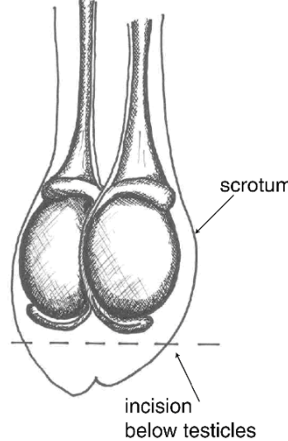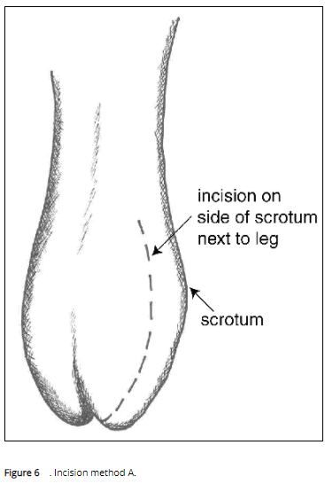

Using the Newberry Knife:
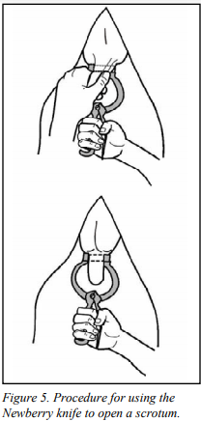
- Pull the testicle through the incision. It will be covered with a thin, but tough, white membrane. Separate this from the testicle by pulling it away near the tip of the testicle. The remaining tough cord contains the artery, veins and spermatic cord.
- The testes can now be removed using an Emasculator, Henderson’s Castration Tool, Ligatures or by Traction.

Emasculator Use:
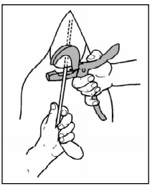

Henderson Castration Tool Use:
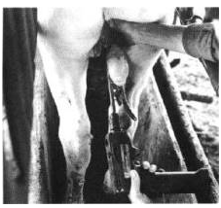

Traction:
There should not be any tissue hanging from the scrotum once the castration is complete. The scrotal sac is left open for drainage from the surgical site following inflammation after the surgical procedure.
The final step in surgical castration is wound treatment. Flies cause annoyance and are associated with an increase in wound infections. Liberally apply fly spray repellant. Surgically castrated animals should be released immediately to a clean, dry area. Unweaned animals should be returned to their mothers. A clean, dry uncrowded area allows the animal to calm down and walk around or lie down as it sees fit. A crowded, excited calf will bleed more.

BLOODLESS CASTRATION TECHNIQUE
Elastrator
- Place the rubber ring on the Elastrator® applicator and expand it. Position the applicator near the bottom of the scrotum with the prongs pointing towards the calf’s body.
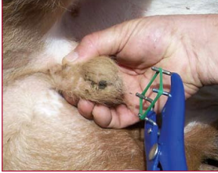
- Pull the tip of the scrotum through the expanded ring which is positioned above the testicles close to the calf’s body.
- Apply gentle pressure at the neck of the scrotum to force the testicles below the rubber ring into the scrotum. Do not place the ring too high up the neck of the scrotum as this may pinch the adjacent skin on the abdomen.
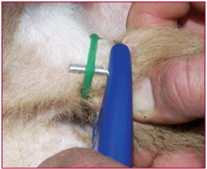
- Release the pressure on the applicator so that the ring tightens around the neck of the scrotum.
- Carefully remove the rubber ring from the prongs of the applicator.
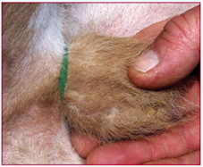
Callicrate Bander
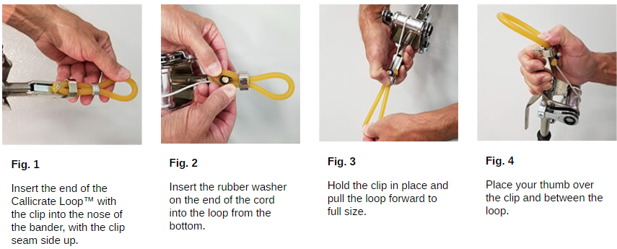
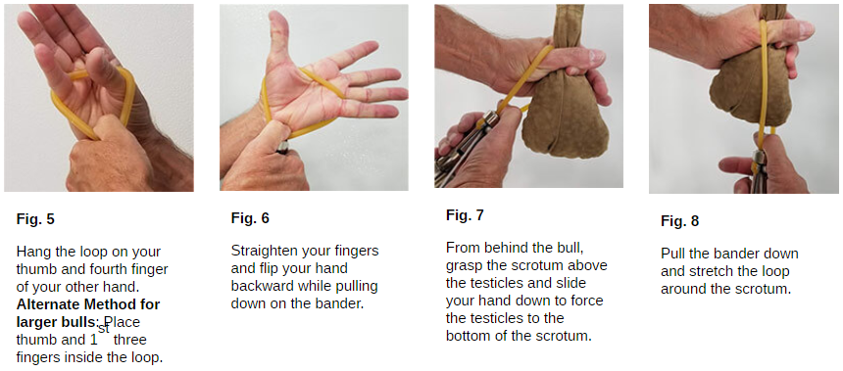
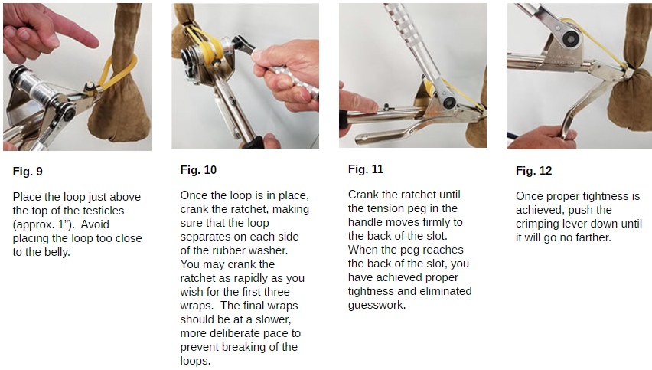

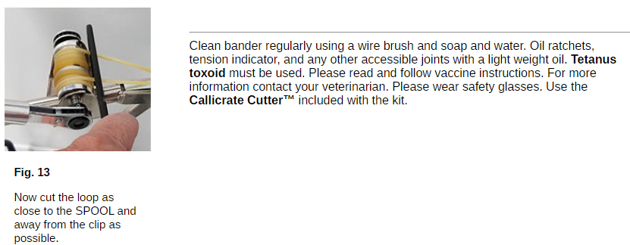

Burdizzo
- Restrain calf (standing position is best) [Use this technique when the spermatic cord can be palpated - one month and older.]
- Choose and use the proper sized forceps for the size of animal. With undersized forceps, there will be too much tissue between the jaws and there will not be enough force to properly crush the arteries.
- Feel for left spermatic cord at neck of scrotum and move it to the outer edge.
- Clamp the Burdizzo® tightly over the left cord for 10–20 seconds. (Do not crush the midline of the scrotum with its blood flow).
- Reapply clamp about 1cm below first point – again for 10–20 seconds.
- Repeat double clamping on the right cord (again avoiding the midline blood supply).
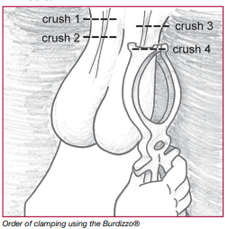

The Ritchey Nipper Tool is a similar device to the Burdizzo Castration Tool. Both tools operate on the same principle of crushing the spermatic cord. The difference between both tools can be illustrated in the picture below.
Burdizzo (Left), Ritchey Nipper (Right)

Castration Method | Advantages | Disadvantages
Surgical | - Castration is certain  - Healing is faster than with rubber ring | - Can be bloody  - Risk of Infection from open wound  - Requires experienced operator
Elastrator Banding | - Bloodless  - No open wound (no infection)  - Can be done in very young animals  - Relatively cheap | - Tetanus Risk  - Not suitable for older animals  - Cannot confirm success of the procedure
Burdizzo | - Can be done in older animals  - Bloodless  - No open wound | - Requires experienced operator  - Costly  - Cannot confirm success of the procedure
Callicrate Bander | - Done in older animals  - Bloodless  - No Open wound | - Requires experienced operator  - Cannot confirm success of the proceedure
Short Scrotum Method | - Testosterone secretion still present which improves growth  - Advantages in feed efficiency  - Leaner carcass | - Aggressive behaviour still present  - Risk of sperm production  - Requires Skilled Operator

References:
- Malone E, Norton E, PhD D, Dobbs E, Ezzo A. Small ruminant castration [Internet]. Open.lib.umn.edu. 2020 [cited 11 October 2020]. Available from: https://open.lib.umn.edu/largeanimalsurgery/chapter/small-ruminant-castration/
- [Internet]. Animalwelfarestandards.net.au. 2020 [cited 11 October 2020]. Available from: http://www.animalwelfarestandards.net.au/files/2011/05/Sheep-Castration-discussion-paper-5.3.13.pdf
- [Internet]. Open.lib.umn.edu. 2020 [cited 11 October 2020]. Available from: https://open.lib.umn.edu/app/uploads/sites/208/2018/11/sm-rumin-castration-web-doc.pdf
- Castration of Calves [Internet]. Omafra.gov.on.ca. 2020 [cited 11 October 2020]. Available from: http://www.omafra.gov.on.ca/english/livestock/beef/facts/07-029.htm#pain
- [Internet]. Futurebeef.com.au. 2020 [cited 11 October 2020]. Available from: https://futurebeef.com.au/wp-content/uploads/A-guide-to-best-practice-husbandry-in-beef-cattle-Branding-castrating-and-dehorning.pdf
- [Internet]. Extension.tennessee.edu. 2020 [cited 11 October 2020]. Available from: https://extension.tennessee.edu/publications/Documents/PB1664.pdf
- 7. [Internet]. Projectblue.blob.core.windows.net. 2020 [cited 11 October 2020]. Available from: https://projectblue.blob.core.windows.net/media/Default/Research%20Papers/Beef%20&%20Lamb/theshortscrotummethodofcastrationinlambs_210710_final_report.pdf

