PRE- OPERATIVE- case 3
A cow with a history of stepping on a nail some weeks ago which got infected and the animal has a solar abscess. You want to drain and repair.

Solar abscess- Injuries to the sole of the foot are commonly associated with excessive wear of moisture- soften feet on rough abrasive flooring. Injuries can also be caused by puncture wounds, bruising and abrasions. These injuries can lead to infections and lameness resulting in abscessation or even infection in the interdigital tissue, up the lower leg into the joints. Solar abscesses may occur on any claw, but it is common on the outside claw of the hindlimb. If there is damage to the white line area, this allows bacteria to penetrate the foot.

Anatomy of the hoof in a cow:
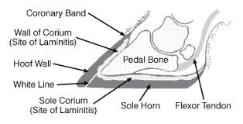
Clinical signs seen:
Sudden, severe lameness
• Varies from barely perceptible to non-weight-bearing
• Owner may believe horse has fractured its limb
Bounding digital pulse
Affected foot is warmer than contralateral foot
Distal portion of limb, esp. pastern, is often swollen
Draining tract at the coronary band

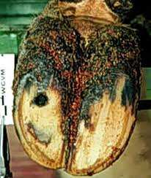

Diagnosis of a solar abscess-
A distance exam can be used to determine which limb is lame. The gait and stance of the animal would be examined. Once the limb that is lame is identifed, the cow is then physically examined. The hoof is cleaned and examined for any black spots that may not belong. Hoof testers may be used as a examination technique. X-rays can be used also to check for gas in the hoof, bacteria present, or rule out fractures and foregin bodies. Laminitis could also be seen to identify bone involvement. Identifying how severe the problem is critical for the treatment plan of the animal.
DDx- A differential diagnosis is fracture of the distal phalanx.

TOOLS AND EQUIPMENT: There should be proper PPE used such as gloves and protective glasses to avoid any injury.
Grinder –

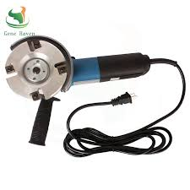- used to shave down the hoof

Hoof nippers-
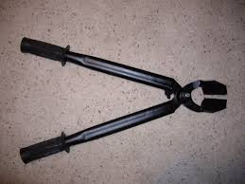- removal of any excessive hoof or any foreign body

Right/left hand hoof knife-
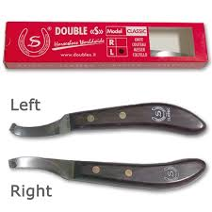- used to trim the hoof, clear away any foreign material

Rasp:
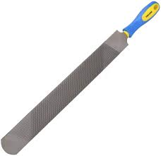

Gigli wire saw

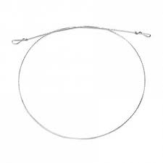- used for amputation of digit or claw

Drill:
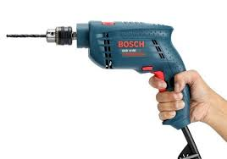- used to create a drain for the abscess

Restraints:
Cows should be properly restraint for inspection. The cow should be placed in a crush or have its head tightly tied with its feet accessible for investigation in a stanchion. A belly strap should be in place if the animal loses her footing and slips. This strap also helps in calming down the cow. Lifting from the hock is much more comfortable for the cow, and because she can still lean on the raised leg there is very minimal risk of injury.
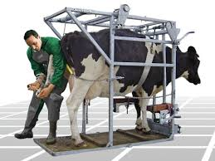

Videos showing how to lift fore and hindlimbs in a cow
https://www.youtube.com/watch?v=hhZfvYDyZIk – forelimb
The tie should be placed below the due claw. The rope should have a double hitch on the bar for added control of the limb. The limb is then pulled and once in position the rope is tied with a quick release slip knot.
https://www.youtube.com/watch?v=MgxGSBEVYWY – hindlimb

Chemical restraints maybe used if the animal is very aggressive or surgical intervention is needed.

DRUGS:
Drug | Route of admin. | Concentration | Dose rate | Toxic Dose | Withdrawal time | usage
Xylazine | IM | 20mg/kg | 0.5mg/kg |  | 14 days | Sedation
Ketamine | IM | 100mg/kg | 1mg/kg |  | 3 days | Sedation
Lidocaine | IV or SQ | 20mg/kg | 2mg/kg | 10kg/kg | 1 day | Local or regional
Flunixin | IV | 50mg/kg | 2.2mg/kg |  | 4 days | Anti-inflammatory
Penstrep | IM | 200000 IU/ml | 40000 IU/ml |  | 30 days | Antibiotic

Calculations:
Volume (ml)= (Dose * Weight)/ Concentration.
Example: weight of a cow- 400 kg
Lidocaine 2%- therefore concentration= 2*10= 20mg/kg
Volume= 2*400/20= 40 ml

