Haemostatic forceps | Straight  Curved  Mosquito  Kelly  Crile  Carmalt  Satinsky  Bull dog clamp  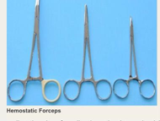 To ligate, and occlude vessels.
Scalpel handles & blades | 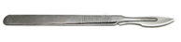 to incise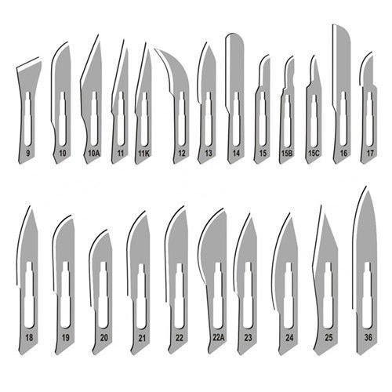
Needle holders | Mayo-Hegar  Olsen-Hegar  Mathieu  Castroviejo (microvascular)  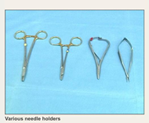 Grasp suture needles when suturing tissues
Towel clamps | Backhaus  Lorna  Roeder  Jones  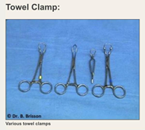 To secure.
Surgical drapes | 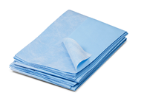
GENERAL INSTRUMENTS, TOOLS, EQUIPMENT & MATERIALS CAN BE FOUND IN THE OUTER CMAP GENERAL INFO.

