Equipment | Image | Description
Scalpel | 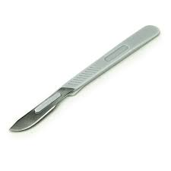 | Used to make fine and precise incision into skin or tissue.
Gloves | 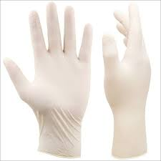 | To maintain sterility and prevent cross contamination
Drape | 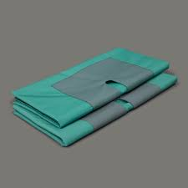 | Used to isolate surgical area and maintain sterile surgical field.
Suture | 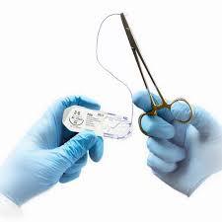 | For closing open wounds made during surgery
Rope halter | 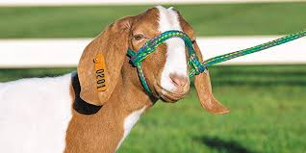 | To restrain animal during surgery and limit movement
Stanchion/ Chute | 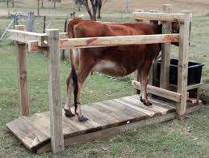 | Used to restrain and isolate animal to a confined area during surgery.
Handheld lid retractor | 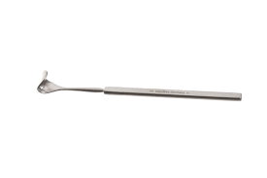 | To hold eye lids open allowing room for visibility
Eye patch | 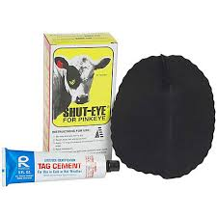 | To maintain a safe and clean environment for healing
Allis tissue forceps | 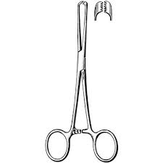 | Used for grasping of tissue surrounding the eye.
Hair clipper | 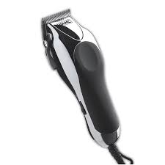 | For removal or hair surrounding surgical site to facilitate adequate cleaning.

