Squamous cell carcinoma removal of eye

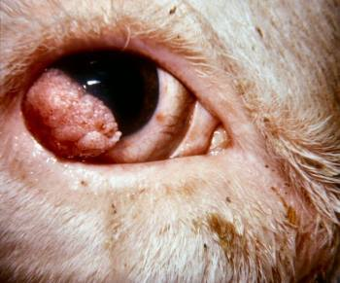

Causes:
- Multifactorial: heritability(associated with eye pigment), sunlight, nutrition, eyelid pigmentation, and perhaps viral involvement playing roles.
- High UV light areas, eg those at high altitude or latitudes nearer the equator.
- Keratitis and trauma caused by tall, rough grasses and insects may stimulate
- Increased vascularization, which increases susceptibility to neoplasia.

Surgical treatment options:
This depends upon the location and extent of tumor.
- Local excision: Removal of the intraocular contents only (sclera and extraocular muscles are left attached)
- Enucleation: For advanced lesions confined to the globe, enucleation is recommended.
- Exenteration: When adjacent tissues are affected, removal of the globe and all orbital contents, this should be performed.

PRE-OPERATIVE CONSIDERATIONS;

Indications for Enucleation:
- For the presence of an extensive, inoperable intraocular neoplasm of the cornea, upper, lower or third eyelid
- For the treatment of a painful, blind eye
- Extensive inflammation or trauma to the orbit or periorbital tissues eg. Abscessation
- Severe perforating ulceration
- Glaucoma

History
- No history was obtained for the cow at the time of the procedure, but it is very important in routine operations that this is obtained. Some of the relevant information that is included in this is:
  - Animal’s age, tag number and parity
  - Present or past illnesses
  - Vaccination history (if up to date or not) *vaccination against tetanus necessary
  - Current diet plan
  - Any current or previous medication used
  - Prior medical and surgical procedures underwent
  - Any recent goat deaths on the farming operation

Signalment
- ID#: 873
- Nickname: -
- Age: 7 years
- Breed: Hereford
- BCS: 3/5
- Weight: 500kg

Physical exam
- A physical exam is always preceded by a distance exam. The environment is observed and assessed for factors such as cleanliness, proper and adequate bedding, airflow and presence of other pen mates. The animal’s appearance is then assessed by its ability to stand, gait and posture, any visible abnormalities, signs of fecal staining and the respiration rate. After this, a 5-station physical exam is done, and all parameters are observed to check if they are within the normal ranges and systemically healthy.
- Before surgery, determine the patient’s age and pregnancy status, which are pertinent for determining the feasibility of eye enucleation. Old age and nonpregnancy may negate the merits of surgery.

Restraint and Safety
- Use of a standing chute
- Halter and nose lead is used to maintain positive head control with the head turned to the side.
- 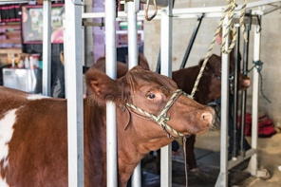

Equipment
- Curved mayo scissors
- Curved hemostats
- Surgical blade
- Number 3 Absorbable suture material eg. Catgut thread chromic
- Number 3 Non-absorbable suture material (example: polyamide thread).
- Bandage materials

Patient Preparation
- Standard aseptic preparation; clip and remove hair in the orbital area with a small animal clipper head.
- Scrub the surgical area with 3.75% povidone iodine surgical scrub, followed by 70% methylated spirit, and repeat 3 times
- Diluted 1:20 povidone iodine solution is soaked on gauze sponges and cover the area.
- Alternate iodine with saline and work out preparing the eyelid margins.
- A final preparation of periocular skin from the margins outwards is done.
- Keep the eye lubricated with sterile saline or methylcellulose gel to prevent corneal drying.
- Trim excess neoplasia with scissors to help with enucleation.

CALCULATIONS OF DRUGS

Drug | Dose rate | Concentration | Volume to be given | Withdrawal
Xylazine (IV) | 0.05mg/kg | 20 mg/ml | V= (dose x weight)/ concentration  =0.05mg/kg x 500kg / 20mg/ml  = 1.25ml | Meat- 4 days  Milk- 24 hours
Butorphanol (IV) | 0.01mg/kg | 10mg/mL | V= (dose x weight)/ concentration  =0.01mg/kg x 500kg / 10mg/ml  = 0.5ml | Meat- 2 days  Milk- 0 hours
Lidocaine | 0.2 mg/kg | 20mg/ml | V= (dose x weight)/ concentration  =0.2mg/kg x 500kg/ 20mg/ml  = 5ml | Meat- 1 day  Milk- 24 hours
Tetanus antitoxin (IM) | 50,000 IU/ 200,000 IU | 1ml | 1ml | Meat- 21 days  Milk- 0 days
Penicillin 12,000 IU/kg SID for 3 to 5 days. (IM) | 12,000 IU/kg | 300,000 IU/mL | V= (dose x weight)/ concentration  = 12,000 x 500kg / 300,000 IU/mL  = 20ml | Meat- 21 days  Milk- 3 days
Flunixin meglumine 2.2 mg/kg (IV) | 2.2mg/kg | 50mg/ml | V= (dose x weight)/ concentration  =2.2mg/kg x 500kg / 50mg/ml  = 22ml | Meat- 4 days  Milk-72 hours

