CASTRATION OF A HORSE
Need to know – ANATOMY OF TESTES
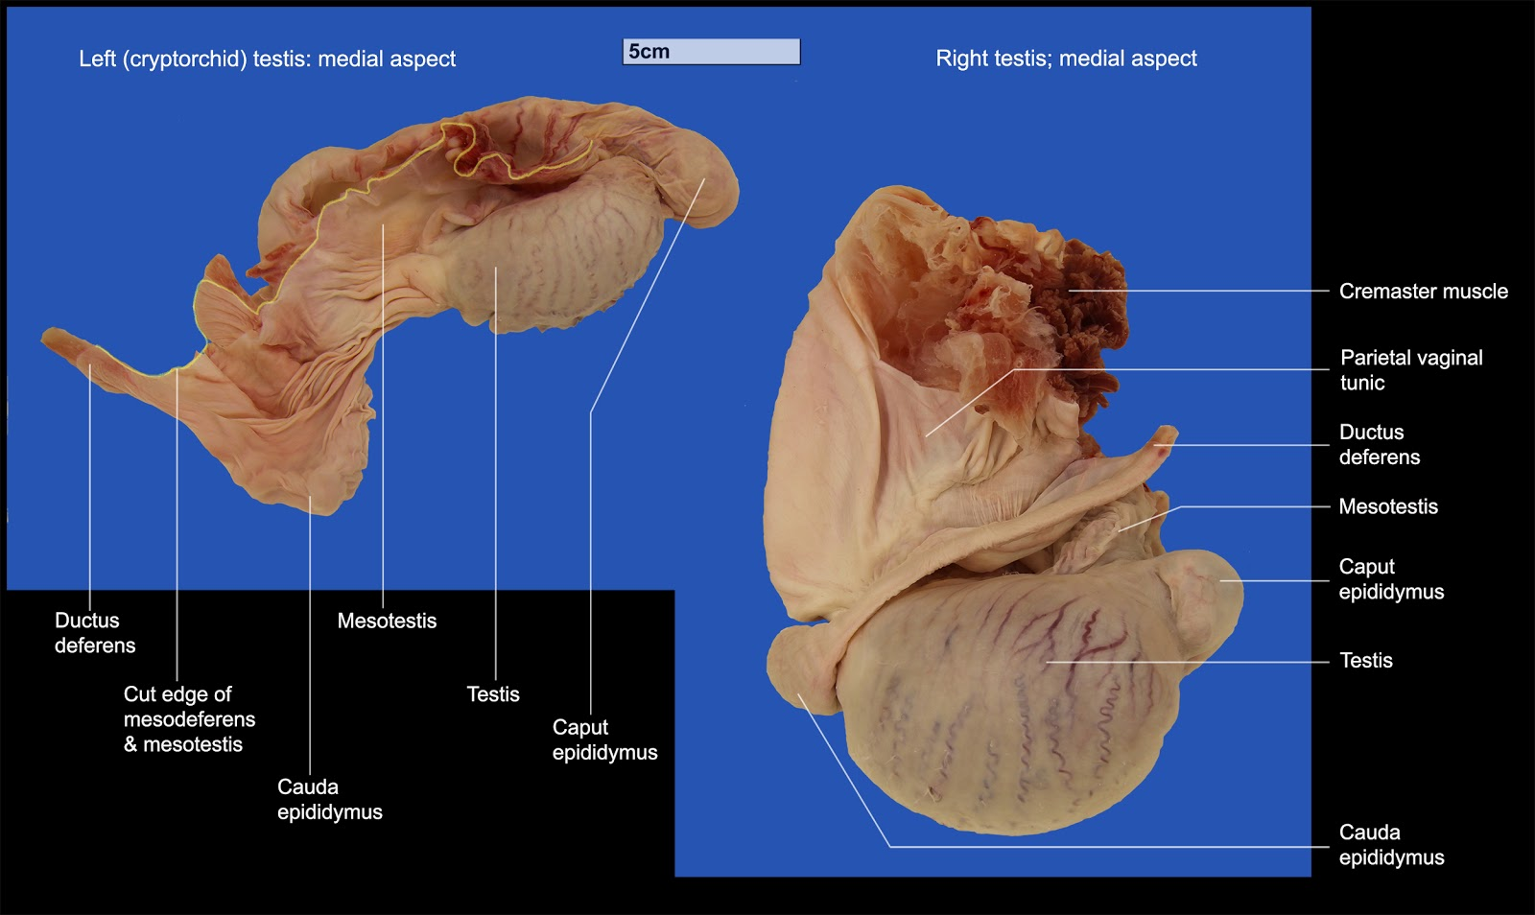
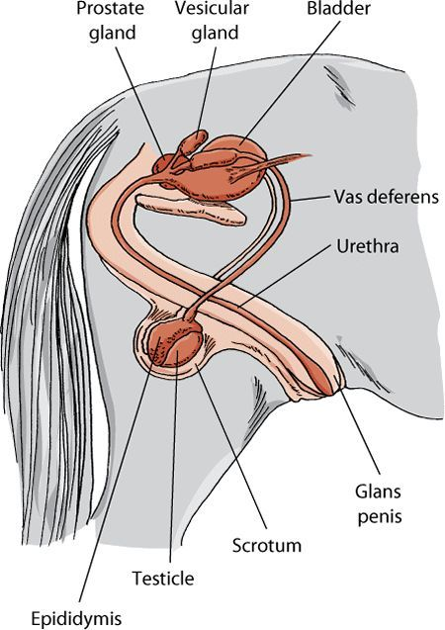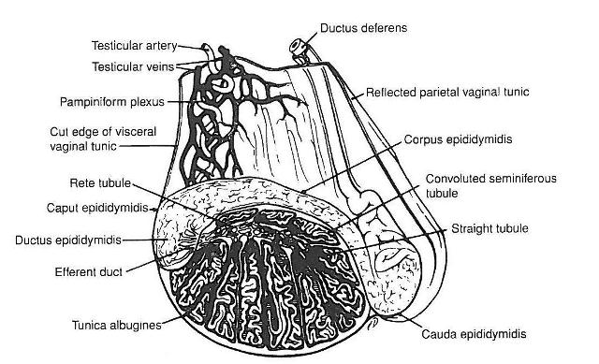

The testes of the horse are ovoid in shape and positioned in the prepubic area. It is in a horizontal direction with the tail caudally.

Castration can be performed in both Standing or Recumbency positions.

How is Castration done in the horse? https://open.lib.umn.edu/largeanimalsurgery/chapter/equine-castration-overview/
Distance and Physical exam conducted. ASA grade and BSC should be noted. The testes should be palpated.
Administration of Xylazine, alpha-2 agonist, followed by ketamine to anesthetize horse.
Pre-surgical scrub of testes should be done.
Local analgesic block with Lidocaine should be injected where the incision line is made on the testes as well as intra-testicular and intra-spermatic cords.
For open castration in horse,
- 2 vertical incisions are made on each testes approximately 1cm from median raphe
- 1st incision is made for the length of the testis
- The incision is continued through the Tunica dartos and scrotal fascia
- The common tunic should be left intact
- Then apply pressure to extrude testes
- Then vaginal tunic separation is then done by blunt dissection
- The common tunic is then incised over cranial pole of testis
- The testis is now released from common tunic
- The spermatic cord is then separated from the common tunic, ductus deferens and external cremaster muscle.
- Ligation around spermatic cord should be done.
- The spermatic vessels are emasculated (below ligation) after leaving as much of common tunic.
- Afterwards, antibiotic powder should be applied on both sides of scrotal sac

For closed castration,
- An incision is made only through the scrotum and not through the parietal tunic
- Dissection of scrotal fascia is done.
- Emasculation then primary closure is done

Post- Operation Considerations
- Open scrotal incision – Hydrotherapy for decreased swelling or movement
- Closed castration- horse should be confined to promote primary intention healing
- Isolate from mares
Observe for any complication such as edema. In that case, allow animal to exercise or promote hydrotherapy. If that proven futile, then reopen scrotal incision and allow drainage. In case of haemorrhage, wait and observe and find bleeder. In case of evisceration, anesthetize and replace contents back into abdomen- common in Drafts and Standardbreds.

