Pre-operative equipment

Name | Use
Rope Halter and lead rope  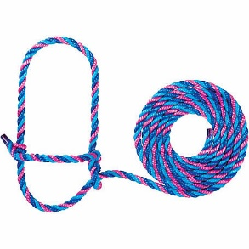 | Used on the bull calf to make a quick release slip knot. Allows for cattle to be safely restrained making surgery less dangerous for those performing it as well as decreasing risk of cattle injuring itself.
Rope  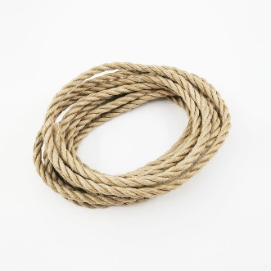 | Was used to restrain the hind limbs of the calf.
Boots  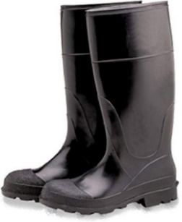 | To protect feet from being stepped or stamped.  Keeps the veterinarian clean and also provides some protection from injury and dirt.
Coveralls  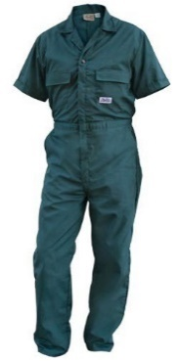 | Worn when working with the cattle and are normally removed when exiting the farm to prevent any cross contamination between farms.

Intra-Operative Equipment

Name | Use | Advantage | Disadvantage
Gloves  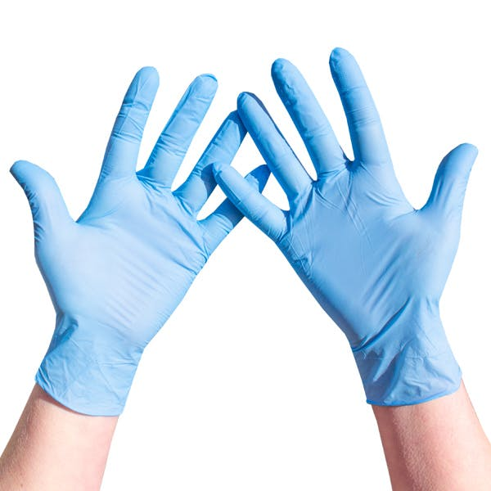 | - Used to keep hand and area clean and decrease the spread of bacteria onto the castration site thus increasing risk of infection. | - Helps decrease risk of wound infection by no having te veterinarian in direct contact with the wound | - Makes it harder for the veterinarian to tie ligatures as there is less grip.
Plastic Bag  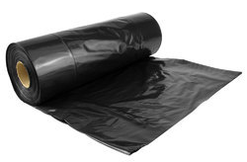 | - Was used to provide a ‘clean’ area to do the castration of the calf.
Haemostat  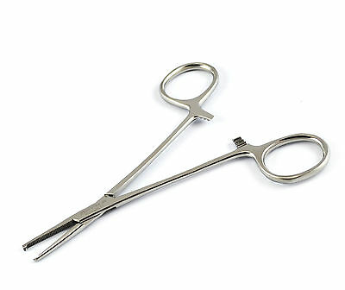 | - Used to clamp arteries in the spermatic cord as well as provide a clear indication of where should be incised.
Scalpel blade and scalpel handle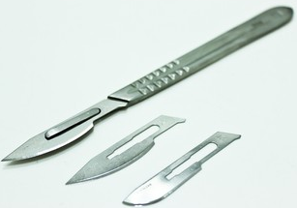 | - Used to incise surgical area | - Sharp and precise tool | - Due to sharpness, there is a risk of a slip and injury
Reimer Emasculator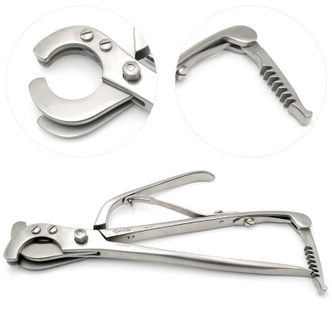 | - Used in both open -open and open-closed methods and is used in crushing and cutting of the spermatic cord. | - This method is more effective at ensuring the animal is fully castrated. | - There is a higher risk of infection and complications.
Burdizzo Emasculatome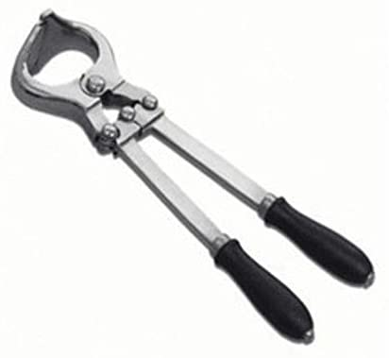 | - Used to closed castration to crush the skin and the spermatic cord as well as stop blood supply to the testis.  - Used in stallion and bulls  - Small ones are used in sheep and goats | - This is bloodless and less painful for the animal.  - Less chance of infection due to there being no open wound.  - Quick and easy to complete | - Increase risk of gangrene due to lack of blood supply to the scrotum.  - If the cord is incompletely crushed, the animal can still breed.  - Increase risk of injury to animal or the veterinarian
Elastrator  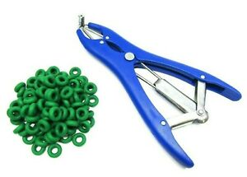 | - Elastic rubber ring is placed around the scrotum with the testicles below | - Bloodless so increase risk of infection due to no open wound  - Less painful than cutting  - Quick and easy  - No risk of maggot infection due to no open wound | - There are age limitations as it has to be done before ram lamb is 10 days old  - There is a risk of a wound forming that can lead to an infection in particular tetanus  - The discomfort can lead to decreased growth rate  - Sometime scrotum doesn’t completely fall of and remainder will need to be cut
Newberry knife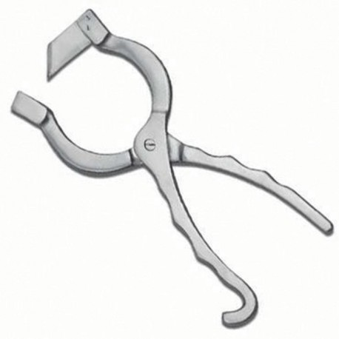 | - Makes 2 vertical incisions on either side of the scrotum to allow for testicle removal. | - Slits the scrotum in half  - Allows for good drainage of the wound  - Good access to the testis
Gauze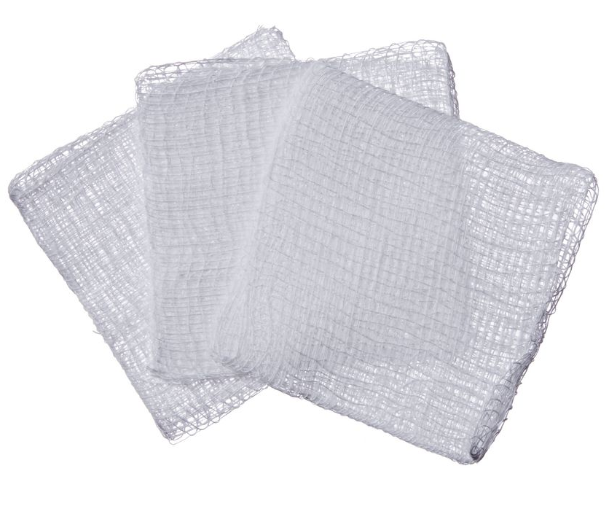 | - Used to clean surgical area or to provide grip during surgery. | - Used to soak up excess blood/ fluid to provide better visualisation of the surgical area. Can also be used to provide better grip. | - Risk of gauze being forgotten in surgical site by accident and leading to infection
Suture material (catgut)  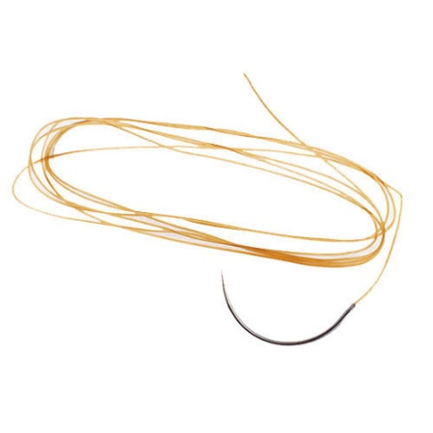 | - Was used to form a strangle knot to stop bleeding when the spermatic cord is cut. | - It's absorbable so it doesn’t need to be cut to be removed.
Specimen Container | - Used to collect the testis for observation and histopathology if necessary.

Post-operative equipment

Name | Use | Advantage
Tetravet Spray | - An antibiotics spray used to treat and prevent topical microbial infections. | - Decreases risk of infection developing at the wound site.  - Its a topical antibiotics spray that contains Oxytetracycline hydrochloride as the active ingredient. It’s a broad-spectrum bacteriostatic antibiotic and its colours allows for easy identification of where in the wound was sprayed.
Matabichera Fort dodge Spray | - This is an anti-myiasis spray which repels insects and flies from the wound area. | - This decreases risk of fly laying eggs leading to maggot wounds.  - Its an anti-myasis spray and antiseptic that contains Active ingredients are chlorfenvinfos and dichlorvos

