Name | Use
Twitch  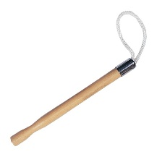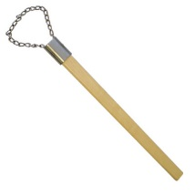 | Used as a lip witch before the nerve block to distract the horse from the incoming pain of the needle.  The rope twitch is gentler so if restraint is needed for an extended time to rope twitch is recommended.
Halter and lead rope  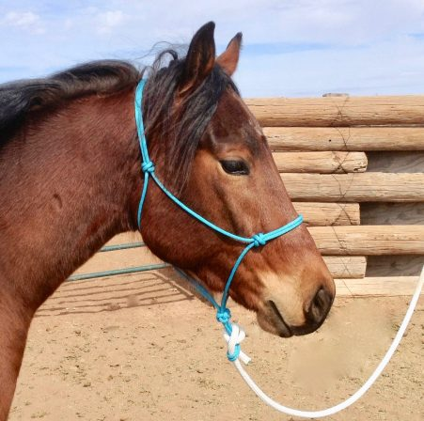 | Can either be used to restrain the horse by tying the lead rope to an area or the lead rope can be held by the horse’s caretaker.
Needle and syringe  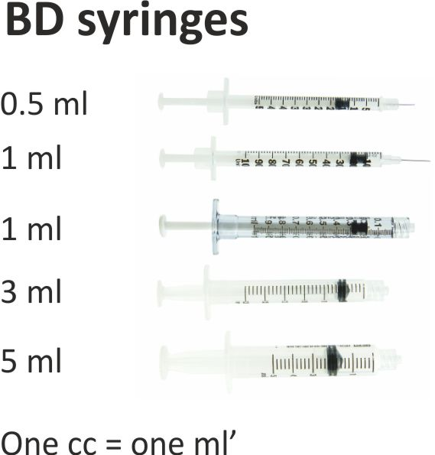 | Used to both measure and disseminate the drugs into the required areas.  Appropriate needle and syringe size is chosen depending on the viscosity or the fluid given, the volume and the pain it will cause the horse when injected. Note that the larger the gauge the smaller the needle diameter.
Gauze or cotton  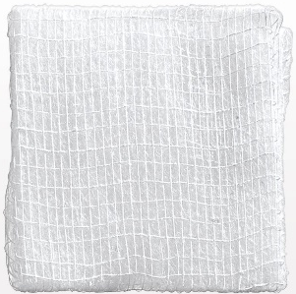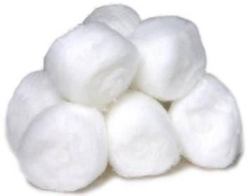 | Used in the skin prep of the patient to be soaked with alcohol or antiseptic scrub to scrub the area.
70% Isopropyl Alcohol | Used during skin prep of the patient to decrease risk of infection
Antiseptic soap: Povidone-Iodine or chlorhexidine | Used in aseptic skin prep along with alcohol to severely reduce the risk of infection by killing bacteria present on the skin.
Hoof Testers  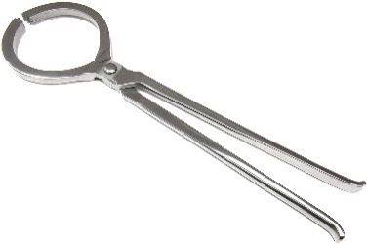 | Used to apply pressure in specific areas of the hoof to identify the area of pain.

