Claw Amputation Visuals

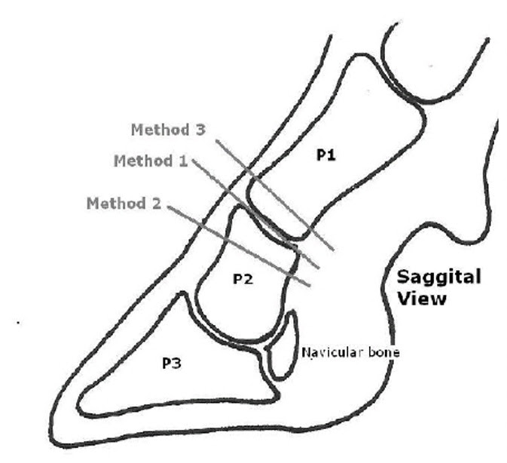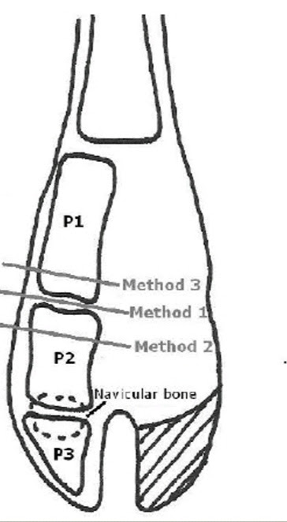
Figure 1 Figure 2

Figure 1 and 2 shows the views of the different approaches to digit amputation. Method 2 represents the Low Digit Amputation approach and method 3 represents the High Digit Amputation approach.

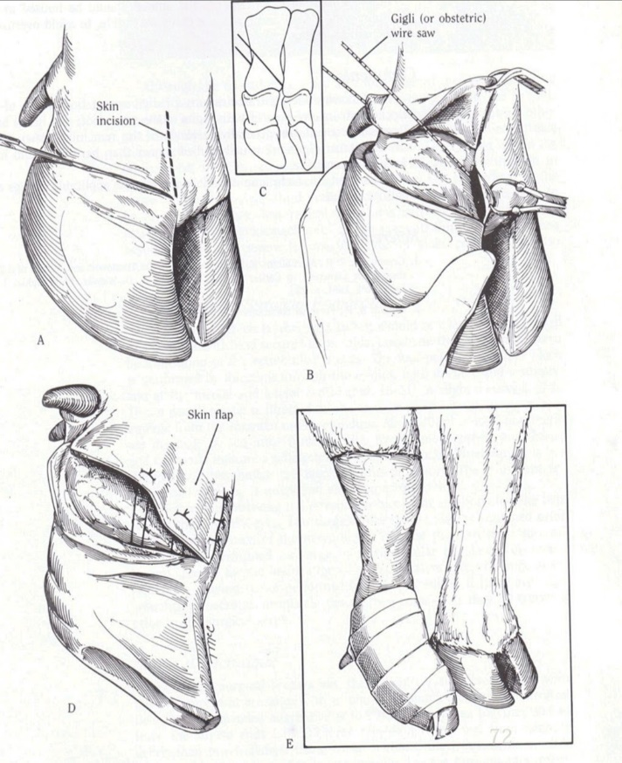
Figure 3
Figure 3 shows the steps done to carry out the amputation process.
a: shows how the incision is made exposing the underlying tissues.
b: shows the skin is opened to allow a proper view for amputate of digit.
c: shows how the Gigli wire should be directed.
d: shows how the skin is sutured at the interdigital space.
e: bandaging of the digit after amputation has completed.

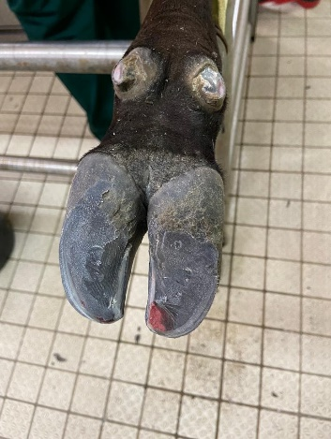
Figure 4

Figure 4 shows intact digits before amputation.

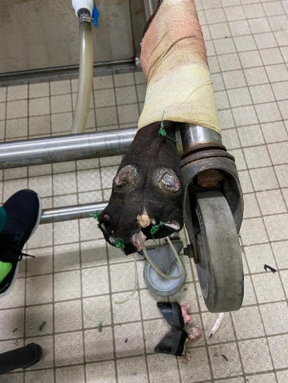
Figure 5

Figure 5 shows the limb after amputation.

