PREDISPOSING FACTORS FOR LAMENESS
https://dairy-cattle.extension.org/lameness-in-dairy-cattle/
https://www.merckvetmanual.com/musculoskeletal-system/lameness-in-cattle/risk-factors-involved-in-herd-lameness-of-cattle
Housing and Environment
Dairy cattle confined to concrete may have more feet and leg problems. Properly designed and bedded freestalls will encourage cows to lay down and curb height over 6 inches should be avoided. Cows lying down 10 or more hours are more content with their environment and have fewer claw problems.
Movement of cows at the manager’s pace on rough or hard surfaces increases the incidence of lameness. Allow cows to go single file at their pace to reduce foot problems.

Nutrition:
Subacute ruminal acidosis (SARA) is a common problem in high-producing dairy herds. Successfully managing SARA depends on the quantity and digestibility of the carbohydrate fed. The more rapidly carbohydrate is digested, the more rapidly rumen acidosis will develop.
If a nutritional problem is suspected, a "walk around" should be done. Feed storage facilities should be evaluated for clues
Nutrition plays a significant role in foot disorders, and changes in the normal pattern of ruminal fermentation tremendously influence claw health. Feed a total mixed ration (TMR) to regulate concentrate-to-forage ratio. Closely observe changes in forage moisture content and modify rations accordingly. Successful feeding programs will maximize feed intake, minimize acidosis, while maximizing energy intake during early lactation.

Hoof Trimming
Hooves should be trimmed or evaluated once or twice a year to improve comfort and performance. One of the trimmings should be scheduled early in the dry period. Proper weight bearing on the hoof wall of the inside claw of the front feet and the outside claw of the back feet is especially important.
If hoof trimming is not done the required amount for the year, overgrown hooves can lead to disease which can cause lameness. Additionally, the animal would not be able to evenly bear weight on the hooves leading to lameness/pain.
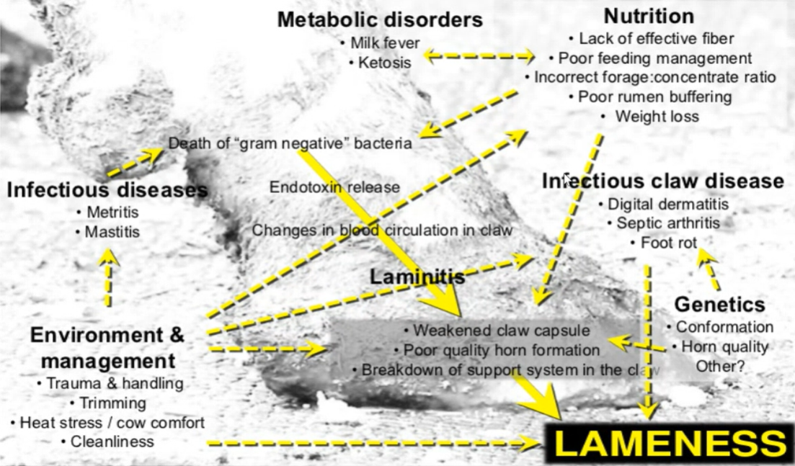
FLOW CHART SHOWING PREDISPOSING FACTORS THAT MAY LEAD TO LAMENES

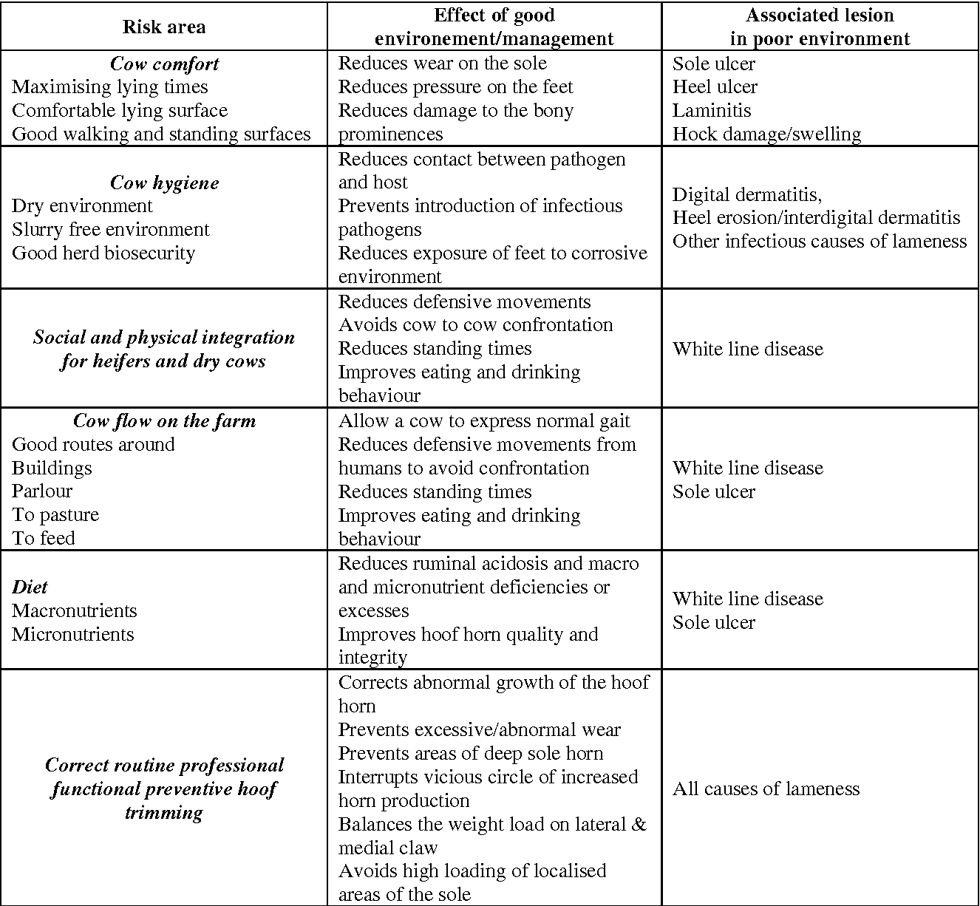
TABLE SHOWING RISK AREAS IN RELATION TO THE OCCURRENCE OF LAMENESS

