Equipment & Indication | Example
Surgical needles- different sizes and types are used in various procedures  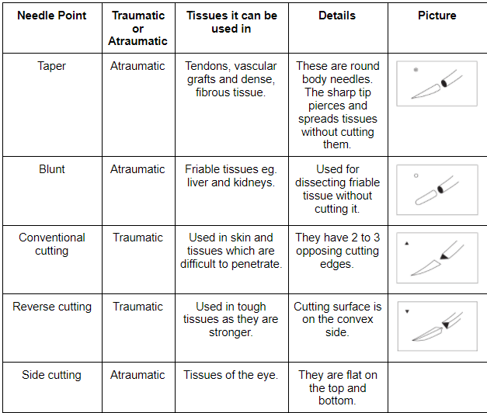 | - Four Point Block: 18gauge, 6mm needle  - Peterson Nerve Block – 18 gauge needle, 10cm needle  - 4 Point Block – 18 gauge, 9cm needle  - Retrobulbar Block – 18 gauge, 9cm (half circle) needle
Syringes | 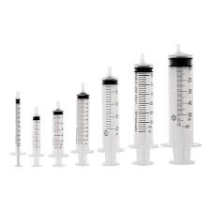
Alcohol swabs | 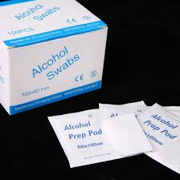
Surgical gloves | 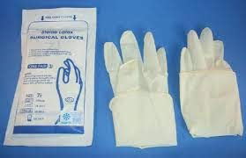
Halter and rope | 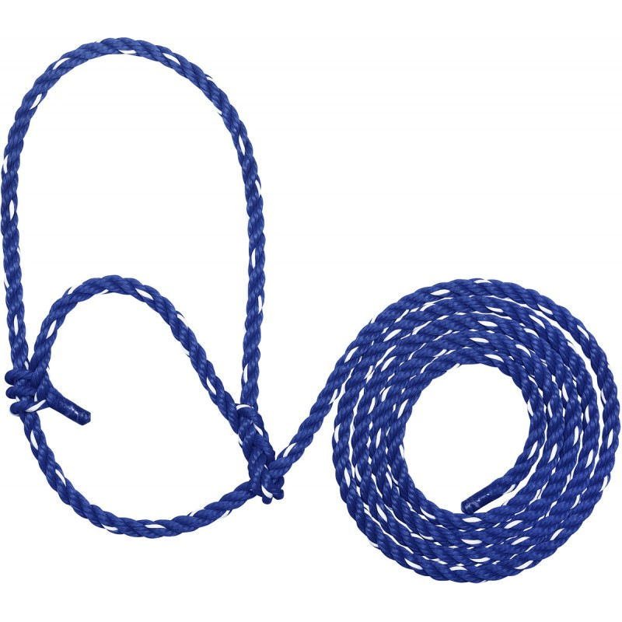
Stanchion | 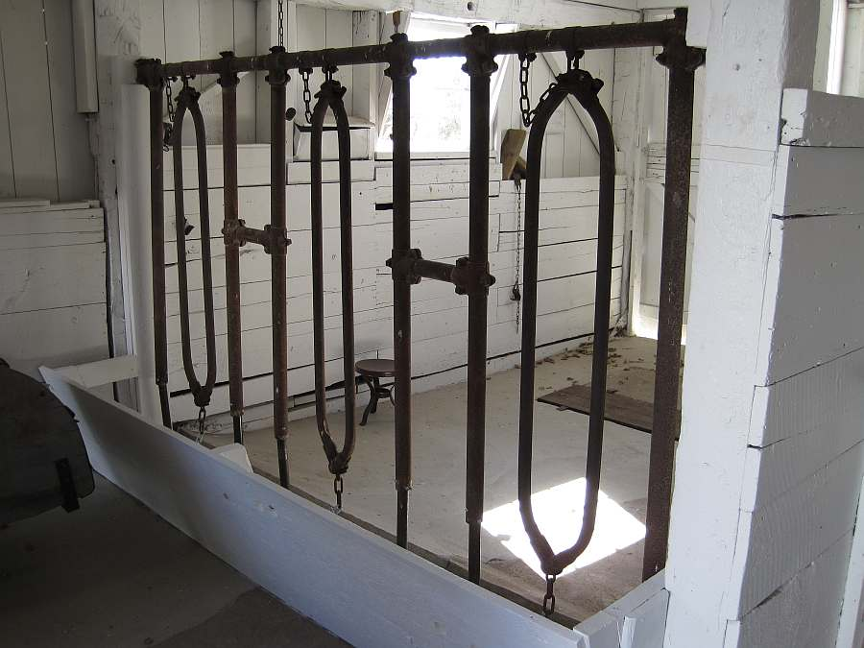
Surgical scissors | 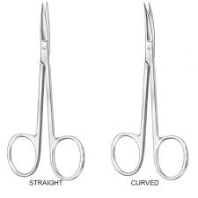
Hemostats | 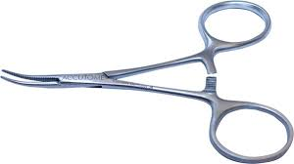
Forceps | 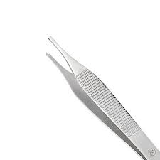
Scalpel blades and handles | 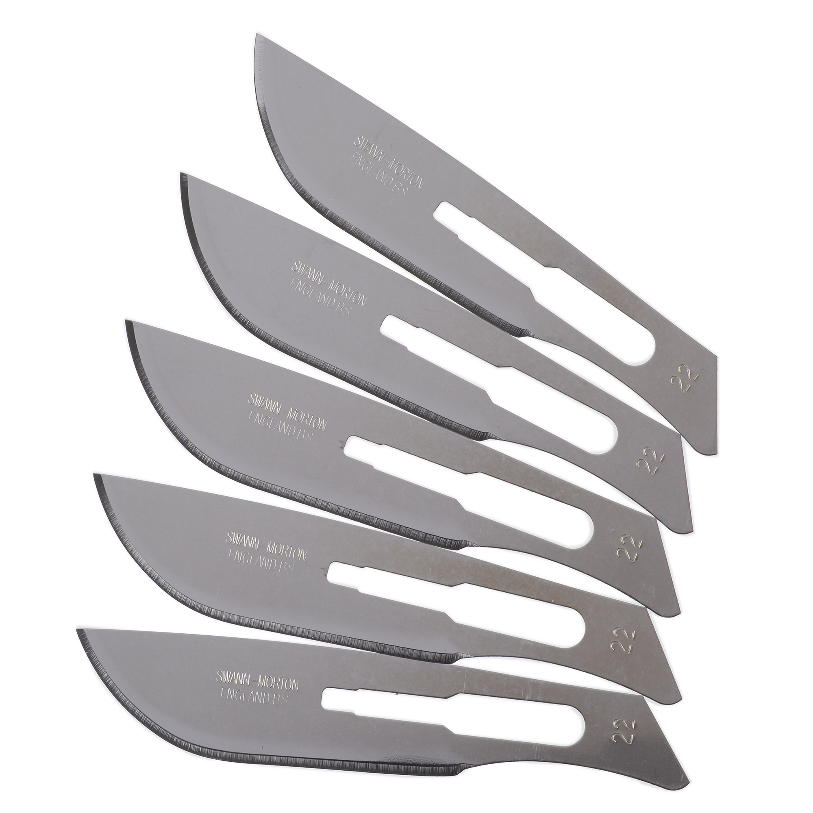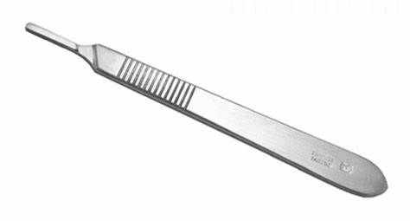
Tongue depressor and jaeger plate- offers stability and protection for the ocular globe and cover the eyeball providing a rigid surface on which surgeons can perform lid dissection | 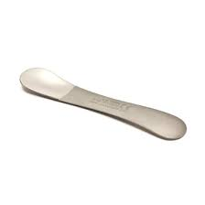
Electric shavers | 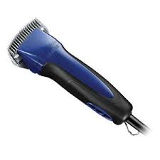
Gauze and cotton | 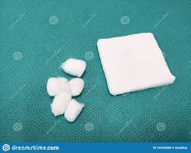
Colibri Forceps: A Semi-sharp, fine tips eases grasping and holding the Corneal and Scleral Flap | 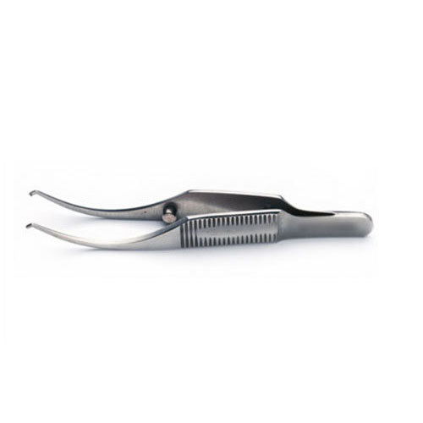
Right Angled Forceps - used to hold tissue in place for eye removal procedures | 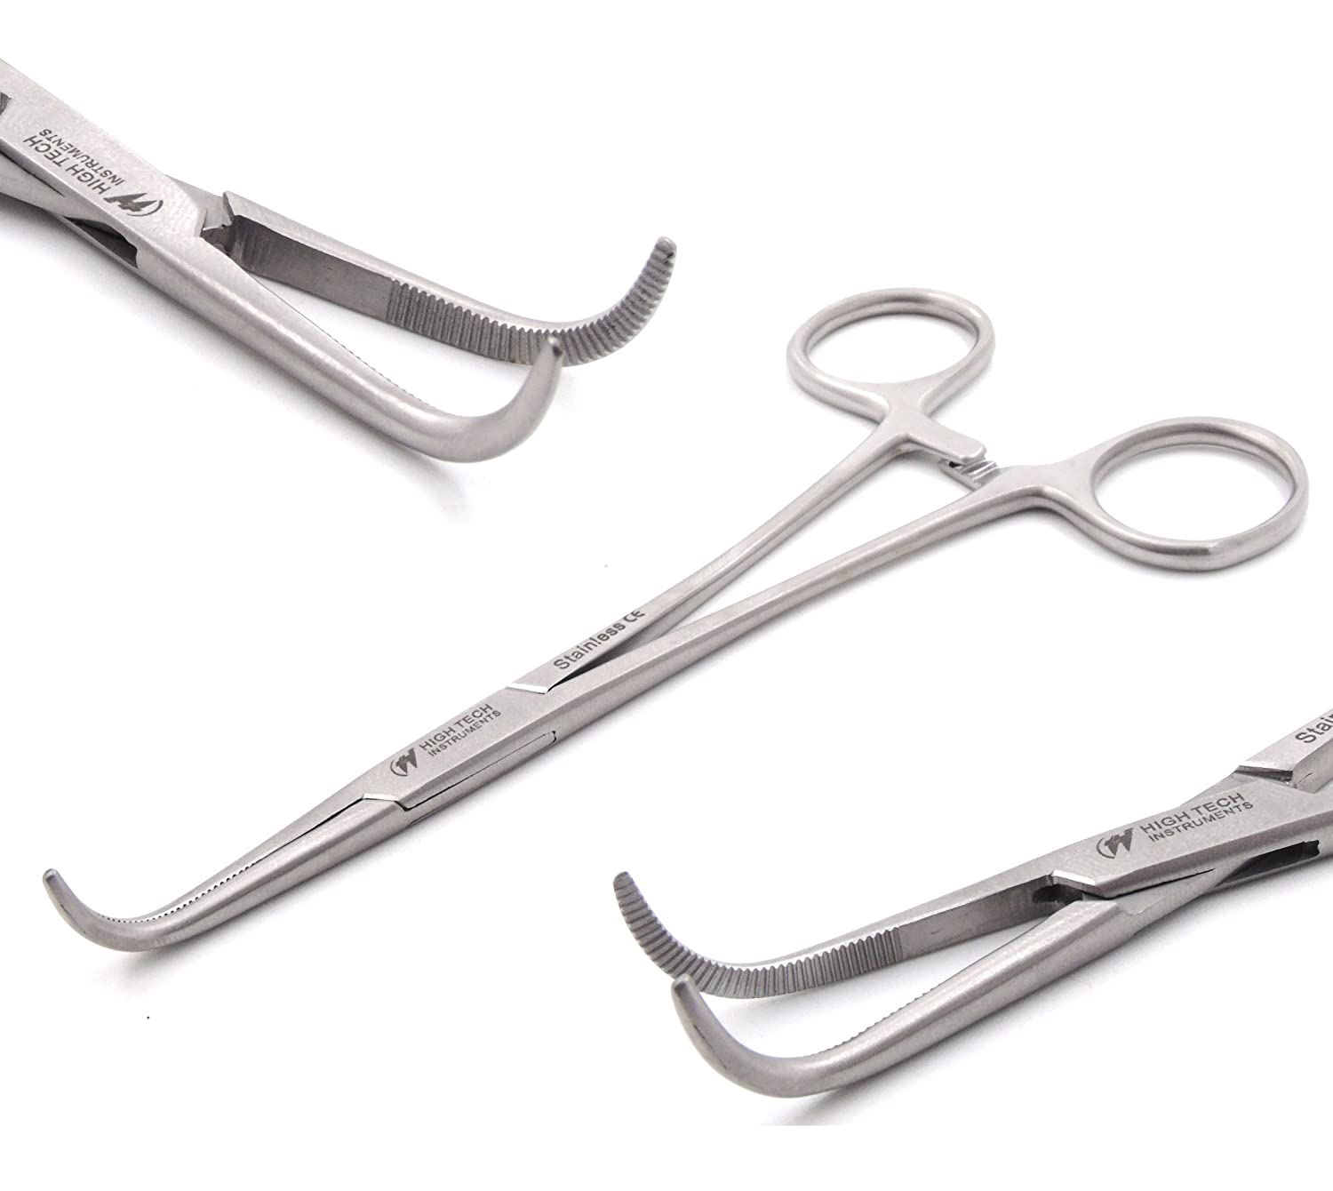
Castroviejo eye speculum: Used to hold the eyelids open during optic surgery | 