Equipment and Material Used
Equipment and materials used in the surgical treatment of Ocular disorder
Forceps | For [Grab your reader’s attention with a great quote from the document or use this space to emphasize a key point. To place this text box anywhere on the page, just drag it.]  - ceps must have a thin edged (atraumatic), to gently grasp the eyelids and conjunctiva,  - E.g., Brown-Adson or larger Bishop-Harmon forceps
 | Bishop Harmon forceps |  | Brown Adson forceps
 | 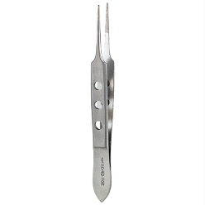 |  | 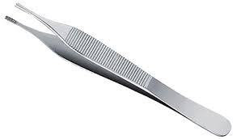
Scalpel and blade | - A No. 4 scalpel handle  - A No. 22 scalpel blade
 | No. 22 scalpel blade |  | No. 4 scalpel handle
 | 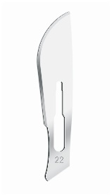 |  | 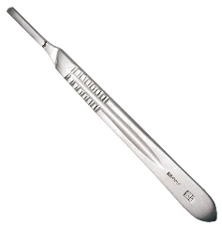
Scissors | - Atraumatic scissors (sharp – sharp or stevens tenotomy scissors)
 | Sharp-sharp | Stevens tenotomy scissors
 | 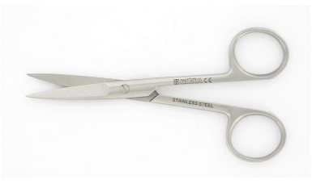 | 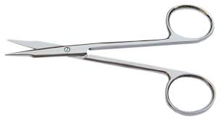
Haemostats | 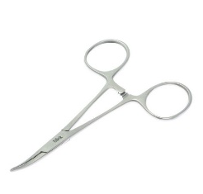  - Mosquito forceps are ideally used, however other fine tip or even regular haemostats can be used
Needle holders | - Would be dependent on the size of the sutures being used  - For most sutures a Derf needle holder can be used  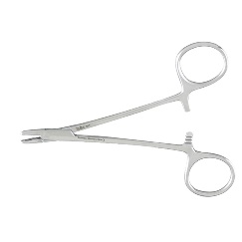
Sutures | - For skin incisions, 3-0 nylon (nonabsorbable)  - For any ligation or subcutaneous procedure, 2-0 or 3-0 Poliglecaprone (monocryl) (absorbable)  Size used would depend on the animal being operated on size
Needles and syringes | - 5 ml and 22-gauge needle  - 10 ml and 20-gauge needle  - 6-inch or an 8.75inch 18-gauge needle (long) needle used for four-point nerve block
 | 6-inch or an 8.75inch 18-gauge needle. (The needle below is a 20 inch, I included this instead of the sizes mentioned above, since the size difference between these sorts of needles and regular needles can be appreciated.)
 | 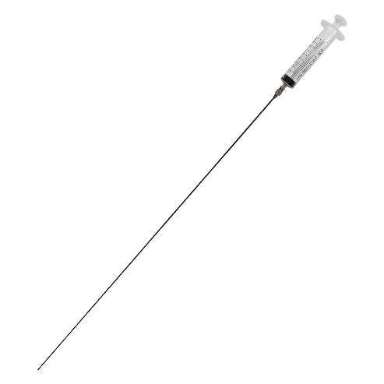

All materials and equipment relating to surgery of the eye, must be thin and handled gently.
Additional materials that may be used:
- Gauze
- Latex gloves

