Equipment and Instruments

- Restraint
- Halter and Lead rope
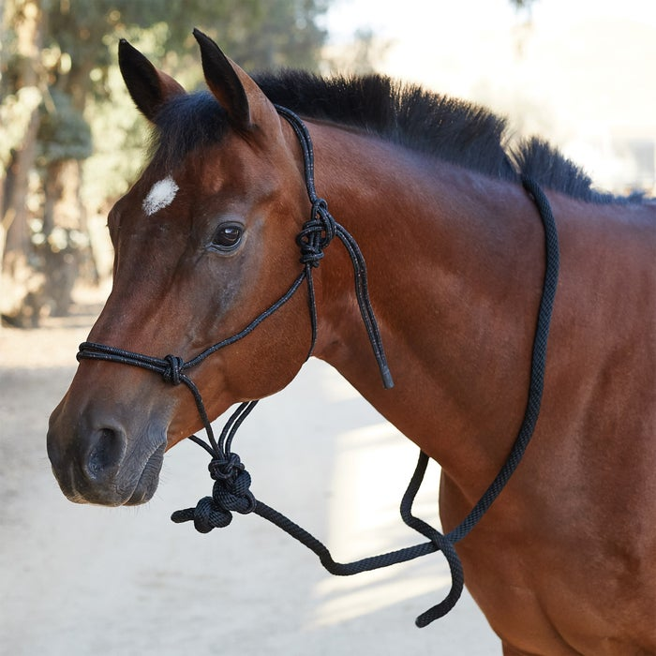

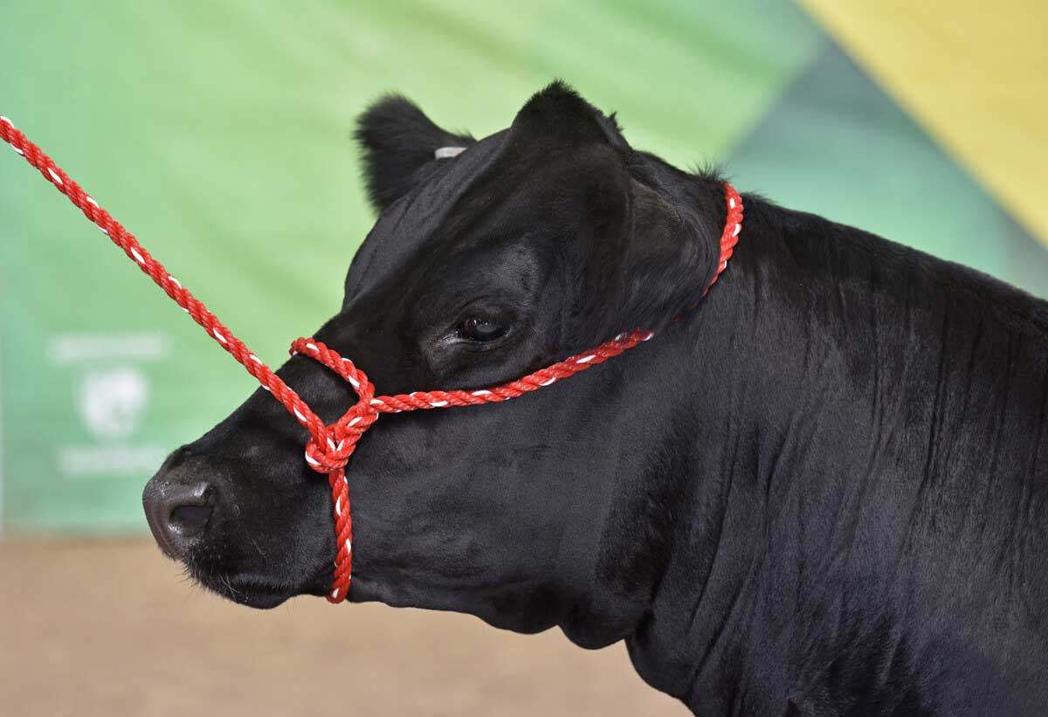

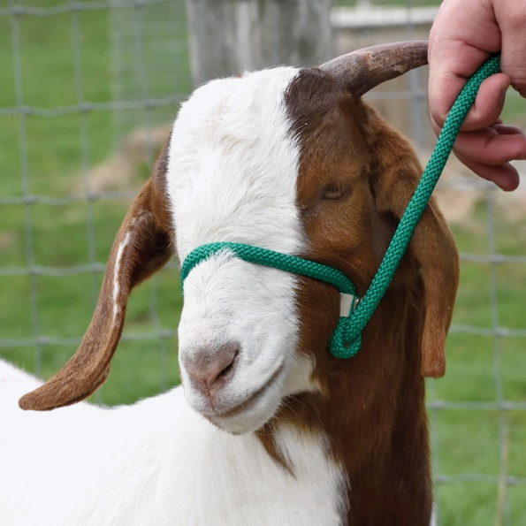

- Chute
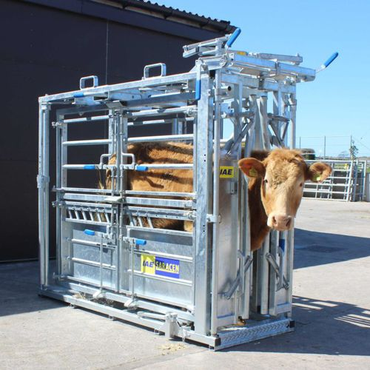

- Stanchion
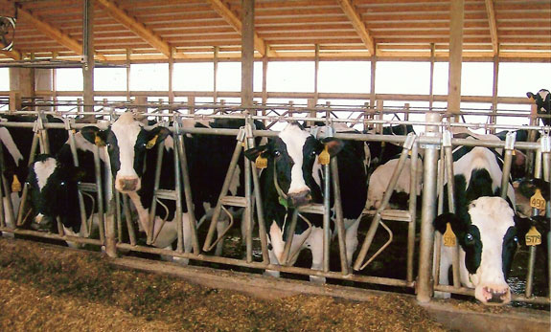

- Nose tong
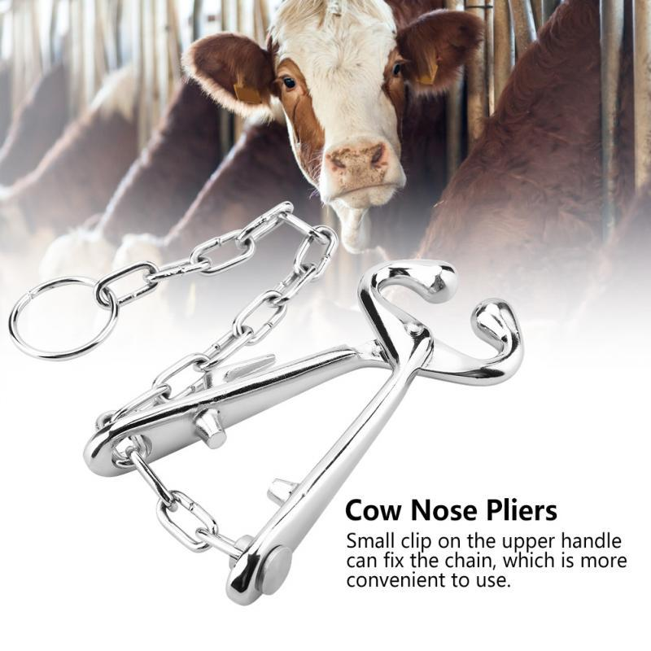

- Physical and Ocular Examination
- Thermometer
- Stethoscope
- Penlight
- Schirmer tear test strip
- Fluorescein dye and other materials

- Nerve Blocks
- Auriculopalpebral
- 20 gauge needle, 3-5cm in length
- 10 ml syringe

- Line Block
- 20 or 22 gauge needle, 2.5 cm in length
- 10 ml syringe

- Peterson’s
- 18 gauge needle, 10 cm in length
- 20 ml syringe
OR
- 22 gauge needle, 2.5 cm in length
- 10 ml syringe
- 14 gauge needle, 2.5 cm in length
- 20 ml syringe

- 4 Point
- 6mm needle
- 10 ml syringe

- Retrobulbar
- 18 gauge hypodermic needle, 15 cm in length OR 14 gauge 5” catheter needle
- 20ml syringe

- Surgical Procedures
- Surgical preparation material:
- Diluted povidone iodine solution (diluted at a ratio of 1:10 to 1:50).
- Saline solution
- Gauze
- Towel
- Lubricant
- Methylcellulose gel (to prevent cornea from drying)
- Ophthalmic ointment

- Enucleation:
- Eyelid speculum
- Scalpel blade/ surgical scissors
- Forceps
- Strabismus (muscle) hook
- Curved hemostat
- Sterile gauze sponges
- Suture material

- Eyelid tacking:
- Suture material
- Mayo hagar needle holder
- Forceps
- Cotton tip applicator

- Hotz Celsus:
- Scalpel
- Jaeger eyelid plate
- Steven's tenotomy scissors
- Forceps
- Suture material

- Resection of Eyelid for neoplasia (V-plasty):
- Suture material
- Scalpel

- Eyeflush:
- om cat catheters OR
- 3.5 to 5 polypropylene canine urinary catheter OR
- red rubber feeding tube (this is very flexible and is difficult to get past an obstruction)
- 20ml syringe with warm sterile saline is needed to perform the flush

- Eye injection:
- Needle
- Syringe

- Drugs
- Xylazine
- 2 % Lidocaine
- 1% proparacaine ophthalmic solution
- Flunixin meglumine
- Penicillin
- Atropine
- Epinephrine
- Tolalozine

- Other
- Hair clipper
- Vacuum

