Teat-End Injuries
Etiology
Teat ends are the most common site of mammary injury in dairy cattle and are the most common reason for owners to seek veterinary consultation regarding the teats of dairy cattle. Teat-end injuries may affect the sphincter muscle, the streak canal, or both. Injuries to the teat end are caused by the digit or medial dewclaw of the ipsilateral limb of the affected cow or by injury from neighboring cows stepping on the teat. Teat-end injuries are more common in cows with pendulous udders or in those that have lost support laminae. Acute injuries cause inflammation, hemorrhage, and edema within the distal teat stroma and sphincter muscle. Subsequent soft tissue swelling in the teat end mechanically interferes with proper milk release from the streak canal. In addition, the streak canal epithelium and keratin may be disrupted, crushed, lacerated, partially inverted into the teat cistern, or partially inverted from the teat end. Occasional distal membranous obstruction occurs as a result of teat injuries followed by local fibrosis (Figure 8-15). Obvious laceration of the distal teat skin may be present but frequently is not. When present, lacerations tend to be at the teat end. Degloving injuries to the teat end are also occasionally encountered subsequent to claw or limb trauma when the teat becomes trapped against solid flooring. Repeated or chronic teat-end injury leads to fibrosis of the affected tissues, granulation tissue at the site of any mucosal or streak canal injury, and continued problems with milkout. Subclinical teat-end injury has been associated with defective milking machine functions such as increased vacuum pressures or overmilking.
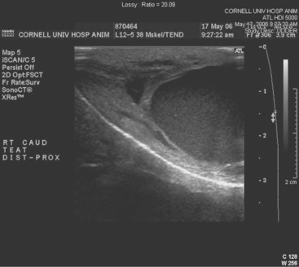
Figure 8-15 Sonogram of the distal aspect of the teat made with a linear 12.5-MHz probe (distal to the left). A focal occlusion at the distal aspect of the teat cistern is identified as a 3-mm band of tissue. The rosette of Furstenberg and the streak canal (thin hyperechoic line at the tip of the teat) are normal.
(Courtesy Dr. Amy Yeager, Cornell University.)
In addition to traumatic injuries, teat-end ulceration is a common problem that may involve individual cows or be endemic in certain herds. Crater-like ulcers filled with dried exudate and scabs make milkout very difficult and predispose to mastitis. Many causes, including irritation from teat dips, excessive vacuum pressure, and mechanical abrasions have been suggested, but the exact cause of the lesion often is difficult to ascertain.
Signs
Painful soft tissue swelling of the distal teat is the cardinal sign of acute teat-end injury. The skin may be hyperemic or bruised (Figure 8-16). The cow resents any handling or manipulation of the teat end and objects to being milked. A combination of mechanical interference with milkout and pain-induced reluctance to let down milk predisposes to incomplete milkout from affected quarters. Mastitis is the feared and frequent sequela to incomplete milkout in cows with teat-end injuries. The cow is further predisposed to mastitis if the physical defense mechanism of the streak canal is compromised.
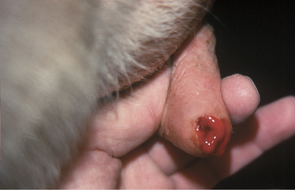
Figure 8-16 Acute teat-end injury showing diffuse swelling and a blood clot extruding from the streak canal.
Chronic teat-end injury often includes a history of acute injury followed by continued difficulty in milking. Palpation of the teat end allows detection of fibrosis in the sphincter muscle or granulation tissue dorsal to the streak canal and sphincter muscle at the ventral-most portion of the teat cistern. Pain is not as apparent with chronic teat-end injuries as in acute cases.
Treatment
Treatment of acute teat-end injuries should address both the injury and any management factors that might lead to further injury, such as overcrowding, lack of bedding, and milking machine problems.
Treatment considerations must be acceptable and logical to the milkers because the milkers are responsible for any ongoing treatment. Milkers also are subject to the end results of the cow’s pain caused by manipulation of the acutely injured teat. Unless one has milked cows, it may not be apparent exactly how difficult it is to remain patient when being kicked at by cattle that object to having injured teats handled. Client compliance necessitates empathy for the patient, as well as the people responsible for milking the cow. Advice regarding patient restraint, minimizing pain, and preventing mastitis must be included in any treatment regimen.
The best treatments for acute teat-end injury include symptomatic antiinflammatory therapy and reducing further trauma to the teat end. Each injury must be assessed individually. If milkout is simply reduced but not prevented, milkers sometimes use dilators of various types between milkings to stretch the sphincter muscles, thus allowing machine milkout. If milkout is difficult, it is best to avoid further machine milking and to utilize a teat cannula to effect milking twice daily when the other quarters are machine milked. If cannulas are used, the milker must exert extreme care to avoid exogenous inoculation of the teat cistern with microbes. Therefore, the teat end must be cleaned gently, and alcohol must be applied before introducing the sterile cannula. Usually a disposable 1-in plastic cannula is used for this purpose. After complete milkout, the teat end is dipped as usual and a repeat dip performed in 10 minutes. Alternatively, some practitioners recommend indwelling plastic cannulas that may be capped between milkings. Several types are available commercially. In addition to facilitating milkout, these indwelling cannulas act as dilators that may reduce the possibility of streak canal adhesions or fibrosis. Teat dilators impregnated with dyes are not favored because they seem to induce chemical damage to the steak canal. However, many owners use such dilators anyway (Figure 8-17). Wax and silicone teat inserts that may retain patency with less iatrogenic mastitis are commercially available. The wax insert is recommended for initial use, but it disintegrates after several days. Insertion of silicone rubber inserts after the wax has disintegrated is recommended. The inserts have comparable efficacy and antibacterial properties. Both inserts are readily available in the United States. Alternatively, milk can be drained from the gland, intramammary antibiotics infused, a wax teat insert (Figure 8-18) placed in the teat, followed by icing and bandaging the teat with no further milkout for 2 to 3 days.
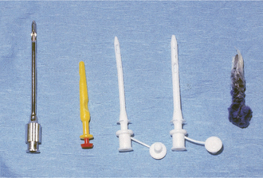
Figure 8-17 Teat cannulas and dilators.
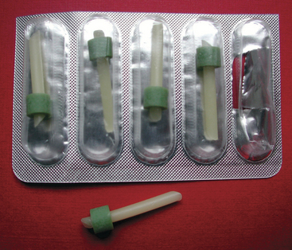
Figure 8-18 NIT natural teat inserts.
Nursing care is helpful but unfortunately is often not available on modern dairy farms. Soaking the injured teat with concentrated Epsom salts in a cup of warm water for 5 minutes twice daily helps reduce edema and inflammation. It is most important to avoid further trauma to the teat end and to minimize the risks for developing mastitis. Therefore avoidance of machine milking is indicated for at least several days whenever possible.
Problems that have been associated with teat-end lesions include crusts, necrosis, ulceration (Figure 8-19), and mastitis. All result in continued pain to the patient and mechanical interference with milkout as a result of scab or exudate buildup. Gentle soaking in warm dilute Betadine solution (Purdue Pharma, Cranbury, NJ) followed by removal of crusts or exudate aids complete milkout. Teat injury predisposes the cow to mastitis, particularly infections with gram-positive organisms.
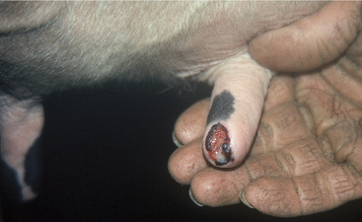
Figure 8-19 Chronic teat-end injury with an ulcerative bed of granulation tissue ringed by crusted edges. This type of wound repeatedly produces a crusty scab that interferes with effective milkout and is an extremely common sequela to acute teat-end injuries.
Gradual return to normal milking is hoped for in 3 to 7 days following acute teat-end injury. Subacute or chronic injuries that continue to interfere with milkout may necessitate surgical intervention. Surgery should be avoided in acute teat-end injury because any sharp injury to an already damaged sphincter muscle and streak canal only serves to worsen the acute inflammation and hemorrhage, as well as the ensuing fibrosis. If milk flow is still obstructed after edema has resolved, examination should determine site of injury, fibrosis, or granulation tissue obstruction. Granulation tissue at the most dorsal aspect of the streak canal or most ventral part of the teat cistern is common. Fibrosis of the sphincter musculature also is very common. Instrument manipulation or sharp surgery on the teat end is then indicated. Wax inserts should be used to decrease stricture.
Before surgical intervention, the quarter should be full of milk. Experienced owners will not milk out the affected quarter before the veterinary visit, but if they have forgotten and done so, the cow should be given 20 units of oxytocin IV to fill the quarters. Without adequate milk in the quarter, it is impossible to assess how much the obstruction has been relieved.
For surgical correction of obstructed teat ends, the teat should be washed, cleaned, and disinfected with alcohol (Box 8-1). The cow should be restrained and/or sedated before surgery. A teat bistoury or knife, preferably one with a small single cutting edge and blunt tip, should be used. The aim of this procedure is to relieve the stricture in the streak canal through two to four angled cuts made at 90-degree intervals (Figure 8-20, A and B). The cuts are made into the dorsal sphincter muscle but tapered so as not to cut the distal sphincter or teat end. We prefer the use of a Larsen teat blade because it allows a better control of the dept of the cut and facilitates the creation of a tapered incision. These radial incisions release the sphincter and frequently are the only treatments required. Some veterinarians use wax inserts to reduce hemorrhage following this procedure and to diminish subsequent inflammation and swelling that may impede milkout.

Preparation for Teat Surgery or Treatment
Infusion of quarter or placement of cannula
-Wash and completely clean teat and base of udder with mild soap or disinfectant
-Dry
-Alcohol swab teat end carefully
-Treat or cannulate with sterile devices
-Alcohol swab teat end carefully
-Apply teat dip used by owner
Surgical manipulation through the teat canal
-Restrain and/or sedate cow
-Wash and completely clean teat and base of udder with soap or disinfectant
-Dry or alcohol swab until dry
-Ring block base of teat if prolonged manipulation anticipated
-Alcohol swab teat end carefully
-Perform procedure with sterile or cold-sterilized/disinfected instruments
-Alcohol swab and teat dip (unless the owner is to strip quarter frequently)
Surgical thelotomy or repair of full-thickness lacerations and fistulae
-Decide on position (standing, tilt table, dorsal recumbency), means of restraint, and required sedation
-Aseptic technique including clipping hair on udder, surgical preparation, ring block of base of teat, and fenestrated drapes are indicated
-Sterile instruments
-Preoperative and postoperative antibiotics
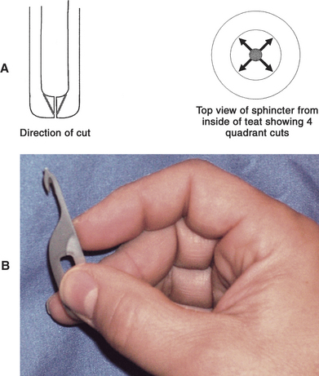
Figure 8-20 A, Schematic illustration of teat knife incisions required to relieve sphincter muscle fibrosis. B, Preferred teat bistoury for radial cut for treatment of streak canal fibrosis. Note cutting edge is in the acute angle and thus allows control of the depth of the incision. In addition, if the operator flexes his/her wrist while pulling distally, only the proximal half of the streak canal will be incised.
A Moore’s teat dilator also has been used for sphincter muscle fibrosis. This instrument is inserted into the teat following routine preparation and advanced slowly to stretch the sphincter muscle without sharp surgery.
Masses of granulation tissue in the streak canal can act as an obstruction between the canal and teat cistern. They are generally a result of injury to the rosette of Furstenberg. These masses or growths are generally removed with the aid of a Hug’s teat tumor extractor. This instrument can be opened to allow excessive tissue to be grasped and cut off by the sharp edge of the extractor. It is a commonly used teat instrument, but care should be taken not to excise excessive surrounding healthy mucosa when removing granulation or fibrous tissue. The collateral mucosal damage associated with the blind use of the teat tumor extractor frequently results in recurrence of the stenosis. To precisely remove diseased tissue, and leave adjacent healthy tissue undisturbed, thelotomy with sharp incision is indicated (see teat-cistern obstructions). Minimally invasive fiberoptic theiloscopy in combination with electrosurgery is preferable, but the equipment is expensive, although it leads to improved long-term outcomes. The equipment is available from the Karl Storz Company (Charlton, MA).
Occasional instances of prolapsed streak canal mucosa are observed following crushing teat-end injuries. This tissue should be cut off flush with the teat end and then gently probed with a teat cannula to replace any everted tissue back into position in the streak canal.
Most veterinarians initially are too cautious and conservative when treating teat-end fibrosis. Experience is necessary to know “how much to cut” to allow not only short-term results but also to avoid subsequent reoperation because of recurrence of the problem. If in doubt, it is best to be conservative because the procedure always can be repeated. Most experienced veterinarians not only want to see a reduced resistance to hand milkout but also a slight dripping of milk immediately postoperatively. This dripping usually subsides as sphincter tone improves following resolution of dilatation associated with surgical instrumentation.
Repeated self-induced teat-end trauma to a specific teat dictates evaluation of the cause. Foot-induced trauma may be detected by smearing dye on the medial dewclaw and observing the teats for dye transmission onto the teat. In this case, removal of the medial dewclaw may help prevent injury in the future. Cows with pendulous udders that suffer repeated teat-end injuries usually have to be culled.
Teat-end necrosis or ulceration is difficult to manage because buildup of scab material in the crater-like ulcer recurrently interferes with milking. Gentle soaking and mechanical removal of the scabs are necessary for milkout. A mild teat dip with glycerin or lanolin for softening is indicated in these patients. Some require surgical manipulation if continued irritation or overmilking damages the sphincter muscle or dorsal streak canal. When teat-end necrosis is observed in more than one cow in a herd, the milking machinery and procedures should be examined carefully to rule out excessive vacuum pressure and physical or chemical irritants in teat dip or bedding (Figure 8-21).
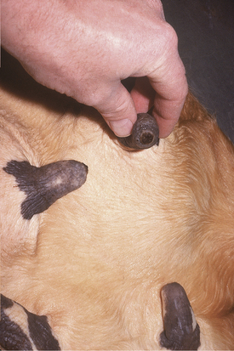
Figure 8-21 Chronic proliferative teat-end lesions caused by excessive vacuum pressure or overmilking. Such lesions are hyperkeratotic or proliferative, circular, and tend to be present in more than one quarter in each affected cow. The problem usually appears in multiple cows within the herd.

Acquired Teat-Cistern Obstructions
Etiology
Teat-cistern lesions resulting in obstructed milk flow may be focal or diffuse. Most teat-cistern obstructions result from proliferative granulation tissue, mucosal injury, or fibrosis—all secondary to previous teat trauma. Occasional cases have no history of previous acute injury. Focal and diffuse lesions in the cistern cause an increasing degree of flow restriction that interferes with effective milk delivery to the streak canal during machine milking. With ultrasound examination, obstruction at the junction of the gland and teat cistern can be visualized (Figures 8-22 and 8-23). This type of obstruction leads to slow refill of the teat cistern such that they cannot be milked by machine. However, they can be milked by teat cannula or siphon. In addition to fixed lesions, floating objects known as “milk stones” or “floaters” may cause problems in milkout because they are pulled into the teat and mechanically interfere with milking. These floaters may be completely free or may be attached to the mucosa by a pedunculated stalk. Mucosal detachments also are encountered secondary to external teat trauma. The detached mucosa folds onto the opposite teat wall, causing a valve effect as milking progresses. Submucosal hemorrhage or edema from previous trauma is thought to cause detached mucosa; the problem may not be apparent until resolution of the submucosal fluid allows the detached mucosa to become mobile within the cistern.
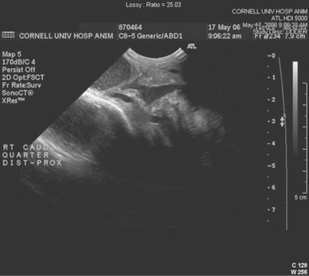
Figure 8-22 Sonogram of the junction of the teat and gland cistern made with a convex 8.5-MHz probe (distal is to the left). At this location, the lumen abruptly narrows from 2 cm to 3 mm because the wall of the teat is thick and irregular. Also, a 3-mm thick band of tissue occludes the lumen of the teat cistern.
(Courtesy Dr. Amy Yeager, Cornell University.)

Excerpt taken from: https://veteriankey.com/diseases-of-the-teats-and-udder/

