Conditions Requiring Rectal Surgery

Rectal prolapse is a common occurrence in cattle and small ruminants. Prolapse of the rectal mucosa occurs following straining which may be associated with tenesmus (as occurs with coccidiosis, colitis, etc.), dysuria (as a complication of cystitis, urolithiasis, dystocia, neoplasia, etc.), neuropathy (as a complication of being 'ridden down‘by other cattle during estrus, spinal lymphoma, use of epidural alcohol blocks, spinal abscess, etc), chronic coughing (as a complication of bovine respiratory disease), or genetics. Many other factors have been associated with the development of rectal prolapse including neoplasia, diet (e.g., clover, high estrogenic compound feedstuffs such as soybean meal) and various toxins. Intermittent rectal prolapse has been seen in embryo transfer cows and may be caused by obesity with excessive pelvic deposition of fat and chronic administration of estrogenic hormones.

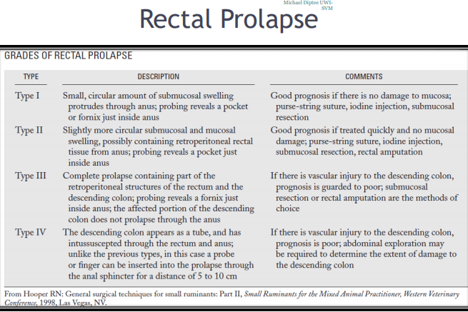Rectal prolapse most commonly is seen in sheep as a complication of tail amputation. Typically, the tail is amputated so short that the innervation of the anal sphincter and perianal muscles are compromised. This results in chronically progressive rectal protrusion and ultimately prolapse.

Diagnosis of rectal prolapse is not difficult during the physical examination, but care should be taken that the prolapse does not contain other organs and that the rectum is not further damaged during the examination. The mucosa rapidly becomes edematous and often shows bleeding lesions. Rectal prolapse may be described by the extent of involvement of various tissues as Grade I–IV. Grade III and IV rectal prolapses usually require surgical resection of the effected portion of the rectum. The severity of injury to the rectum may be described by the extent of tissue damage as Grade I–IV.

**Treatment**

**1. Mucosa Intact**

The simplest procedure for correction of rectal prolapse is reduction by gentle massage and retention by application of a purse-string suture pattern using umbilical tape. The suture is passed in and out through the skin around the anal opening at a distance of 2 to 4 cm from the anus. An opening should be left when tying the purse string such that defecation is possible. The suture usually is left in place for 5 to 10 days. This should be done only if the rectal mucosa is viable and no laceration is present on close inspection. Treatment of the primary cause of the prolapse must be initiated immediately to prevent subsequent prolapse. In sheep, when rectal prolapse is associated with tail amputation, pararectal injection of irritant solutions has been advocated in an attempt to create adhesions between the rectum and surrounding pelvic structures. These adhesions act to restrict the rectum within the pelvic canal and thus prevent prolapse.

**2. Damaged Mucosa/ Submucosal Resection**

When damage to the rectum is present, correction of the prolapse can be approached in different ways depending on the nature and extent of the injury. If the mucosa only is damaged, mucosal resection and anastomosis can be done. In this case, the mucosa is dissected free from the submucosa and the cut edges sutured back together leaving the underlying submucosa and blood supply intact. This technique is uncommonly performed because of time, facility, and technical constraints of field surgery.

*Procedure*

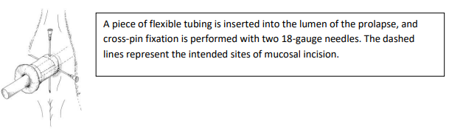

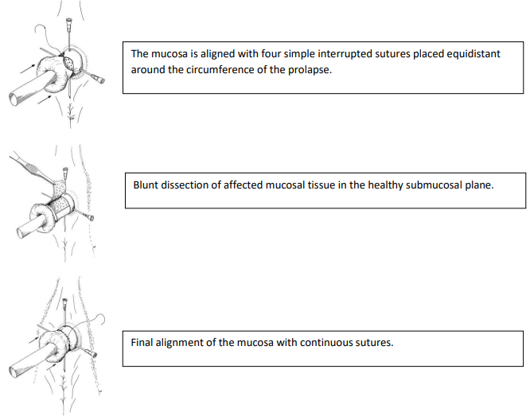

**3. Necrotic Tissue**

Surgical amputation is performed most commonly when rectal prolapse is severe. For this surgery, desired **instruments** include: hemostats, scalpel blade, scissors, thumb forceps, two 18-gauge needles (or Steinnman Pins) 3 to 6 inches long, suture material, and a small-diameter rubber tube (optional). Surgery is performed after administration of epidural anesthesia. When using a tube as a stent in the rectal lumen, the tube is inserted and fixed in the rectum by inserting the two needles through the rectum at right angles to each other so that they pass through the rectum and tube and emerge from the opposite side. The dissection is started about a centimeter from the mucocutaneous border where the mucosa is still healthy, and the entire circumference of the exposed mucosa of the rectum is cut down to the serosa of the inner wall. Hemorrhaging is usually minor and controlled with gauze until all the layers have been dissected and the dorsal artery of the rectum is cut. Once the dissection is completed around the prolapse, the rectum is held in place by the needles. The cut ends of the rectum should be sutured together using size 0 absorbable suture material in a cruciate pattern. After the rectum has been sutured, the needles then are 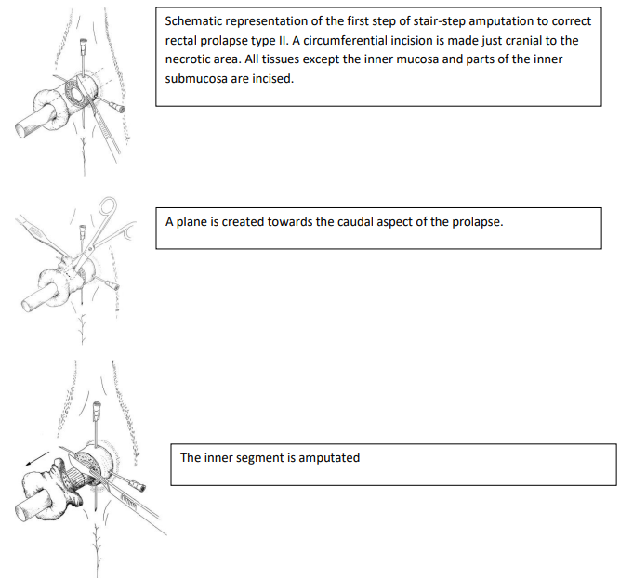pulled from the tube, and the tube is removed from the rectum. The rectum is allowed to retract into place.

*Procedure*

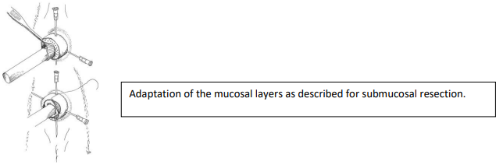

**4. Prolapse Ring**

An alternative method of rectal amputation is to use a prolapse ring, PVC tubing, syringe case, or corrugated tube. The ring or tubing is placed in the rectum, and the halfway point on the tube needs to be inserted as far as the anal sphincter. A ligature or rubber band then is applied over the prolapse as near as possible to the anus. The ligature or rubber band must be tight enough to disrupt blood supply to the prolapse. Feces may go through the tube or may block the tube. Usually, the necrotic prolapse sloughs off in 7 to 10 days with the implant in place, and then fecal production returns to normal.

**Post-Operative Management**

Postoperative management is aimed at alleviation of the inciting cause, maintenance of soft feces (e.g., legume diet, mineral oil, cathartics such as magnesium hydroxide), and anti-inflammatory and analgesic medication (e.g., flunixin meglumine). Complications seen with rectal prolapse are reoccurrence, dehiscence,constipation, bladder retroversion, eventration of the small intestine, abscess, rectal stricture, septic peritonitis, and death. Fecal impaction of prolapsed tubes is common. Significant complications, such as rectal stricture, abscess, peritonitis and death, are expected to be more common with use of prolapse tubes than with surgical amputation with primary reconstruction of the rectum.

In livestock with unrelenting pain and straining, epidural blocks have been used to stop nerve sensation to the rectum. Short-term epidural analgesia can be obtained using lidocaine 2% HCl (60 to 120 minutes duration), xylazine (120 to 180 minutes duration), or xylazine + lidocaine (180 to 240 minutes duration). Longer term analgesia may be obtained using epidural morphine (12 to 18 hours duration). When analgesia is required for days to weeks, alcohol blocks (ethyl alcohol) have been used as an economical alternative. Alcohol blocks must be done cautiously and should not be done routinely. The author does not support use of long-term (weeks to months) epidural nerve blocks except in extraordinary circumstances because of the potential for adverse events. Complications of alcohol blocks include fecal contamination of perineum, tail injury, death, paralysis, ataxia, and exacerbation of underlying disease.