**Large Animal Digestive System Anatomy**

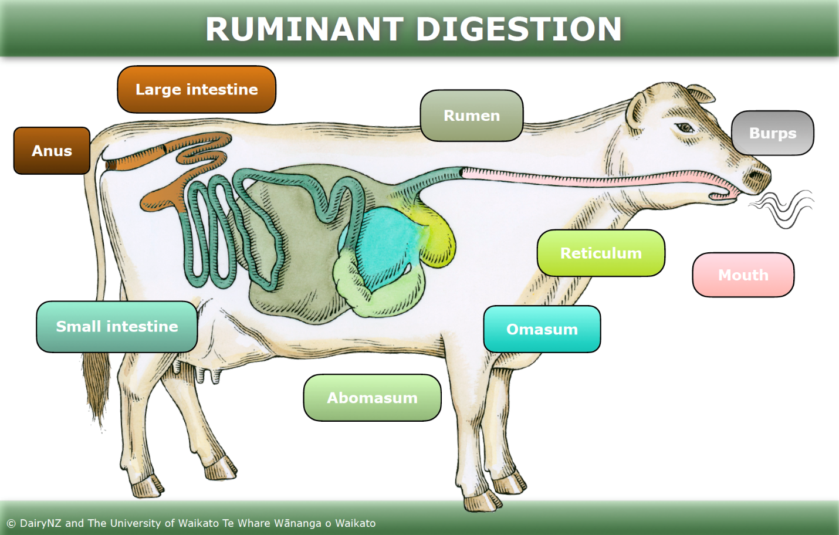

The digestive system’s main function is the uptake, breakdown and absorption of nutrients from food for the purpose of energy, growth and cell repair. It disposes of unwanted material and is made up of the gastrointestinal tract, liver, pancreas and gallbladder. The gastrointestinal tract is a long connected ‘tube’ extending from the mouth where food is acquired to the anus where undigested material is excreted. Generally, it’s sequence is as follows: mouth > oesophagus > stomach > small intestine > large intestine > rectum > anus.

***The Oral Cavity***

This is the first section of the gastrointestinal/alimentary tract that receives food. It extends from lips until pharynx and consists of the oral cavity proper and the oral cavity vestibule.

**Function:** prehension, mastication, insalivation and in respiration in oral breathing

**Structures:**

1. Oral cavity proper: This is the cavity with the dental arcades. It’s margins are the hard and soft palate dorsally, teeth and gum margins of the jaw laterally and the tongue ventrally.
2. The oral cavity vestibule: Contained are the:

a. labial vestibule (lips and teeth) and

b. buccal vestibule (between molar teeth cheek)

3. Accessory structures (the salivary glands as sublingual, palatine and lingual).

4. Projecting structures (the teeth and the tongue).

*Lips*

These are musculo-membranous folds which surround the oral opening and are attached to the

gum by labial frenulum. They are mandibular (lower lip) which has a mentum and the maxillary (upper lip) has a philtrum.

**Function:** Prehension, Communication and Suckling

**Structures:** Composed of skin, muscles, nerves, mucosa and small salivary glands (labial glands) scattered among the muscles.

**Species Difference:**

* **Form:** Diet and feeding habit determine the form of lips, so it is well developed in the horse poorly developed in and cattle. They are movable in all animals except in ox and pig with moderate movement.
* **Modifications of the Lip include:**

1. The upper lip:

a. In cattle, the upper part of maxillary lip with the area between the nostrils form a moisten coal area termed the muzzle.

b. Median groove (Philtrum) in small ruminants

c. Hair in the horse

*Cheeks (Buccae)*

They form the lateral walls of the oral cavity. They are important in the process of mastication and drinking in herbivores. It consists of skin, muscular (buccinators) and buccal glands which are mucous, serous and mixed glands open by small orifices on the mucous membrane of the cheek. They include a dorsal/maxillary group, ventral/mandibular group and a middle group.

**Species Difference:**

* A: dorsal group--- maxillary group (Horses, pigs and ruminants)
* B- ventral group --- mandibular group (Horses, pigs and ruminants)
* C- middle group--- Ruminants only

S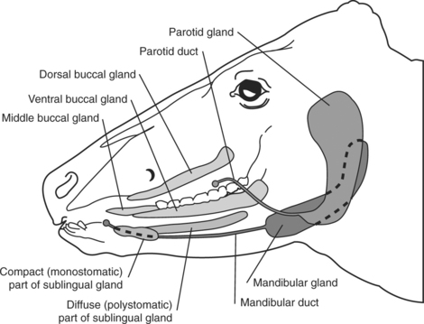chema summarizing the distribution of salivary glands in ruminants.

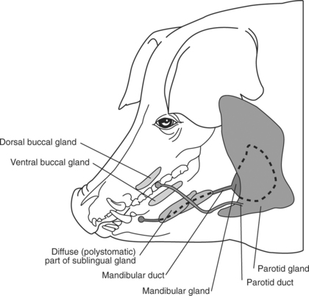

Schema summarizing the distribution of salivary glands in pigs.

The large quantity of salivary glands in ruminants and swine contribute to large amounts of saliva being produced, estimated to be as much as 100 liters per day in adult cattle.

*Teeth*

The dental formula of large animals is as follows:

*Summary of Teeth and Their Eruption Patterns in Cattle*

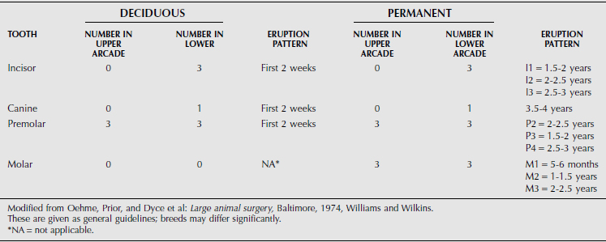

*Summary of Teeth and Their Eruption Patterns in Sheep*

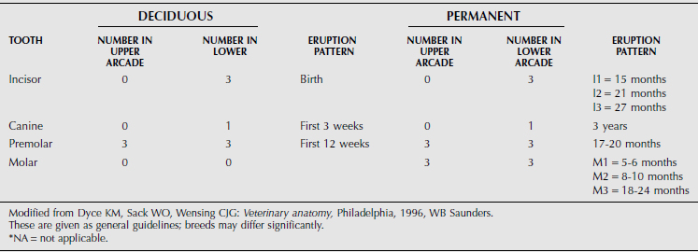

*Summary of Teeth and Their Eruption Patterns in Goats*

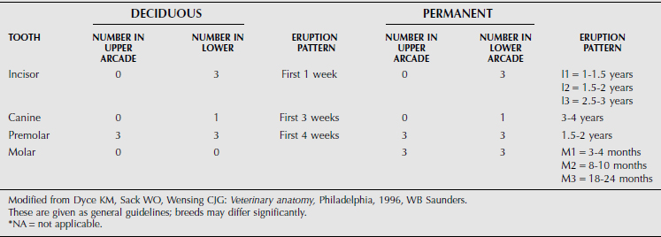

*Summary of Teeth and Their Eruption Patterns in Swine*

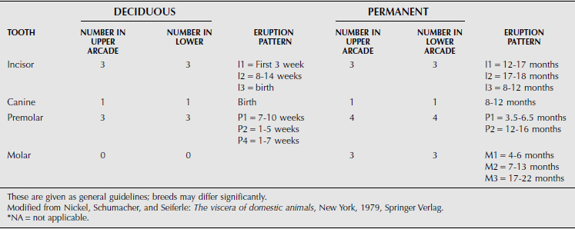

*Hard Palate*

This is a tough mucous membrane attached to bones (palatine process of the incisive,maxillary and palatine bones) forming hard palate.it merges caudally with the soft palate. It is flat but it is constricted in the middle in ruminants. It forms the roof of the mouth, so it forms a partition between the nasal passage and mouth. It is covered by thick mucosa with a series of transverse ridges (palatine ridges or Rugae) which are interrupted by a median plane -the palatine raphae.

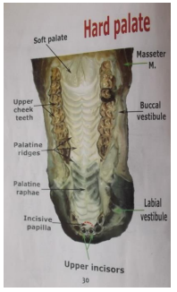

**Species Difference:**

* These ridges are serrated by cornified papillae in the cattle.
* The number of the rugae are 16-18 in horse; 15-19 in cattle;14 in sheep; 20-23 in pig;

12 in goat

* It has rich venous plexus at its rostral part in horses
* Incisive papilla lies behind incisor teeth. It is rounded in horse; diamond in cattle and elongated in pig

Free part of the hard palate:

1. the palatine ridges reach to the level of the soft palate in the horse and pig.

2. there is a free area between the last ridge and the soft palate in other animals

Dental pad ----Replaces the upper incisor teeth in ruminants

Nasopalatine (incisive) duct: It opens into the nasal cavity (between nasal cavity and nasal

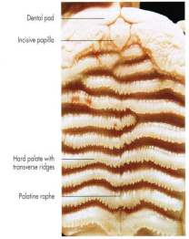vestibule) in common with the vomeronasal organ and passes through the palatine fissure to

open in the bottom of the groove on either side of the incisive papilla, except in the horse.

*Soft Palate*

A movable musclomembranous fold extends caudally from hard palate to isthmus faucium. It is lined by oral mucosa ventrally and dorsally by respiratory mucosa.

**Species Difference:**

* It is remarkable long in horses (Horse vomit through nose).

Glosso-palatine arch: A short thick fold of mucous membrane from each side of the attached border to the

root of the tongue

Palato-pharyngeal arch: A fold of mucous membrane from either side of the free border or palatine arch to the pharyngeal wall.

*Tongue*

It is a mobile muscular organ situated on the floor of the oral cavity proper between the

rami of the mandible. It is attached by its mucous membrane and muscles to hyoid bone, pharynx, soft palate and mandible.

Function:

1- carries organ of taste.

2- Cleaning.

3- Aid in chewing and forming boluses.

4- Aid in drinking

**Oesophagus**

A musclomembranous tube which is the first portion of the alimentary canal which extends from the pharynx to the stomach. It is innervated by sympathetic and vagus nerves.

Parts:

1- Cervical part. 2- Thoracic part. 3- Abdominal part

The cervical part of the oesophagus is separated in the middle and caudal cervical regions from the external jugular vein.

Course of the esophagus:

The esophagus begins in the median plane dorsal to the cricoid cartilage of larynx,

continues dorsal to the trachea till 3rd or 4th cervical vertebrae, then it is deviated to the

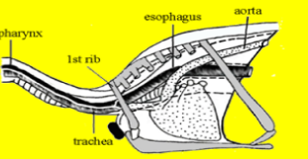left side of trachea up to the thoracic inlet (1st rib) then returns dorsal to the trachea in the median plane up to the 6th thoracic vertebra where it is pushed by the aortic arch shifting

it to the right side (median plane), continues caudally in caudal mediastinum between two

pleural sacs and inclines gradually to left side till it passes through the hiatus esophagus of

diaphragm and enters the abdominal cavity where it opens in cardiac sphincter of the stomach in the left median plane.

**Species Difference:**

* The esophagus opens in stomach by acute angle in equine. While, it joins to the dorsal

ruminal sac on a sort of dome (ventricular antrum) in ruminants.

**Stomach**

Muscular organ receiving food from the oesophagus. It secretes acid and enzymes used to digest food. 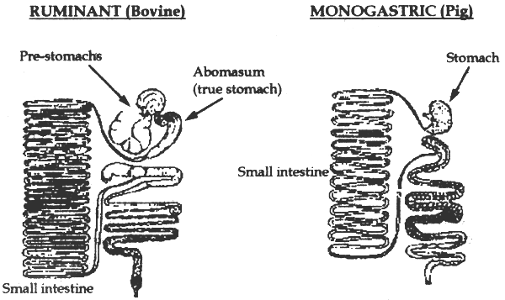

**Species Difference:**

* Horses and pigs are monogastric.
* Ruminants are polygastric. Their stomachs have four compartments: the rumen, the reticulum, the omasum and the abomasum.

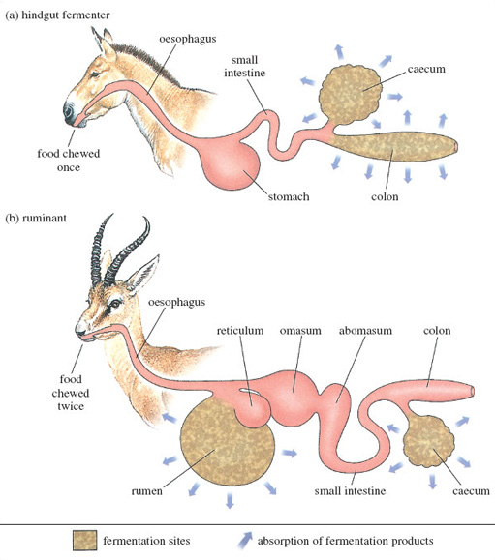

*The Ruminant Stomach*

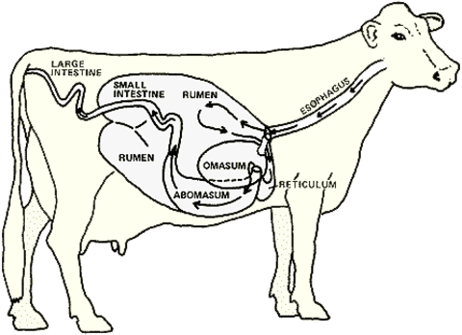

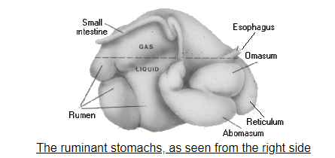

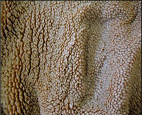

The rumen

The rumen (on the left side of the animal) is the largest stomach compartment and consists of several sacs. It can hold 25 gallons or more of material depending on the size of the cow. Because of its size, the rumen acts as a storage or holding vat for feed.

Aside from storage, the rumen is also a fermentation vat. The rumen’s environment favors the growth of microbes. These microbes digest or ferment feed within the rumen and make volatile fatty acids (VFAs). The rumen absorbs most of the VFAs from fermentation.

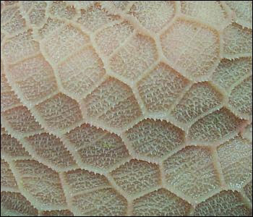A good blood supply to the rumen walls improves absorption of VFAs and other digestion products. Tiny projections (papillae) line the rumen, which increases the rumen’s surface area and the amount it can absorb.

The reticulum

The reticulum is a pouch-like structure in the forward area of the body, close to the heart. The tissues in the reticulum form a network similar to a honeycomb. A small tissue fold lies between the reticulum and rumen, but the two aren’t separate compartments. Together they’re called the rumino-reticulum.

Heavy or dense feed and metal objects eaten by the cow drop into this compartment. Nails and other sharp objects may work into the tissue and cause “hardware disease.” You can use magnets to prevent disease or correct the problem through surgery. Leaving it untreated may lead to infection and possibly death.

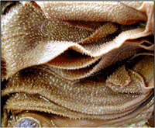The omasum

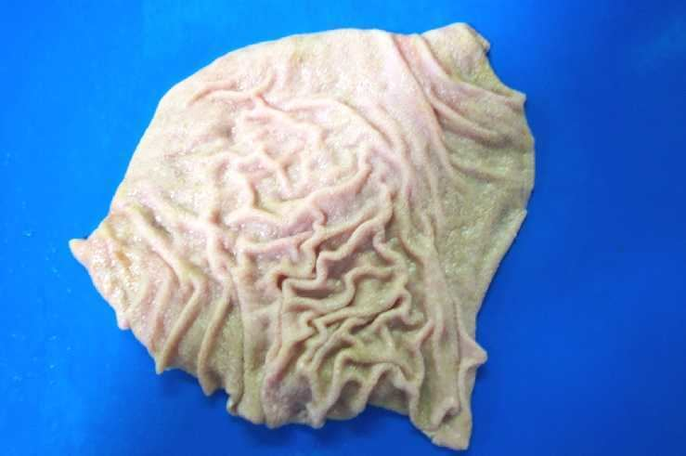The omasum is a globe-shaped structure containing leaves of tissue (like pages in a book). It absorbs water and other substances from digestive contents. Feed material (ingesta) between the leaves will be drier than ingesta found in the other compartments.

The abomasum (Glandular/True Stomach)

The abomasum is the only compartment lined with glands. These glands release hydrochloric acid and digestive enzymes, needed to breakdown feeds. The abomasum is similar to a nonruminant/monogastric stomach.

Digestion produces 30 to 50 quarts of gas per hour in the rumen. Carbon dioxide and methane are the main gases present. Cows must release this gas to avoid bloating. Under normal conditions, swelling from gas formation causes the cow to belch and release the gas (eructation).

**The Small Intestine**

The small intestine consists of three sections: the duodenum, jejunum and ileum. It measures about 20 times the length of the animal.

Secretions from the pancreas and gallbladder aid in digestion within the small intestine. The small intestine completes most of the digestive process and absorbs many nutrients through villi (small finger-like projections). From the villi the nutrients enter into the blood and lymphatic systems.

This process balances the pH in the intestine, ensuring the digestive enzymes work correctly. The jejunum section is lined with villi, which also increase the intestinal surface area. The ileum absorbs vitamin B12, bile salts and any nutrients that passed through the jejunum. At the end of the ileum is a valve, preventing any backward flow of materials. Throughout the small intestine, muscular contractions move the matter forward. In a fully mature cow, the entire organ may be up to 150 feet long and has a 20-gallon capacity.

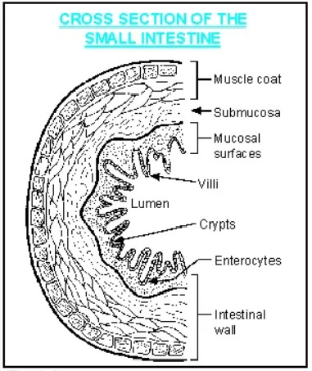

**Cecum**

Sitting between the small and large intestines is a three-foot-long pouch called the cecum. It has little function besides providing storage and a transition between the two intestines, but it does aid in the continual breaking down of material. The cecum has about a two-gallon holding capacity.

**Large Intestine**

Smaller in length but larger in diameter than the small intestine, the large intestine is the final step of the digestive process. It absorbs remaining water and contains bacteria microbes that finish digestion and produce vitamins the animal needs to grow and remain healthy. Its last job is to eliminate any undigested and unabsorbed food from the system in the form of waste.  
When the cow is properly handled and fed, this process continually occurs, keeping the animal healthy and at the right weight. The entire digestion process should take anywhere from one to three days.

If something interrupts this process or the cattle is unhealthy, the sections will no longer be able to function as well as they should, causing diseases and complications.

**Bovine Digestive Tract**

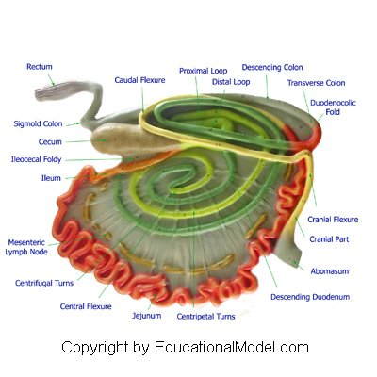

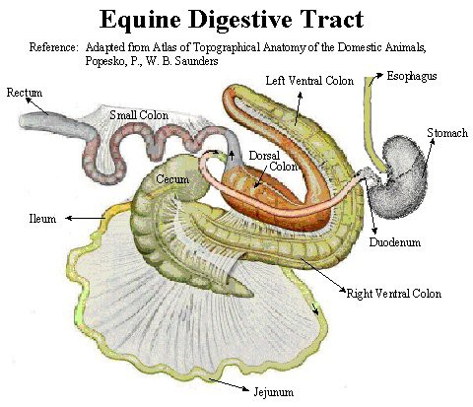

**Swine Digestive Tract**

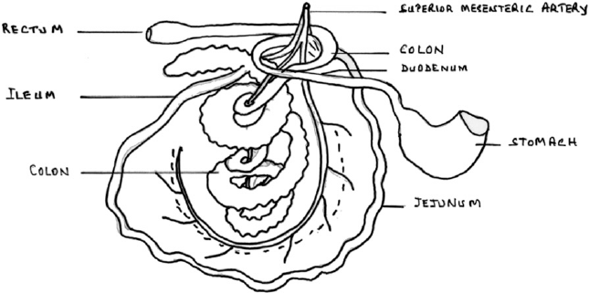

**Image Comparing Digestive Tracts in Large Animals**

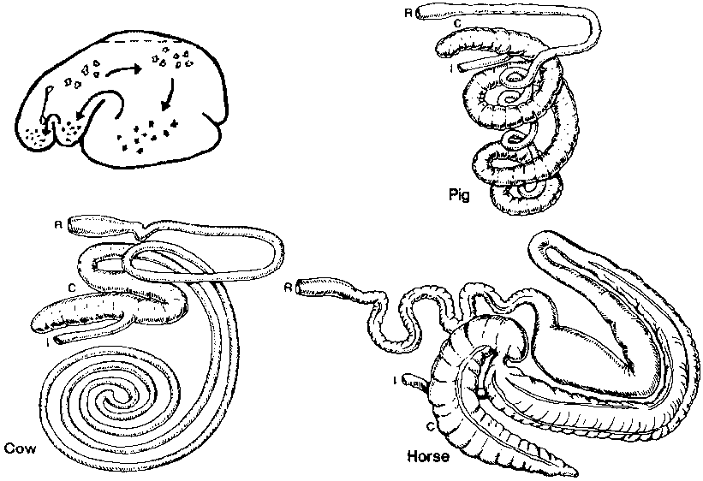

**Rectum**

The rectum is a part of the lower gastrointestinal tract. It follows the shape of the sacrum and ends in an expanded section called an ampulla where feces are stored before its release via the anal canal. In the bovine, it extends from the pelvic inlet to the anus and measures about one foot. The rectum runs almost straight or a slightly oblique course through the pelvic cavity. It is related dorsally to the roof of the pelvic cavity, ventrally to the bladder, vesiculae seminalis, vas deferentia, ureters, Cowper’s glands and urethra in the male or uterus and vagina in the female. The cranial part of rectum, till about the level of the first coccygeal vertebra is covered by peritoneum and is attached by the mesorectum to the roof of the pelvis

The caudal part is not covered by peritoneum and presents a dilatation, *ampulla recti.*

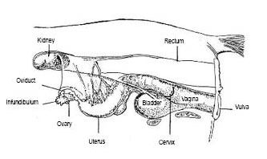

**Anus**

The anus is the opening where the gastrointestinal tract ends and waste exits the body. In bovine, it is covered externally by thin skin devoid of hair but provided with numerous sweat and sebaceous glands. Its lumen, the anal canal is about 5 cm long and is always closed by the contraction of the sphincter muscles and folds of the mucous membrane except during defecation. The mucous membrane is pale, glandless and covered with thick squamous stratified epithelium

*The muscles of the anus are:*

*-*The sphincter ani internus is the terminal thickening of the circular coat of the bowel and

*-*The sphincter ani externus is a broad ring of striped muscle outside the sphincter ani internus.

The action of both is to close the anus. The retractor ani is flat striped muscle, which lies between the rectum and the sacro-sciatic ligament.

It reduces the partial prolapse, which the anus undergoes during defecation.

The suspensory ligament of the anus is a band of plain muscle arising from the first coccygeal vertebra and passing down under the retractor, unites with its fellow below the anus. In the male it is continued as retractor penis muscle. In the female it blends with the constrictor vulvae.

Mucous membrane presents intestinal gland but no villi: solitary glands are numerous.