Equine Lameness
- DEFINITION
Equine lameness refers to abnormality or alteration in gait or stance. The underlying issue can be from the limbs, neck, shoulders, withers, back, loin or quarters.

Note: Lameness in one aspect of a limb may produce soreness in another aspect of the same limb. Likewise, lameness may also be observed in either the forelimb or hindlimb on the opposite side of the primary lame limb.

- CAUSES
- Pain- most common cause of lameness.
- Extended pressure placed on limbs during exertion. E.g. in racehorses where inflammation of joints, ligaments or tendons may occur as a result of racing long distances.

- Mechanical
- From previous trauma (indirect or direct to limbs).

- Neurological
- Ataxia
- Paresis

- THE LAMNENESS EXAMINATION

- Detailed medical Medical History:

- Signalment- type/requirements of horse whether racehorse or dressing horse, breed (breed disposition or discipline disposition, e.g. carpus arthritis in racehorses vs hindlimb suspensory lameness in dressing horses), age and training regimen/

- Enquire about history of previous lameness and if so what treatments and responses to treatments.

- Interim treatments of current lameness issue and response to treatments

- Enquire about if any trauma or underlying disease.

- Enquire about onset of lameness and progression since signs began.

- Interval since last shoeing.

- Distance exam/ “hands off exam”:

- Observation of Body condition score, conformation, weight-bearing and non-weight bearing limbs, balance (stay apparatus) or any obvious lacerations or abnormalities (asymmetry, swellings, muscle loss, abnormal stance)

- Physical Examination:

Always test the suspected lame limb first!

- Palpation of the trunk and limbs where muscles, ligaments, tendons, bones and joints should be checked for obvious for pain, swelling, heat or joint effusion. Limbs should always be compared to their contralateral limb as this can give useful information. The horse’s reaction to palpation should be notes.

- Joint flexion tests which involves testing degree of lameness prior to and after flexion of the joints. This provides further insight on the origin of pain and the horse’s reaction to flexion tests should be noted. Flex the distal phalanges in both forelimbs and hindlimbs independently of the carpus and hock. Bending pressure should be firm but not excessive, which can create false-positive responses. All tests should be done on both sound and lame limbs for comparison. Consistency should always be applied, and individual experience used (this can be achieved by having same handler perform all limb tests and on the same surface).

- The feet should be thoroughly examine by the use of hoof testers where pressure is applied to solar horn using a hoof tester tool in order to assess for sensitivity. Wear patterns from shoes should also be noted. Broken toe/pastern axis; mismatched hoof angles; under-run, contracted, and sheared heels; and disproportionate hoof size are seen more frequently associated with lame horses as opposed to sound horses.

- Shoes should be left on during initial examination in order to prevent footsore in horse which would deter examination when horse is trotted. The shoe should be removed however, for complete examination of the foot when lameness has been localized to the suspected foot and prior to exercise before diagnosis is to be made.

- Neck and back should be thoroughly examined where horse is restrained and placed standing square on a level surface that is firm and non-slip. The back should be assessed for flexibility and extensibility by alternately pinching the midline in the midthoracic region and the sacrococcygeal region. Lateral flexion can be assessed by turning horse short around its own axis.

- A neurological exam should also be performed since lameness may be caused by neuromuscular disorders in some cases.

- Gait Assessment:

- To be considered:
- Whether the horse is definitely lame.
- Identification of the limb or limbs that are lame.
- The severity of lameness.
- Identification of specific characteristics of the lameness.
- Whether there is response to treatment or not.

- Examination during exercise is indicated to localize lameness to specific limb or location on limb. It is also used to evaluate response to diagnostic regional anaesthesia. However, if lameness is apparent and major or acute fracture is suspected, exercise is not indicated as this can cause further damage. Diagnostic regional anaesthesia would not be performed in these instances also. Prior to trotting, it should be noted if the horse was given an analgesic as this can deter assessment results.

To evaluate horse while throtting:
- Evaluate horse while trotting on a hard surface (ensure not safety hazard to horse). Trot horse in a straight line or circles. Horse can also be trotted in inclines. Halter attached to horse should have a loose line as to not restrict movement of horse.
-Identify limb and foot height when lifted off ground and foot placement.

Note: Both forelimb and hindlimb lameness may become worse when the horse is circled; most of the time, the lameness is accentuated when the affected limb is on the inside of the circle.

- Forelimb Lameness

- The more commonly occurring lame limb.
- Identify head nod which is characteristic to forelimb lameness and a consistent sign of unilateral forelimb lameness. The head and neck of the horse rise when the lame forelimb strikes the ground and is weightbearing as to alleviate pressure placed on lame limb. The head and neck then falls when the sound limb strikes the ground as pressure exertion here will not cause pain. This creates a head nod.
- Majority of forelimb lameness occurs below the proximal carpus.

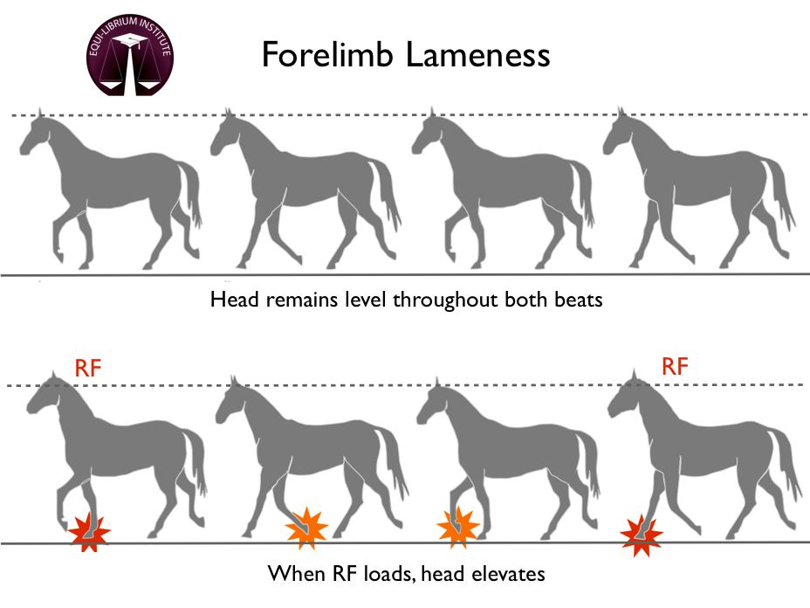

Hindlimb Lameness

- The characteristic marker for identifying hindlimb lameness is evaluation of the tubercoxae during trotting. The tubercoxae on the side of the lame limb with have an increased vertical displacement where the entire pelvis and sacrum will rise when the lame limb strikes the ground and is weight bearing as to alleviate pressure exerted on the limb. It then falls when the sound limb strikes the ground since pressure exertion here will not cause any pain or concussion of the lame limb.
- Majority of hindlimb lameness occurs below the proximal hock.
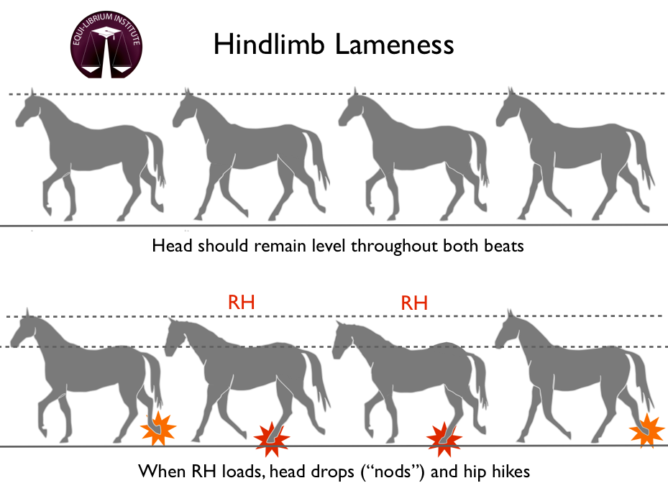

- Lameness is graded based on a scale from 1-5 with 0 being sound.

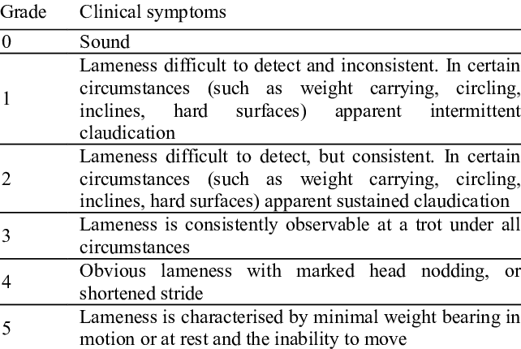

- Diagnostic Local Anaesthesia:

- Involves localizing source of pain by using nerve blocks from distal to proximal in the limb.

- Diagnosis:

- Radiography
- Ultrasonography
- Arthroscopy
- Computed tomography (CT)
- Magnetic resonance imaging (MRI)
- Synovial fluid analysis

