**Equipment & Materials**

* 20 Gauge Needles
* 1ml, 5ml & 10ml Syringes
* 2% Xylazine
* 5% Flunixin
* Penstrip LA
* 10% Tolazoline
* 2% Lidocaine
* size 20 scalpel blade
* Barnes dehorner
* Dehorning Iron
* Alcohol Swabs
* Cotton
* Bactrovet silver AM Spray
* Matabicheras fort dodge Spray
* Halter and rope

**Images Illustrating Equipment**

**20 Gauge Needles Gauges Size 20 scalpel blade**

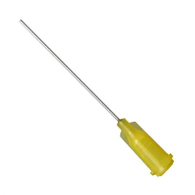 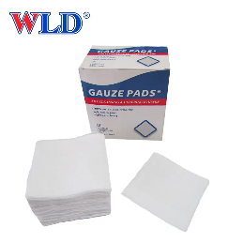 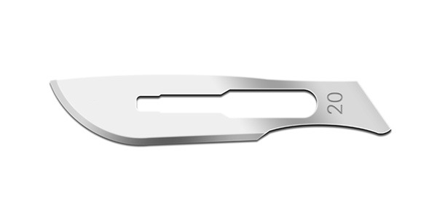

1ml, 5ml 10ml Syringes

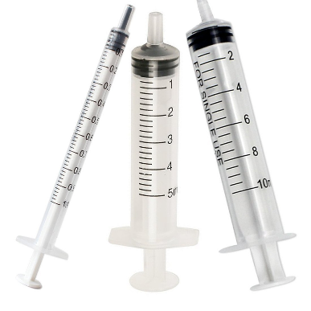

2% Xylazine 10% Tolazoline 2% Lidocaine

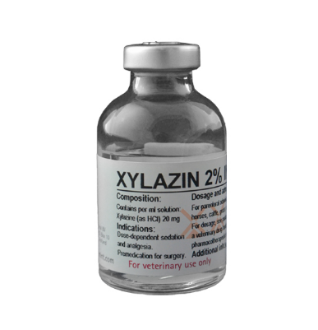 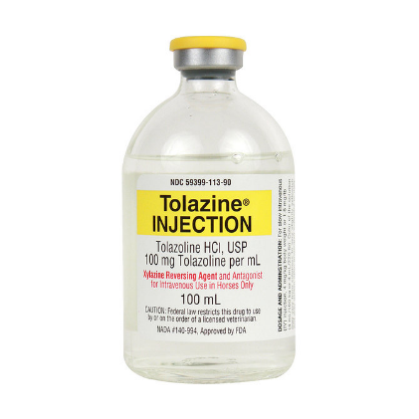

5% Flunixin Penstrip-40

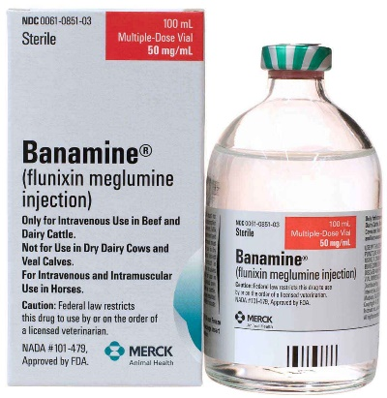 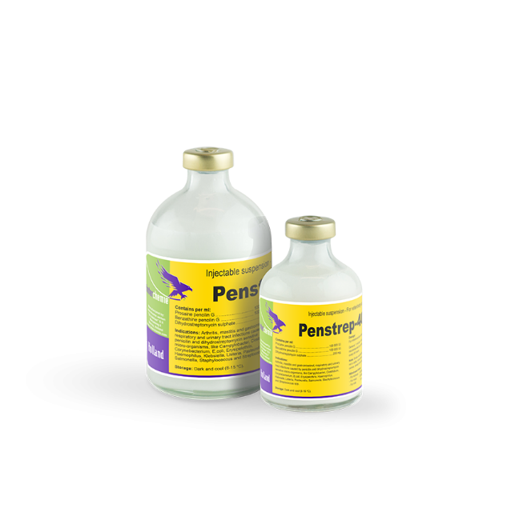

Barnes dehorner Dehorning Iron

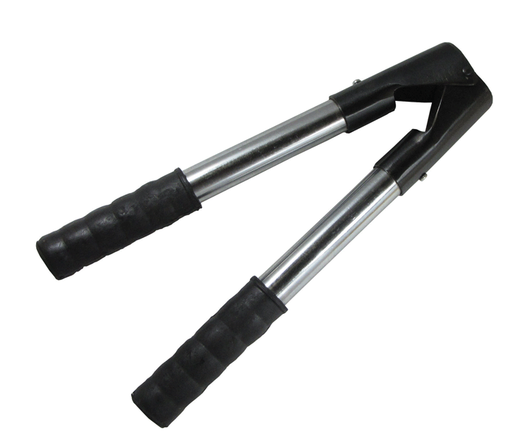 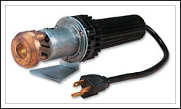

Alcohol Swabs Bactrovet silver AM Spray

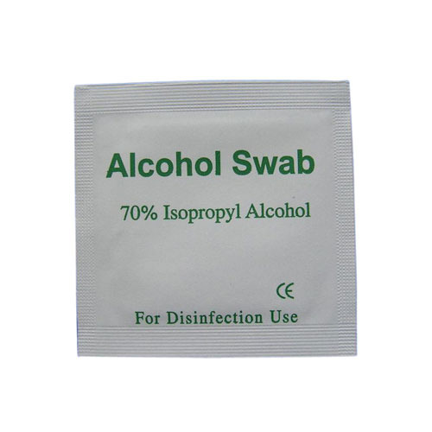 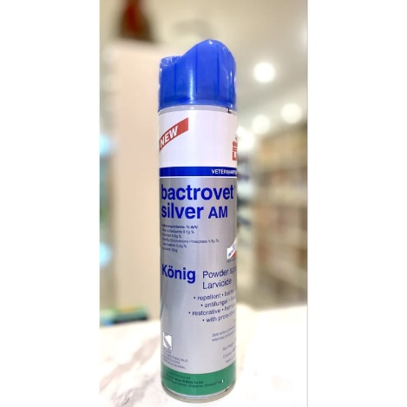

Matabicheras fort dodge Spray Halter and Rope

