**Anatomy of the Forelimb (Bones)**

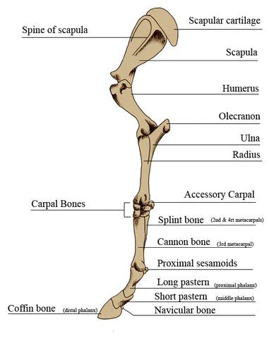

**Image1. Bones of the Forelimb**

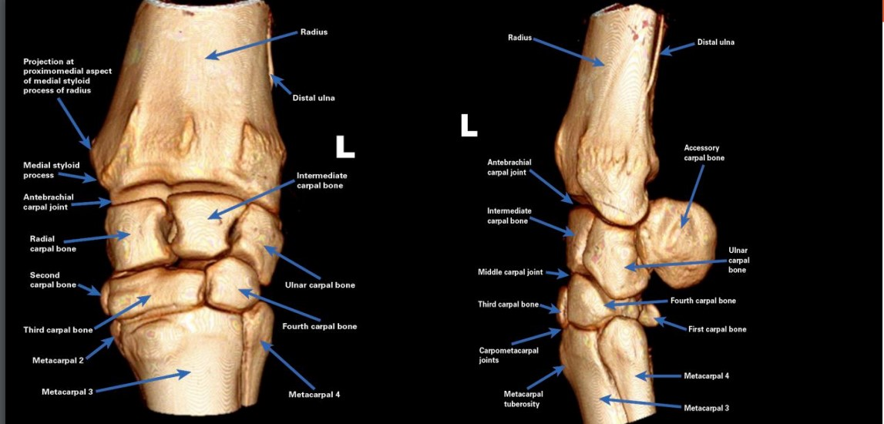

**Image 2. Carpal Bones**

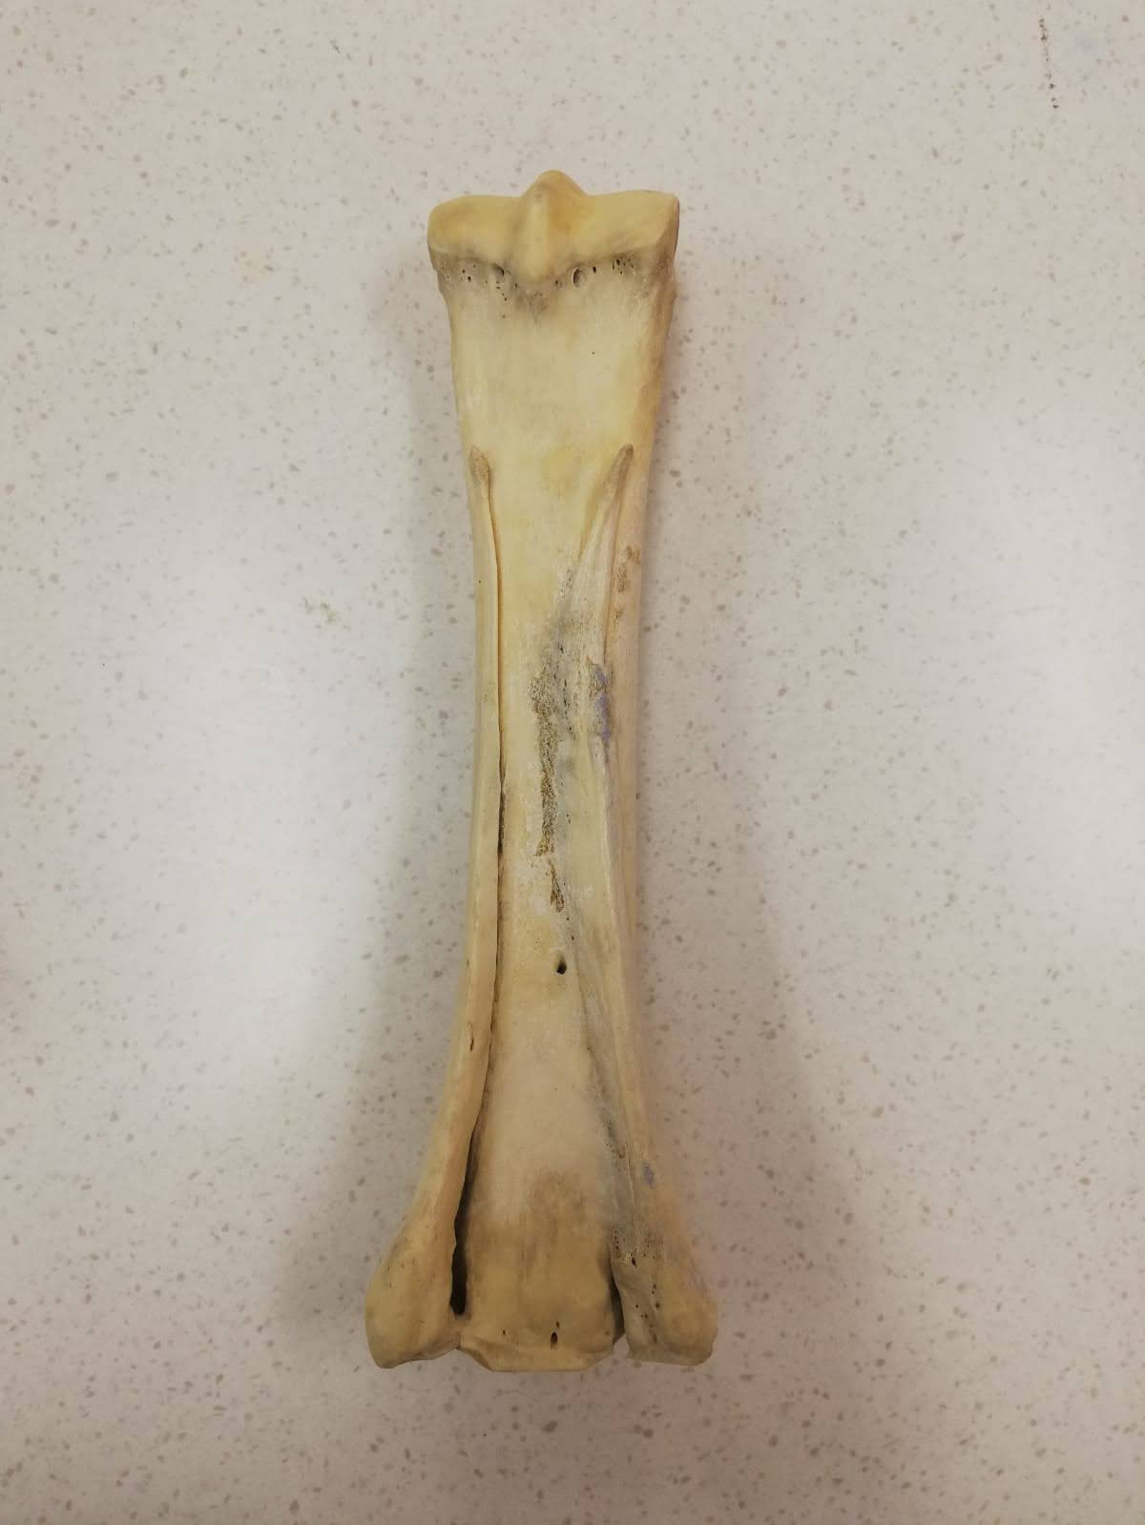

**Dorsal View**

**Palmer View**

MC4

MC2

MC2

Splint Bone

MC4

Splint Bone

MC3

Cannon

Bone

MC3

Cannon Bone

**Image 3: Metacarpus**

**Digits**

