Procedure for Transpalpebral Enucleation

1. The eyelids are sutured together with simple continuous monofilament suture or towel clamps.

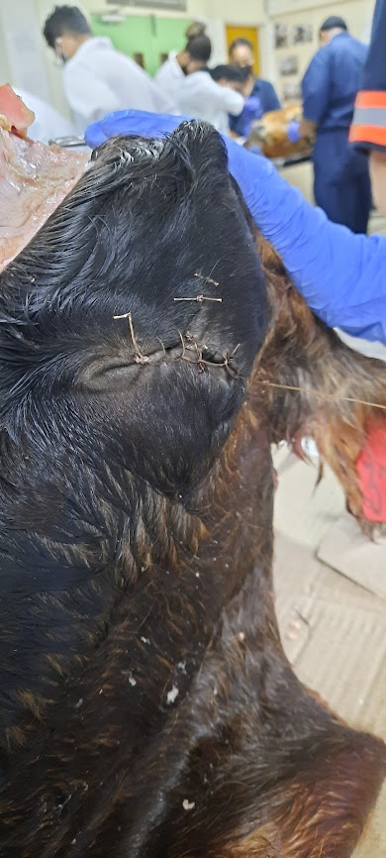

1. A full thickness encircling incision approximately 5 mm from the eyelid edges is made around the palpebral fissure with a scalpel blade, and the eyelids may be grasped with tissue forceps on either side in order to provide easier manipulation. Including SQ tissues, and orbicularis oculi down to the conjunctiva (but not through it!). (Be sure to incorporate both the lateral and medial canthus avoiding the agularis oculi vein).

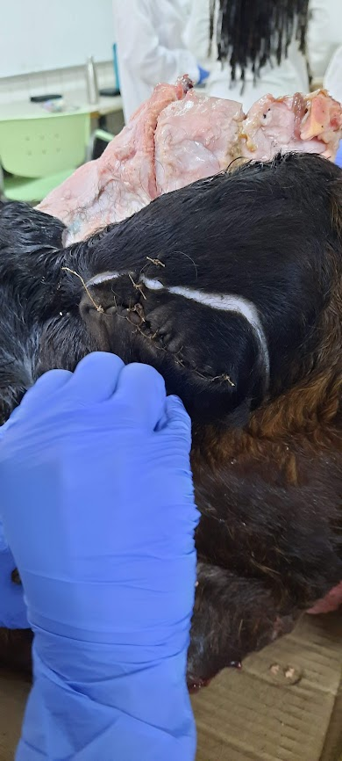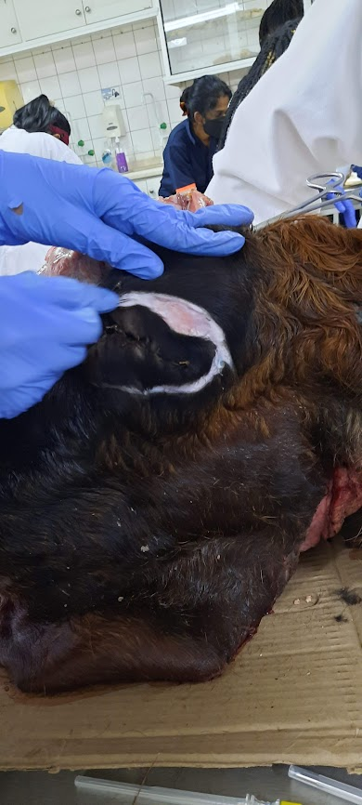

1. Blunt dissection is carried out as far as the orbital margin and sectioning of the lateral and shorter medial canthal ligaments is required. Once the eyelids are mobile, gentle traction is applied and dissection is continued caudally outside the extraocular muscles, taking care not to puncture the conjunctival sac.

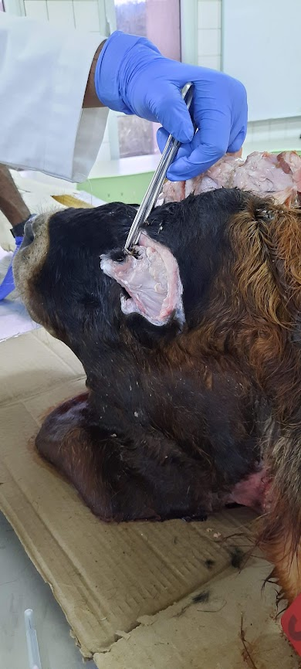

1. Attempts to place a ligature around the optic nerve and associated blood vessels are made as in the trans-conjunctival method, although visualization is not as good. After removing the globe, the periocular tissue should be carefully dissected from the sclera before placing it in fixative.

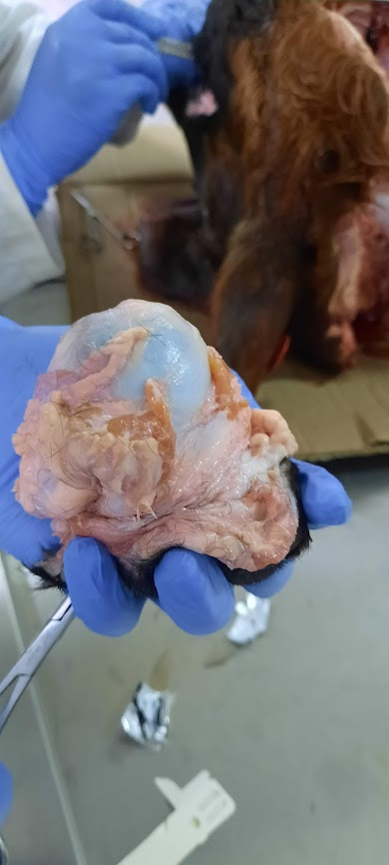

1. Closure requires two techniques (2 layers):

1) subcutaneous tissue (2-0 absorbable suture, simple continuous)

2) skin (0 non-absorbable suture, interrupted horizontal mattress)

Ford interlocking suture closed with an aberdeen knot was used.

