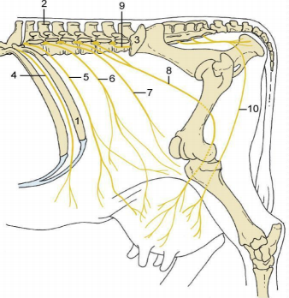
Figure showing Nerve Supply of Udder
- Last rib
- Spinous process
- Coxal tuber
- 12th intercostal nerve
- Costoabdominal nerve
- Iliohypogastric nerve
- Ilioinguinal nerve
- Genitofemoral nerve
- L5 nerve
- Ventral perineal nerve

