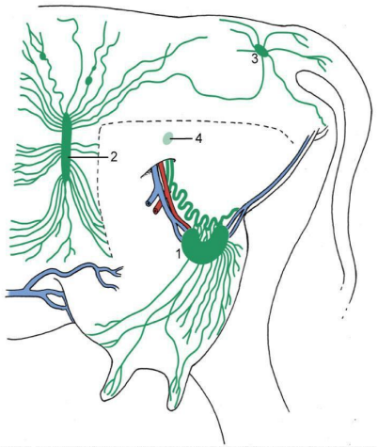
Figure showing Lymphatic Drainage of Udder
- Superficial inguinal lymph node
- Subiliac lymph node
- Ischial lymph node
- Iliofemoral lymph node

