Post-operative Complications with Disbudding
- Scurs: This is the small re-growth of bud formed if the horn bud was not completely cauterized, due to the hot iron not being left long enough or not being hot enough. Treatment requires frequent trimming of scurs or possible second de-horning.
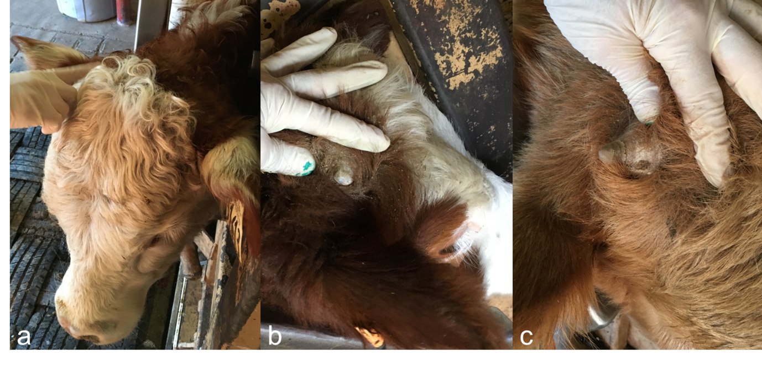Picture showing a scured calf.

- Myiasis and Infection: due to improper aftercare, especially in areas where flies are present. Appropriate fly control and use of anti-myiasis sprays ( such as Bactrovet) can be used as prevention. Additionally use of Ivermectin is helpful.

