Post-operative Complications with Dehorning

- Myiasis: Due to improper aftercare, especially in areas where flies are present. Appropriate fly control and use of anti-myiasis sprays ( such as Bactrovet) can be used as prevention. Additionally the use of Ivermectin is helpful.
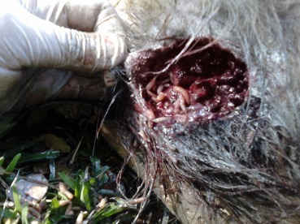
Picture showing what myiasis would look like in an open wound.

- Infection of the frontal sinus: Due to poor aftercare and contamination of bacteria, this can lead to sinusitis. The wound should be flushed and disinfected with use of antiseptics (such as Chlorhexidine), ensuring it is properly cleaned. Antiobiotics (such as PenStrep) can be used topically and systemically in these instances.
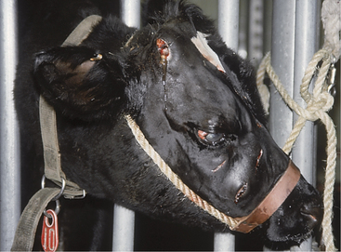
Picture showing infection of frontal sinus in cow.

