Equine

Male Reproductive Tract
- Castration Techniques
  - pros and cons of different techniques – complications
- Cryptorchidism
  - including approach to rigs
- Penile prolapse - paraphimosis/priapism
  - Paraphimosis: Penis extruded and cannot be retracted
  - Priapism: consistent erection
- Penile/preputial masses

Castration
- Indications
  - control of reproduction and sexual behaviour
  - testicular neoplasia (uncommon in horse)
    - 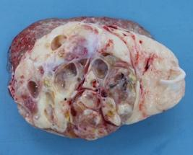 => Teratoma in horse’s testicle
  - testicular trauma
  - inguinal herniation
  - spermatic cord torsion

When to Castrate
- Age
  - Can be done at any age once testicles have descended (but increased risk with age)
    - Size of inguinal rings- larger leaves more risk for herniation
    - Amount of blood supply
  - HAVE TO BE CAREFUL OF ADHESIONS IN YOUNG HORSES
  - Quicker recovery if younger
  - TB (THOROUGHBREDS) usually as 1-2-year olds
    - TESTOSTERONE HAS EFFECT ON CLOSING GROWTH PLATES
- SO IT CHANGES THEIR CONFIRMATION
  - Ponies as weanlings or yearlings
Pre-operative Examination
- General physical examination
- Check for umbilical hernia
  - CAN ONLY FIX IN A GA(GENERAL ANESTHESIA) CAN T FIX A HORSE STANDING UP
- Check both testes present
- Ensure no inguinal hernia
  - Can use ultrasound
- Confirm adequate tetanus prophylaxis
  - Horses are very sensitive to tetanus, so small amounts of toxin cause serious disease.

Restraint
- Standing
  - Avoids risk of GA(GENERAL ANESTHESIA)
  - Cheaper (probably quicker, possibly rushed for time as there’s less control)
    - Because you don’t need anaesthetic drugs
  - Limited to open castration technique- ONLY TECHNIQUE TO THINK ABOUT DURING STANDING SURGERY
    - Closed technique requires ligatures which can’t be placed on a standing horse safely.
  - Access not as good, cannot be sterile
- General anaesthesia
  - Provides superior surgical access and asepsis, can perform a closed and semi-closed castration (reduce risk of herniation)
  - Repair umbilical hernia at same time
  - Increase herniation risk if use open castration

Standing Castration
- Encourage owner to handle the colt as much as possible prior to castration
  - ENSURES FOAL IS COMFORTABLE DURING THE PROCEDURE
- Confined area, in a clean stable with good light
- Heavy sedation with alpha-2 agonist + opioid
  - Detomidine (0.12ml/100kg)/Romifidine (0.9ml/100kg) and Butorphanol (0.2ml/100kg)
  - Neurolept analgesia- state of sedation with combination of opioid and alpha 2 agonist is greater than if either drug was used alone.
- +/- Twitch
  - Lip is preferred to ear. Sedation is a better option than prolonged twitching as this can lead to aural haematomas.
- Local anaesthetic (≈20ml) into each testicle/cord

General Anaesthesia Recumbent
- Field anaesthesia-need suitable area such as a small paddock
- Place an intravenous catheter
  - alpha-2 + ketamine (+/-butorphanol and diazepam)
  - alpha-2 + thiopentone+/-GGE
- +/- Local anaesthetic into testicle to be removed last or both testicles
- Maintenance using top up doses, gaseous or triple drip

Pre-op Medication
- Tetanus prophylaxis
  - tetanus toxoid and tetanus antitoxin
- Antibiosis
  - intramuscular procaine penicillin
- Analgesia
  - Phenylbutazone
  - Flunixin

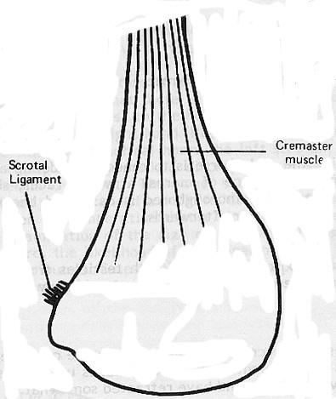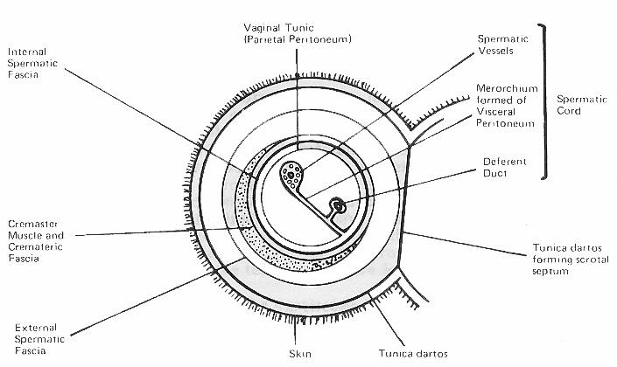

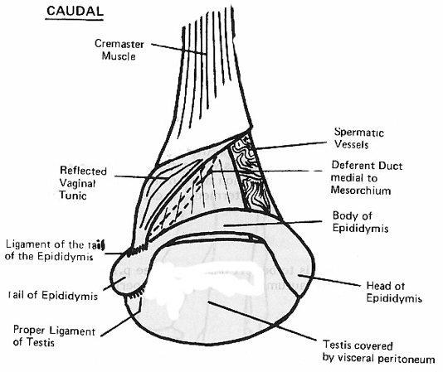
Deferent duct transports sperm from the testicle to the storage organs. Mesorchium is a light peritoneal lining around these structures.

Three major ligaments of the testicular structure in the adult horse:
- Proper ligament of testis
- Ligament of the tail of the epididymis
- Scrotal ligament
  - Scrotal ligament connects vaginal tunic to scrotum.
- These are the remnants of the gubernaculum testis. Structure that guides the foetal testis from its original location near the kidney into the scrotum via shortening and thickening of the ligaments.

Emasculators
- Designed to crush proximally and cut distally
- Nut side is cutting side
  - Place “nut to nut”
  - Wing nut is on side with cut
- Many different types
  - For example, Serra
- Ensure well maintained
  - Dismantle and clean regularly

Methods of Castration
- Closed castration
  - Any age, including stallions.
  - Donkeys have large inguinal rings- do closed castration.
  - Do not enter vaginal tunic
  - 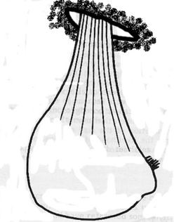

- Open castration
  - Not stallions
  - Upper limit of 3-4 years. After this, their testicles are larger, and risk of complications is higher.
  - Enter vaginal tunic
  - 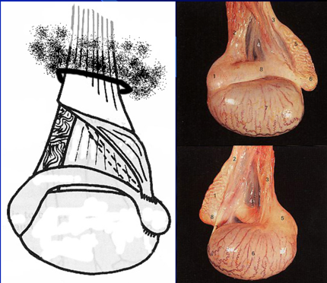
- Semi-closed castration
  - With ligatures
    - Ligatures are more secured on vasculature of well-developed stallions as there’s less tissue at each ligature
  - Can use for mature horses/stallions
  - Briefly enter but close back vaginal tunic

Open Castration
- Incision should be in most dependent part of scrotum
  - Generous longitudinal incision ~4 cm from median raphe
  - Cut through skin, tunica dartos and spermatic fascia
  - Separate the vaginal process from the skin using fingers i.e., break scrotal ligament
  - Then incise vaginal tunic (i.e. into lumen of vaginal process) and exteriorise testicle
- Pull testis distally
  - Identify the spermatic cord and epididymis
  - Included is tail end of vaginal process in the emasculators
- Place emasculators on cord as proximally as possible – “Nut to nut”
  - Ensure placed transversally, not oblique
  - Avoid trapping skin
  - Slightly release tension on cord prior to closure
  - Crush for 30 seconds to 4 minutes
  - Can place haemostats on cord prior to releasing emasculators
- For young, undeveloped horses, do in one go
- For older, more mature horses do in two sections
  - Punch finger though mesorchium and emasculate spermatic vessels first
  - Then ligaments, vaginal process, cremaster muscle and ductus deferens

Advantages and Disadvantages of Open Castration
- Advantages
  - Quick
  - All tissues touched by surgeon are removed
  - No foreign material left behind
- Disadvantage
  - more likely to suffer complications
  - Risk of herniation
  - Infection spreading to abdominal cavity
  - Not good asepsis
Closed Castration
- Must be performed under GA
- Incision as for open technique, only skin, tunica dartos and external spermatic fascia are incised
- Spermatic sac (vaginal process) is bluntly dissected free
- Ligate as high as possible using 5 metric synthetic absorbable suture anchored in external cremaster mm (can use 2 ligatures). Transfixation technique recommended so it doesn’t slip up or down.
  - Grab tissue from the loop
- Emasculators used to transect sac at least 2 cm distal to ligature

Advantages and disadvantages of Closed Castration
- Advantages
  - If use ligature, prevents herniation
  - Peritoneal cavity sealed against infection
  - Can close scrotal skin if wish, rapid healing
- Disadvantages
  - More surgical and anaesthesia time
  - Handle tissues and leave a ligature behind

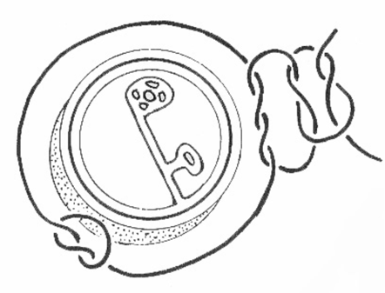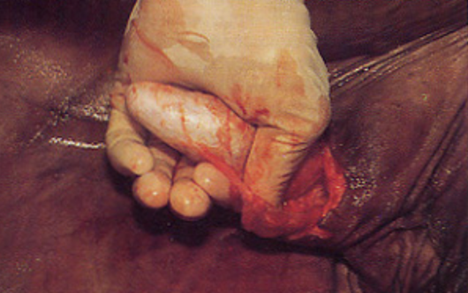 => thumb breaking scrotal ligament. Laparotomy swab or 4x4 swab can also be used to do this.

Semi- Closed Castration
- Under GA
- Initially the spermatic sac is bluntly dissected free as for the closed technique
- Vaginal process is then incised cranial to and just above the testicle and the testicle extruded
- Ligate and divide spermatic blood vessels first
- Then ligate whole vaginal process and remove distal vaginal process containing testicle and epididymis by emasculation
- Better crush as there’s less tissue in the ligature; takes longer than closed.
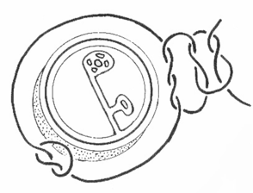
for the semi-closed method, suture would be placed just around the vasculature

Skin Closure and Post-op Care
- Skin incision often left to heal by second intentkon
  - Stable rest for 24 hours
  - Then daily exercise in small paddock
- Suture scrotal skin for first intention healing
  - Box rest 24 hours the walk in-hand for 7 to 10 days
  - #2 Vicryl (5 metric) can be used to ligate testicular vessels. 2 metric can be used if parietal tunic included.
  - 2-0 monocryl (3 metric) can be used for subcutaneous tissue and skin
- Regular inspection of surgical site
  - For complications, swelling and discharge
  - Especially for first few hours
- Leave wounds alone
- Treat as entire colt for at least 4 to 6 weeks

Complications of Castration
- Oedema
- Haemorrhage
- Infection- standing castration is 3x the risk as compared to GA hospital castration (which is 3x the cost)
- Protrusion of tissue/herniation
- Eventration/Evisceration
- Miscellaneous
- Most of the above associated with standing, open/unligated castration
- Recumbent, semi-closed/closed technique with ligation far superior, but tradition and cost get in the way

Castration
Classifications
- Positioning:
  - Standing
  - Recumbent
- Method:
  - Open open
  - Open closed
  - Semi-closed

Equine Standing Castration
- Advantages:
  - Less cost and assistance
  - Quicker
  - Choice if poor anaesthetic candidate
- Disadvantages:
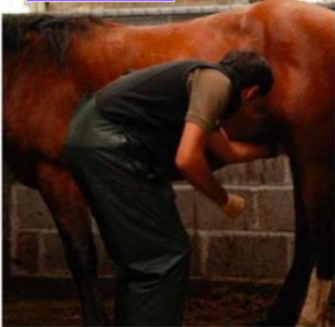
  - Vulnerable position
  - Not for use in young equids
  - Assess temperament prior
- Sedation
  - Alpha-2 agonist +/- butorphanol
- Local Analgesia
  - Essential to castrating standing
  - Spermatic cord or intra-testicle
- Position of veterinarian
  - Tight to horse, keep head up, use reach of arms
- https://www.youtube.com/watch?v=v-idOUJ50cg

Equine Recumbent Castration
- Environment
  - Field conditions
  - Hospital conditions
- Anaesthesia
  - Xylazine followed by ketamine and diazepam
- Recumbency
  - Left lateral versus dorsal
- Rope restraint
  - Tie the limbs to maintain safety

Procedure:
- Surgical scrub followed by local anaesthetic at the place of incision, inside the testicle and in the spermatic cord.
- Two vertical incisions are made on each testis about 1 cm from the median raphe
- Testis is grabbed between thumb and forefinger
- Open closed:
  - First incision is made for the length of the testis
  - The incision is continued through the Tunica dartos and scrotal fascia
  - Incision is only through the scrotum and not through the parietal tunic, so the common tunic is left intact
  - Pressure is exerted by the thumb and forefingers to extrude the testis
  - The testis is grabbed in one hand and the subcutaneous tissue is stripped from the common vaginal tunic proximally (blunt dissection)
  - Emasculation- parietal tunic versus Cremaster muscle
  - +/- primary closure- decreases the risk of herniation and evisceration
- Open open
  - Incision through both scrotum and parietal tunic
  - The common tunic is incised over the cranial pole of the testis
  - One finger is hooked within the tunic to maintain the tension, and the incision is continued
  - The testis is now released from the common tunic
  - Dissection of the ligament at the tail of the epididymis
  - Spermatic cord is separated from the ductus deferens, common tunic and external cremaster muscle
  - Spermatic vessels are emasculated after leaving as much of the common tunic as possible (Leaves Parietal tunic behind). Ligation can be done for homeostasis but there are disadvantages of foreign material being left behind.
- Semi-closed:
  - An incision is made in the scrotum followed by a 2cm incision into the parietal tunic.
  - Eversion of the tunic
    - Flip parietal tunic over thumb
    - Provides grip to aid in retraction
  - Closed castration
    - Emasculate spermatic cord followed by parietal tunic

Open Closed
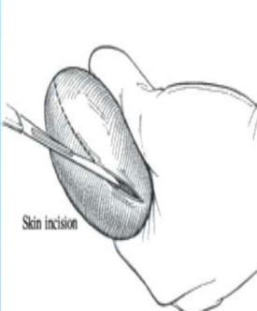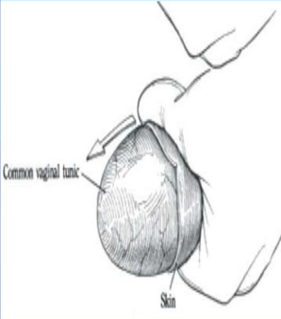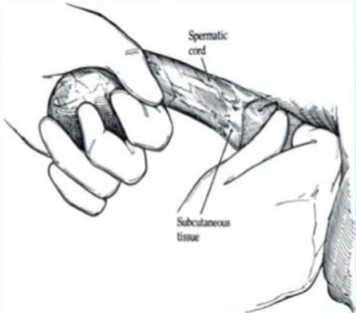

Open Open
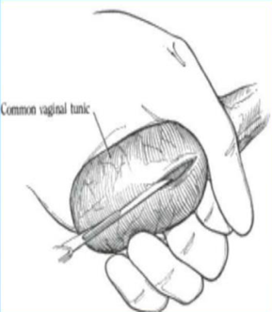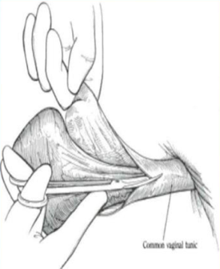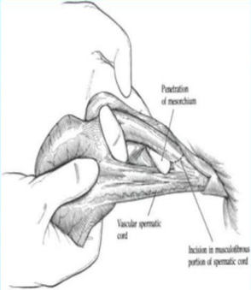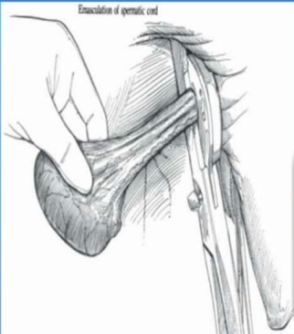

Semi-Closed
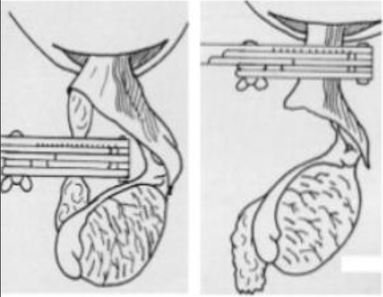

Postoperative Management
- Monitor for haemorrhage
- Concurrent immunization- Clostridium
- Open method- blow fly attacks and infection
- Moderate exercise- promote drainage
- Antibiotic therapy – if there is swelling, pain or temperature
- Supportive fluid therapy
- Still three or more weeks to be sterile

Advantages and Disadvantages of the Open Open Method of Castration
Advantages | Disadvantages
- Permanent method  - No chance for sperm production  - Reduction in aggressive behaviour – no testosterone  - For both young and adult | - Blood loss and other postop complications  - More chance of infection  - High risk of maggot infestation if done during the fly season  - Not reversible  - Require more skill

Scrotal Healing
- Second intention healing
  - Drainage
  - Stretching incision
  - Trim excess fascial tissue
- Primary closure
  - Technique
    - Excellent haemostasis
  - Environment
    - Sterile operating conditions
  - Increased cost

Post-Operative Recommendations
- Open scrotal incision
  - Movement
    - Lunging at the trot daily
  - Hydrotherapy
    - Decrease swelling
- Closed
  - Confinement to facilitate primary intention healing
- Isolation from mares
  - Active spermatozoa
  - Two days minimum

Complications
- Common, normal result
- Management
  - Exercise
  - Hydrotherapy
- If nonresponsive
  - Re-open scrotal incision
  - Promote further drainage
- Abnormal:
  - Oedema
  - Hemorrhage
  - Evisceration
  - Clostridial Infection
  - Septic Peritonitis
  - Penile Damage

