CAUDAL EPIDURAL NERVE BLOCK
Desensitizes the caudal sacral nerves.
Location: between Co1 & Co2 OR between sacrum & Co1
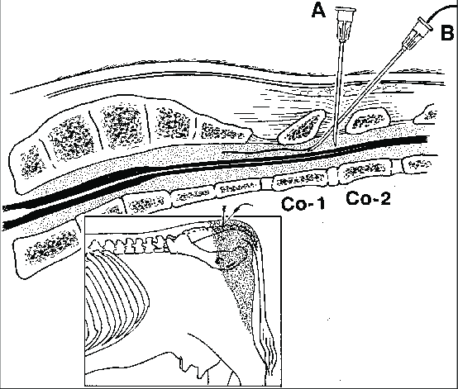
Procedure:
- The site of injection can be located by moving the tail up and down and palpating the area, it is normally the first proximal moving space that can be easily spotted.
- The site is shaved and swabbed thoroughly with alcohol.
- The needle alone is then penetrated into the intervertebral space directed slightly in a cranial direction and advancing slowly.
- No bone should be encountered, if bone is felt re-direct or pull back.
- When a popping sensation or lack of resistance is felt, you are in the epidural space.
- The hanging drop technique can be done to confirm the needle is in the correct position.
- Attach syringe with lidocaine aspirate to ensure no blood vessels were entered and administer and wait 10 minutes to test if block was successful.
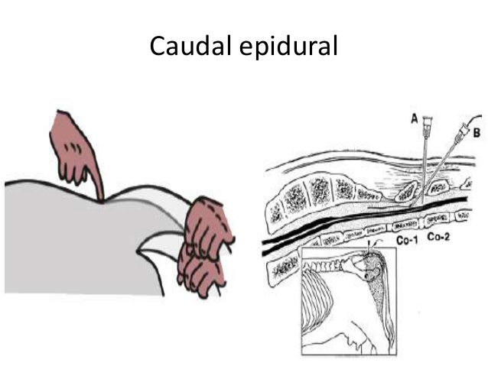

How to confirm you are in the correct position?
- No resistance should be felt to injection
- The “hanging drop” technique: when the needle is placed in the right position, a few drops of lidocaine or saline can be dropped into the needle hub. The drop of lidocaine/saline would aspirate due to the negative pressure in the epidural space if it is the correct position. Therefore if the drop of liquid remains in the needle hub it is not in the correct position.
How to confirm the block was successful:
- After 5-10 minutes the tail will be flaccid.

