PROXIMAL PARAVERTEBRAL NERVE BLOCK
Desensitizes dorsal and ventral spinal nerves T13, L1 & L2 that emerge from the intervertebral foramina.
Location: dorsal aspect of transverse process of the last thoracic (T13), first lumbar (L1) and second lumbar (L2)
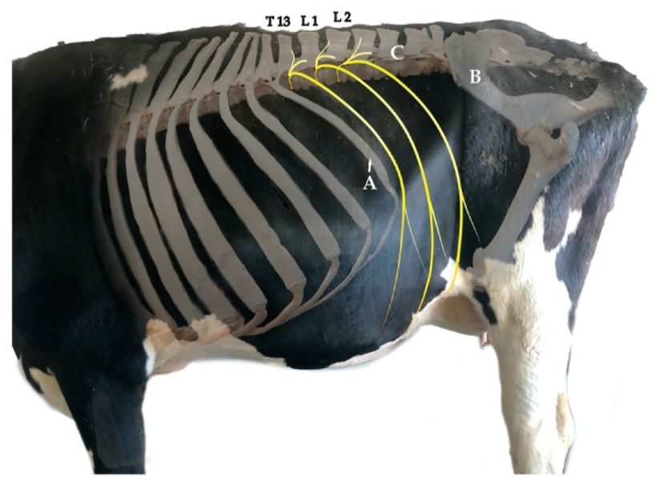
Procedure:
- Palpate and identify the transverse processes of injection sites at T13, L1 & L2.
- The skin over the dorsal aspects of the transverse process is clipped and shaved and swabbed with alcohol.
- At T13 inject needle, a long need is used, above the transverse processes under the skin and administer a small quantity of lidocaine first.
- Then walk the needle off the dorsal margins of the bone to block the nerve branches above and below the fascia.
- Repeat steps for both L1 & L2.
- Wait 5 minutes for block to take effect.

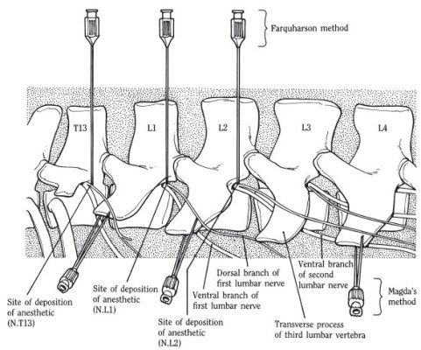
How to tell if the block was successful?
- The animal’s flank will bend and the spine curves toward the opposite side as the muscles are relaxed.
- The skin of the flank would feel warmer due to vasodilation.
Other uses of this block:
- C-sections
- Rumenotomy
- Cecotomy

