PETERSON’S NERVE BLOCK
Indication: desensitizes cranial nerves that supply motor and sensory function to the eye –oculomotor (III), trochlear (IV), abducens (VI) and all three branches of the trigeminal nerve. It immobilizes the globe and provides anesthia of the eye and orbit, but does not paralyze the eyelids. Therefore, it is normally done along with the auriculopalpebral block which would prevent blinking during procedures.
Uses: eye ball enucleation, foreign body removal, ocular mass removals, horn procedures in adult bovine.
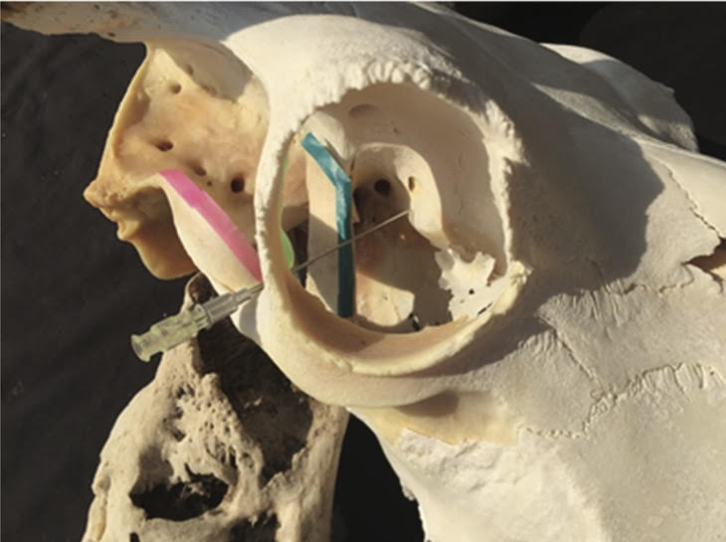
Location: the bony notch created by the supraorbital process (green) and zygomatic arch (pink), around the coronoid process of the mandible (blue).
Method:
- The animal is properly restrained chute, stanchion, halter, nose clamp), sedation of fractious animals may be required using xylazine.
- The area caudal to the eye along the zygomatic arch to the cranial edge of the ear is then surgically prepared.
- A spinal needle (18 guage, 10cm long) is then inserted at a caudal angle from the notch between the zygomatic arch and the supraorbital process toward the back of the eye.
- The needle is directed posterior and walked off the coronoid process anteriorly and advanced to the pterygopalatine fossa.
- 15-20mls of lidocaine is then injected, 10-15mls is injected first and an additional 5ml is deposited as the needle is slowly withdrawn.
- Mydriasis indicates a successful block.

Advantages:
- More effective than alternative techniques, once correctly done.
- Safer than the retrobulbar block as there is a reduced risk of globe penetration and hemorrhage.
- There is less inflammation with this block than with infiltration into the eyelids and orbit with local anesthetics.
Disadvantages:
- The technique is a bit more challenging to perform than alternative methods.
Complications:
- Apnea
- Death

