AURICULOPALPEBRAL NERVE BLOCK
The eyelids are innervated by the auriculopalpebral nerve, which is a branch of the facial nerve. It is a motor nerve supplying the orbicularis muscle, the frontalis muscle and external muscles of the ear. The auriculopalpebral nerve runs from the base of the ear along the dorsal aspect of the zygomatic arch, past and ventral to the eye, giving off branches along its route. The nerve can be palpated as it passes over the zygomatic arch.
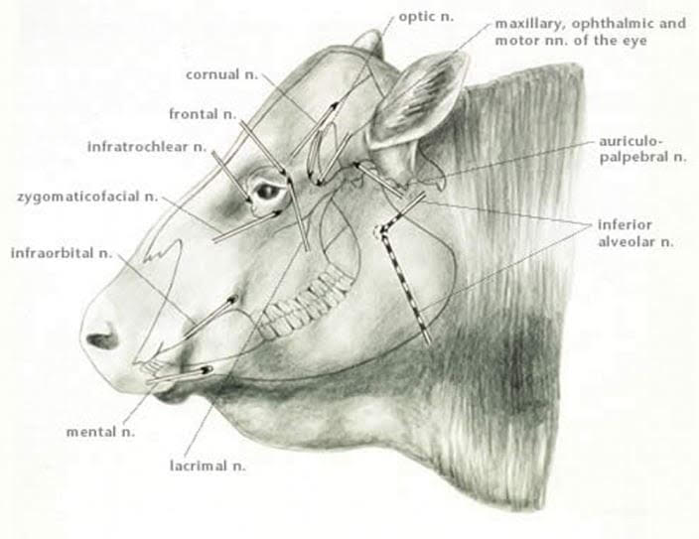
Indication: Eyelid akinesia (motor block) of the auriculopalpebral nerve. Provides temporary paralysis of the upper eyelid. No analgesia: globe retraction and third eyelid movements are unaffected.
Uses: To reduce eyelid movement to facilitate procedures such as performing Peterson’s block and subconjunctival injections. For ocular examination and manipulation of eyelid, should not be used for analgesia for any form of ocular surgery.
For analgesic effect it is used in conjunction with Peterson’s or Retrobulbolar block for surgical procedures.
Location: The auriculopalpebral nerve runs parallel to the zygomatic arch ventral to the lateral ridge of the frontal bone. Injection site is midway between the lateral canthus of the eye and the base of the ear, just dorsal to the dorsal border of the zygomatic arch.
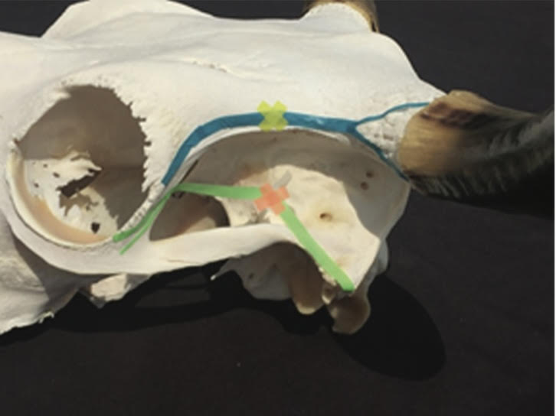
The injection site location is indicated the orange x.

Method:
- Proper animal restraint required keeping the head up. (use of halter, chute, nose pinch)
- The area in front of the base of the ear and at the end of the zygomatic arch was swabbed with alcohol.
- An 18 guage (4cm) needle is inserted into the skin in front of the base of the ear at the end of the zygomatic arch and is introduced until its point laid at the dorsal border of the zygomatic arch.
- 5-10 mls of lidocaine (2%) is injected subcutaneously in this area and the needle is slowly withdrawn.
- After needle removal, massage the injection site to ensure the drug was distributed within the area.
- After 5-10 minutes the upper eyelid would be paralyzed and no blinking is seen.

Advantages:
- Provides good eyelid akinesis
- Can be used in conjunction with sedation and other regional blocks.

