SUBCONJUNCTIVAL INJECTION
Indication: A mean of achieving high therapeutic levels of drugs in the cornea, sclera and anterior segment of the orbit. Placing the injection subconjunctivally bypasses the lipid layers of the bulbar conjunctiva and places the drugs adjacent to the water-permeable sclera, increasing water-soluble drug penetration into the eye.
Use:
- Commonly used to administer drugs to treat Infectious Bovine Keratoconjunctivitis (pink eye) in cattle.
- When topical medications cannot be administered
- To achieve high corneal and intra-ocular levels of drugs for short periods

Location: Bulbar conjunctiva, the space between the conjunctiva and sclera.
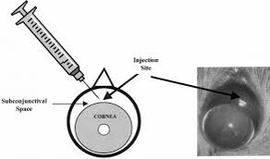 Injection site images
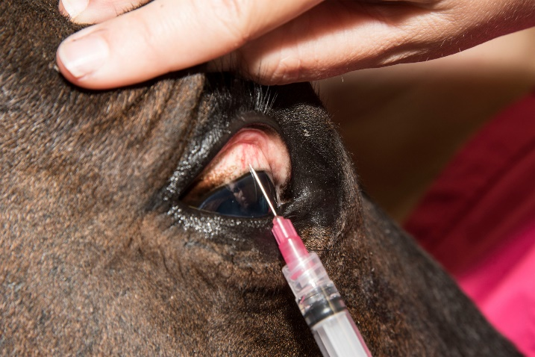
Procedure:
- Proper restraint of the animal is necessary, it is important to ensure the animal is unable to move its head.
- Topical anaesthetic to the cornea can be applied, an auriculopalpebral block would be helpful in minimizing blinking during the procedure to allow easier application.
- Retract the eyelids, a Castroviejo eyelid speculum can be used to keep eyelid open to expose the injection site. Must go in the bulbar conjunctiva, NOT the eyelid conjunctiva or palpebral conjunctiva.
- With the bevel up and finger on the plunger, lay the needle against the globe, away from the cornea (this is so if the patient moves, it won’t stab all the way through the eye), make a pocket of the conjunctiva (an opening for the needle).
- Insert the needle into the space between the conjunctiva and sclera and administer drug slowly creating a bulge or ballooning effect.
- Always ensuring the bevel remains under the conjunctiva during administration, if the needle was removed during administration, the needle can be re-inserted into the bleb that was formed to reduce any further complications.
- When removing the needle, it should be done in a twisting motion to help reduce the opening caused by the needle and prevents leakage of the drug.

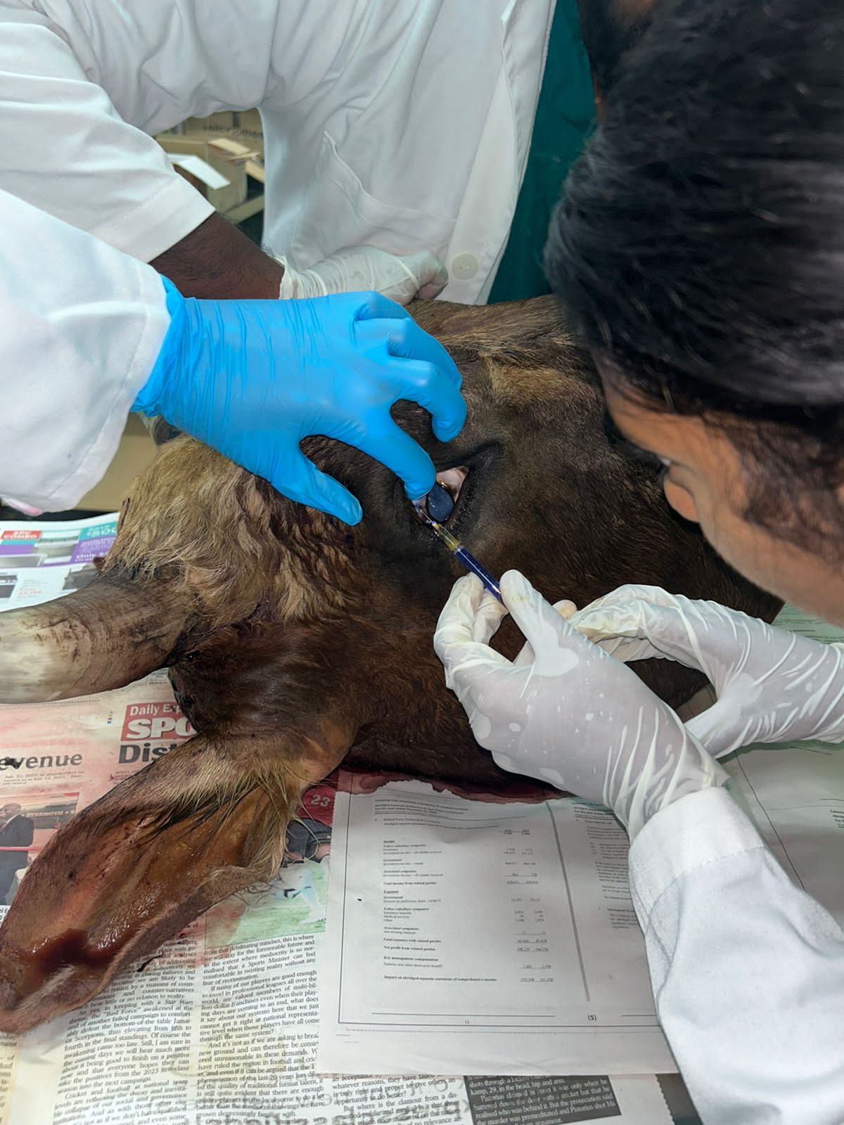Subconjunctival injection being performed.

Advantages:
- Increase penetration of water-soluble drugs
- Allows for high therapeutic levels of short term drugs in the cornea and anterior segment
Disadvantages:
- Irritation, necrosis and granuloma formation can occur at the injection site
- Once drugs administered it cannot be removed, therefore it is important to calculate all drug doses accurately and ensure the right drugs are being used.
- There is a risk of potential injury to the eye while performing injection.
Complications:
- Irritation at the site
- Intraocular penetration, damage to the globe
- Granuloma formation

