TRANSCONJUNCTIVAL/SUBCONJUNCTIVAL TECHNIQUE OF ENUCLEATION
The transconjunctival approach involves an initial incision around the bulbar conjunctiva and has the advantages of reduced orbital tissue loss and subsequent orbital sinking with time, less hemorrhaging intraoperatively, and a faster procedure time. This approach should not be used in a patient with a suspected or known intraocular infection. It is important to identify and remove all conjunctival tissue and nictitating membrane with glands to avoid the postoperative complications mentioned above.
Indication:
- Used in non-contaminated (infectious/neoplasia confined to globe) cases.
- The eyelid remains open
- Between the globe and conjunctiva is dissected.
Surgical site preparation:
- Proper restraint of animal, especially animals head, making sure it is positioned making the surgery site easily accessible.
- Clipping of area around the eye, and gently brushing or blotting away loose hairs. Ensuring all hair clippings are removed, the conjunctiva sac can be irrigated with eye wash or saline to remove excess hair.
- Using gauze and antiseptic solution such as 10% Povidone Iodine to prepare the skin for surgery. DO NOT USE CHLOHEXIDINE TO PREP EYE AS IT IS EXTREMELY TOXIC TO THE EYE!
- Use of towel clamps and gauze to isolate surgical site.

Technique:
- Eyelid remains open
- Perform a wide lateral canthotomy to improve exposure for better access for surgery. (Lateral canthotomy - https://www.msdmanuals.com/professional/eye-disorders/how-to-do-eye-procedures/how-to-do-lateral-canthotomy )
- Grasp the conjunctiva and incise for 360 degrees around the globe approximately 5mm from the limbus
- Clamp areas to be cut with hemostat before incising to reduce hemorrhage
- Extraocular muscles are isolated and transected
- The optic nerve is severed
- Following the removal of the globe, eyelid margins, conjunctiva, third eyelid and gland of the third eyelid are removed.
- Routine closure, same as Transpalpebral enucleation.
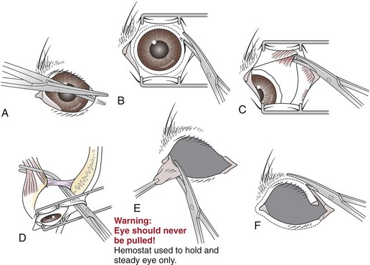
Complications:
- Major complication involved in procedure hemorrhage, which can be minimized by cauterizing the point of bleeding and using a hemostat to crush and cut off blood vessels before incising.
- Pain management during the procedure, ensure all nerve blocks were successfully done before starting operation to minimize pain during operation.

Advantages:
- Soft tissue is left behind to minimize orbital depression.
- The periorbital fat and extraocular muscles are retained which improves the cosmetic result.
- It is also less traumatic and there is less hemorrhage and better exposure of the optic nerve and orbital vessels can be achieved.
Disadvantages:
- Any infectious organism in the conjunctival sac will be introduced into the orbit once the conjunctival space is breached.
- More tissue will be left behind, which is not desirable where there is extension of tumour cells.

