Physical restraints
RESTRAINT | IMAGE | NOTES
Chute | 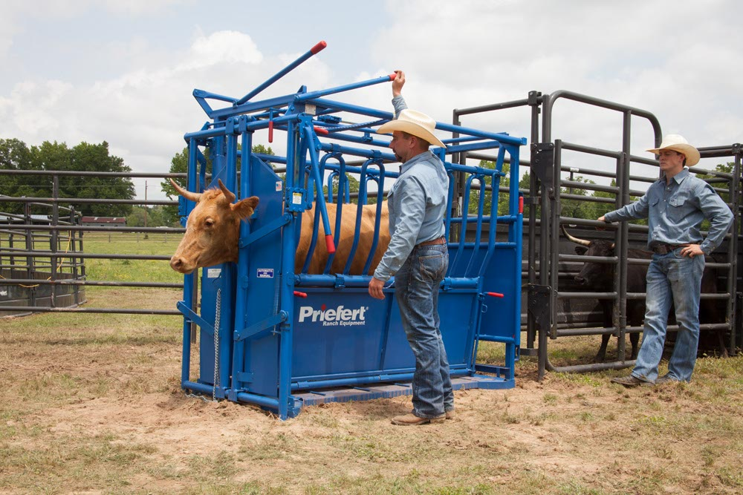 | - Can be used to do small procedures like teat laceration repair  - Prevents surgeon from being kicked whilst working  - Gives easy access to injection sites  - Singles out cow from herd
Halter lead and rope | 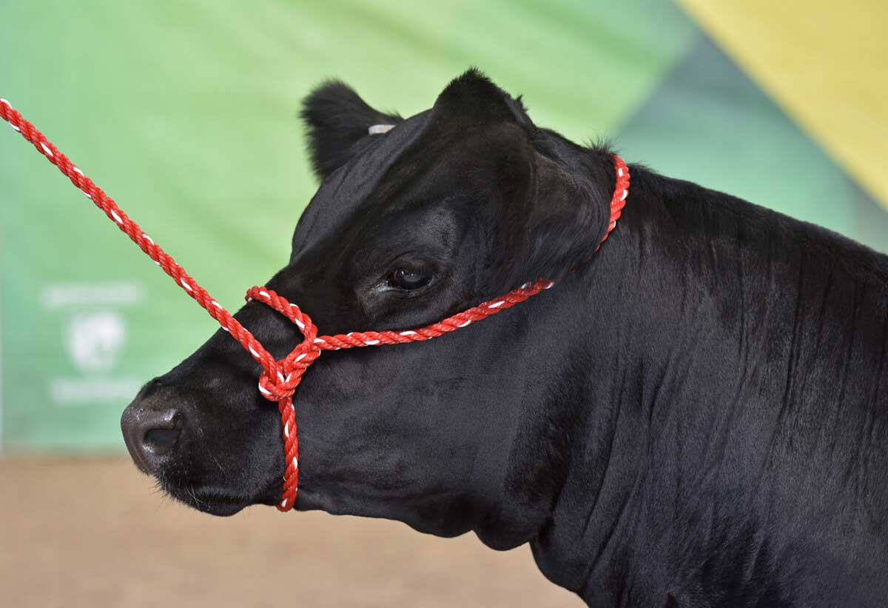 | - Used to guide animals to areas for examination  - Inexpensive and effective  - Useful when chute is not present  - Quick release slip knot, for ease of access the animal hind limbs if possible can be lifted by use of methods including hoof nack or leg beam hook method, Nose lead or tail restraint divert attention from attended area.
Tail tie | 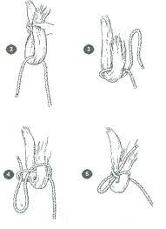 | - Used to restrain tail away from surgeon  - Useful when working on udders  - Uses sheet bend
Chemical restraints
Ring block | 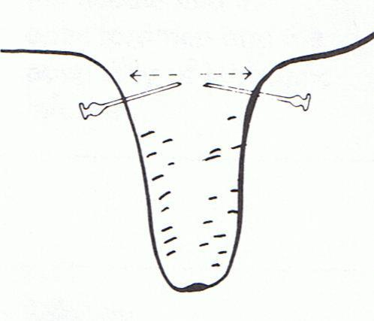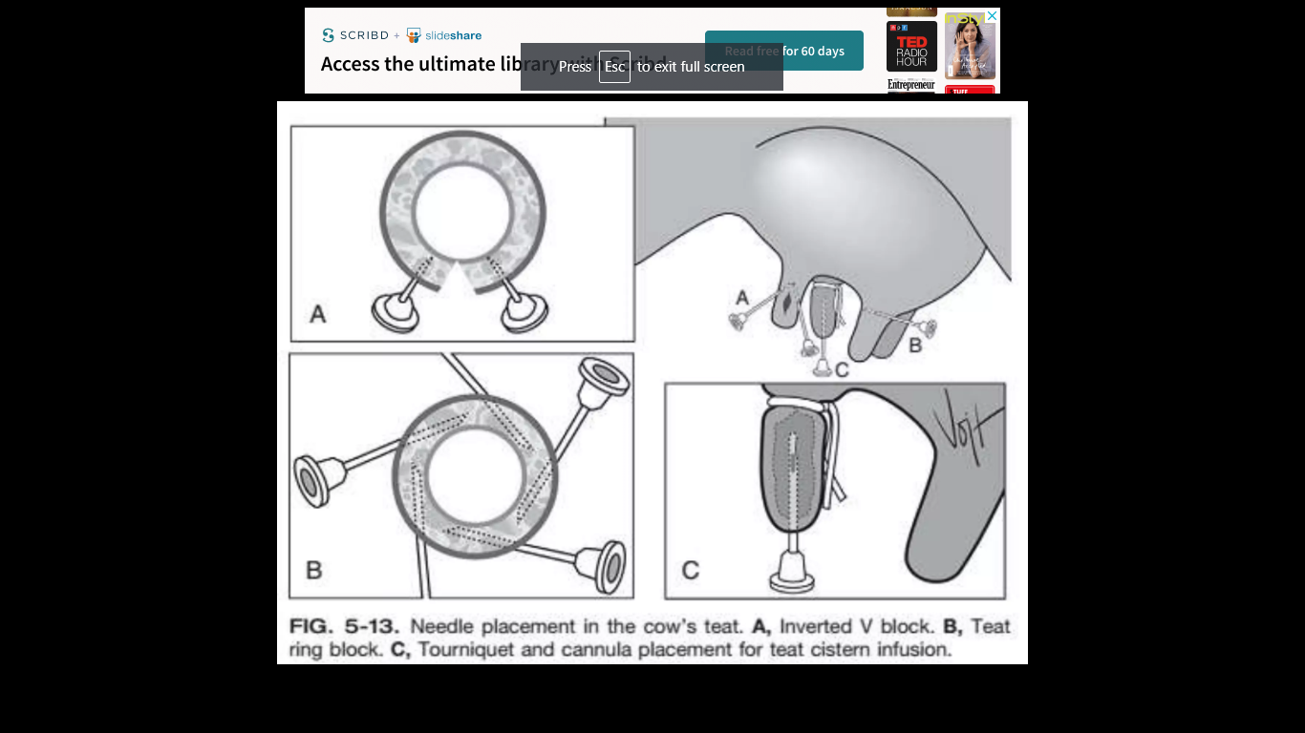 | - Around base of teat to block entire teat  - Use lidocaine  - Good for teat laceration repair  - Good for teat fistula repair
Inverted ‘v’ block | 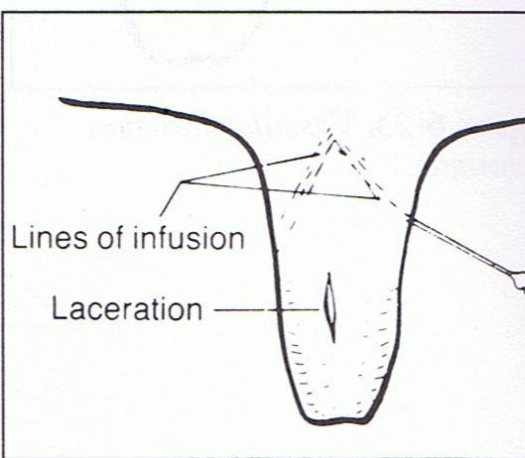 | - Make inverted v at point of incision  - Use lidocaine
Teat cistern infusion | 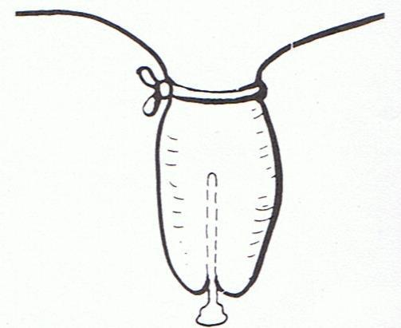 | - Good for removal of teat polyps  - Good for spider teat repair  - Requires tourniquet
Vascular infusion technique | 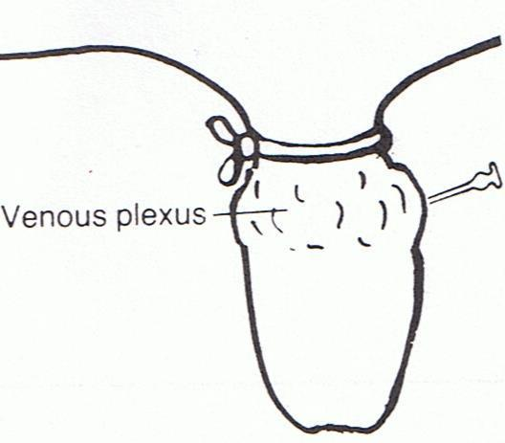 | - Good for traumatic teat laceration repair  - Analgesia and or sedative  - Reduce stress from surgery
anti-cow-kicker | 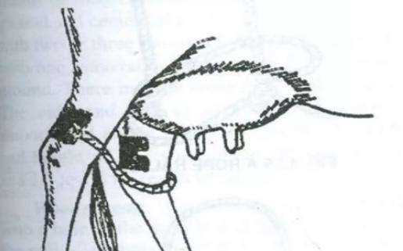 | - It comprises two metal spring clips connected by a chain.  - It is used to control a cow while milking or for examination of udder.  - The clips are fitted on the Achilles tendon region of hind legs so the chain hangs in front of hocks. The left clip is often fitted with another smaller clip into which the tail can be fixed.

