HOOF SURGERY EQUIPMENT & PPE
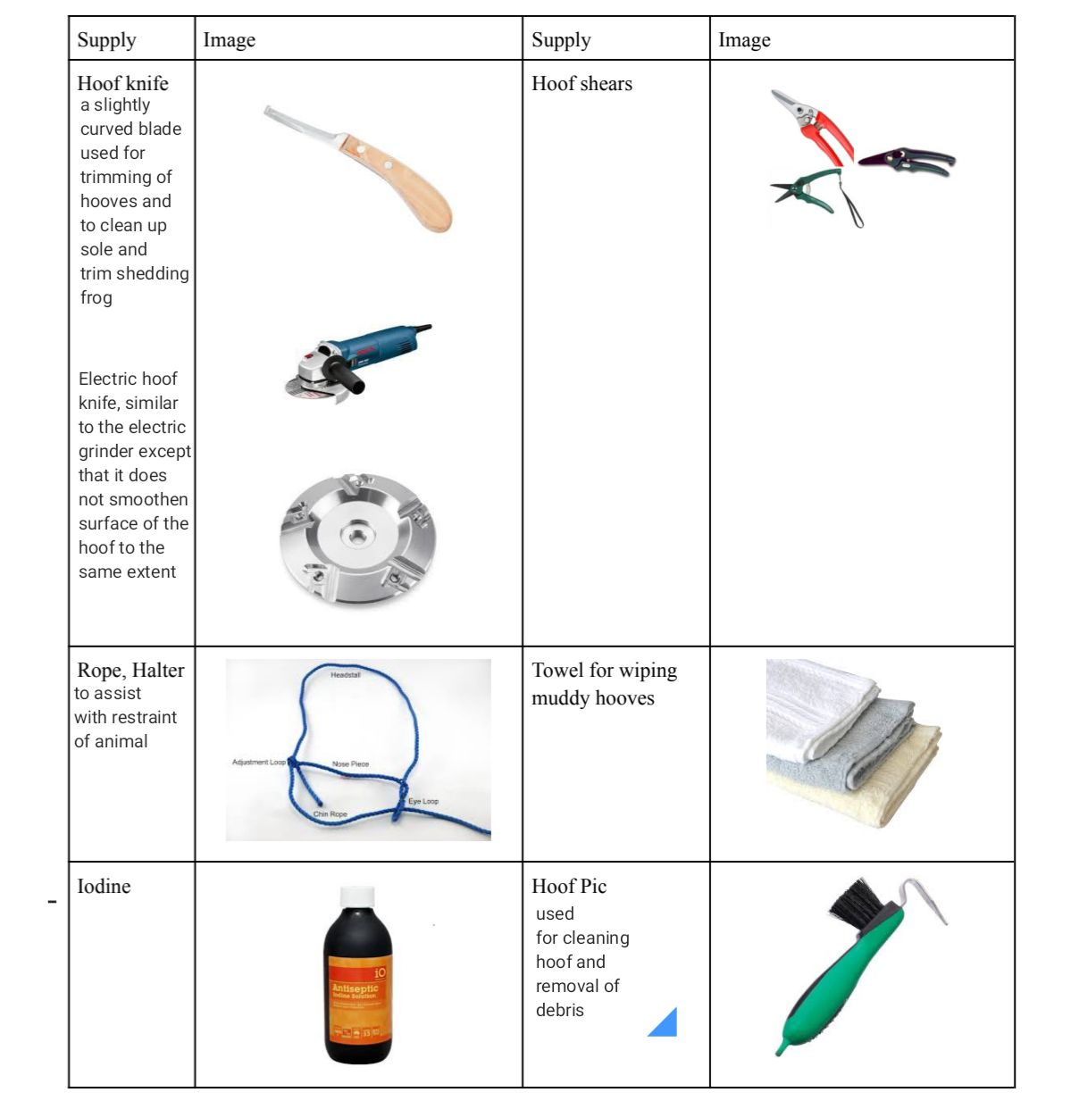
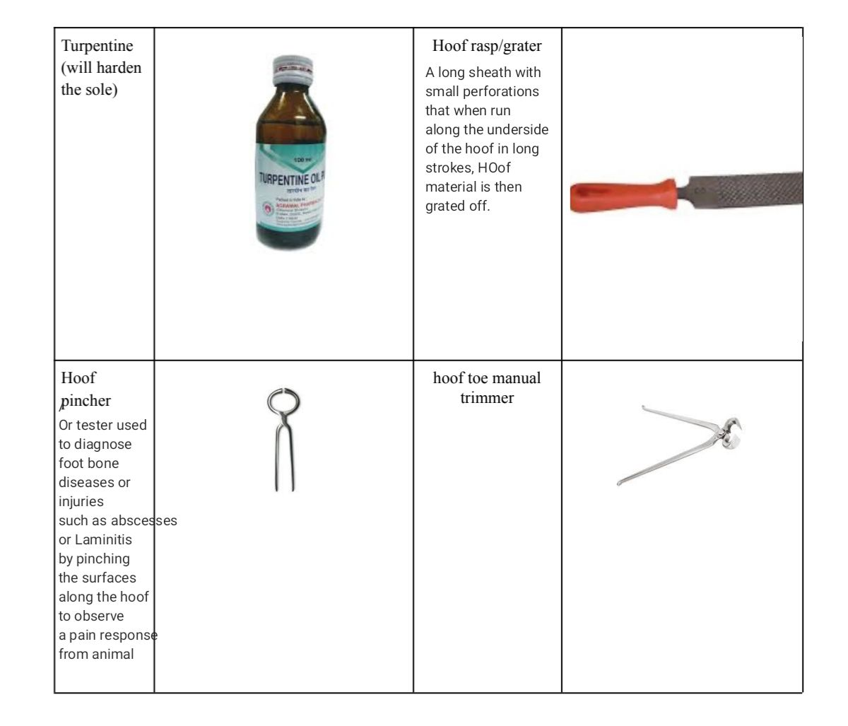
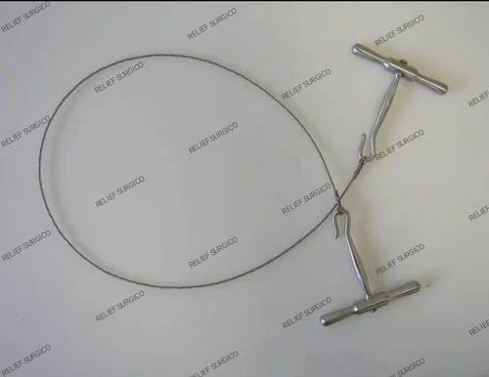
Gigly wire: a flexible wire saw, that allows for smooth even cutting regularly used in limb removal and bone extraction,its usage technique involves a rapid reciprocating movement (long back and forth stroked like a jigsaw) against the limb to be cut.
