RESTRAINT METHODS
Proper restraint should be done for the safety of the animal and handlers to reduce the risks of injuries.
When operating on the limbs of these animals it is important to keep the animal comfortable and the handler safe at all times. Keeping the animal comfortable would be less stress on the animal making it easier for the handler to get the job done. Restraint should be done properly to be effective and done in a way to ensure that the working site is accessible.
- The animal in normally standing and can be manually restrained and securely tied to a post of secured in a stanchion, chute, neck clamp, halter and rope.
- There are different methods used for leg lifting to properly examine and perform hoof trimming.
- There are hoof trimming chutes which makes it easier to lift and keep the animal less mobilized in a tight area or it can be manually done with the use of assistants and rope.
- Chemical sedation in fractious animals is recommended.
- The animal can also be placed in lateral recumbency, especially for surgical procedures. The animal can be casted by the burley’s method with the use of rope.
- When in lateral recumbency or standing the legs not being performed on can be further secures with a tom’s fool knot or use of anti-kickers.
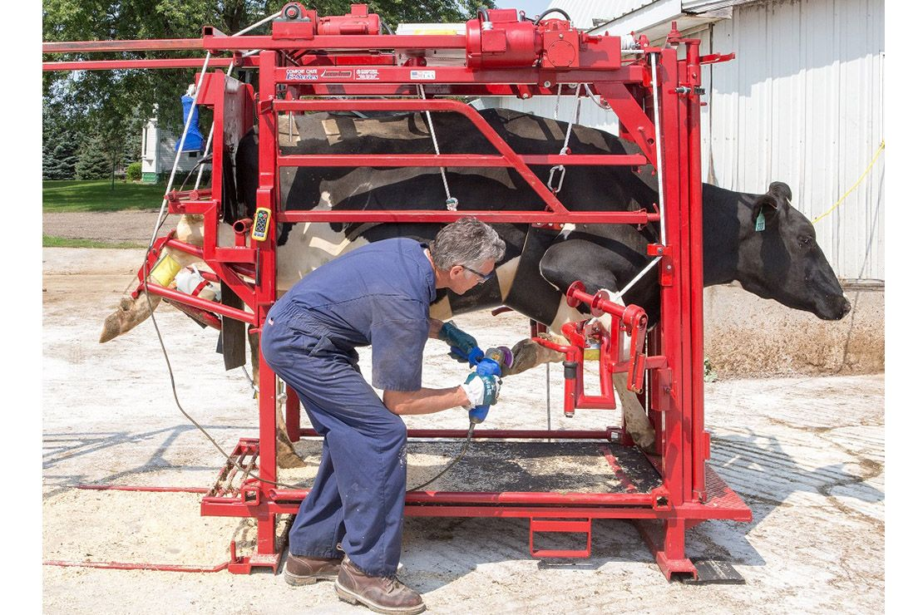
Picture showing hoof trimming crushes designed for better handling.
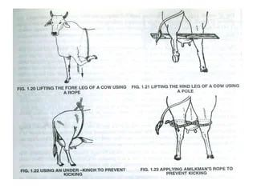
Manual restraint can be done using rope to help lift the leg to be worked on and secure the other limbs.
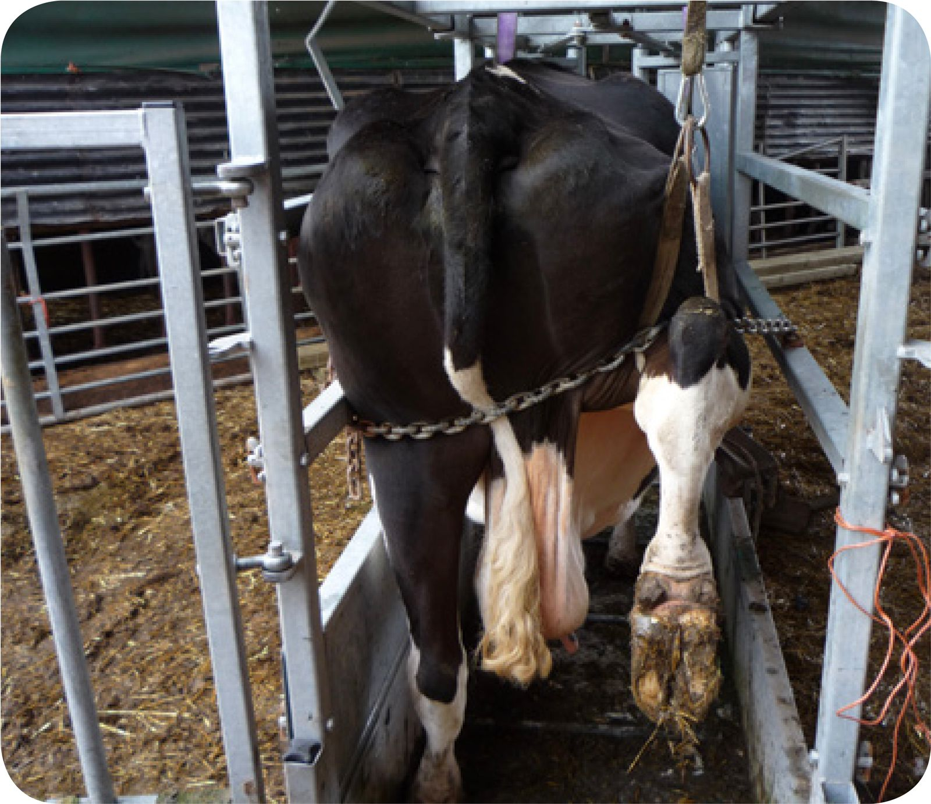
Animal in chute and hindlimb lifted with chain.
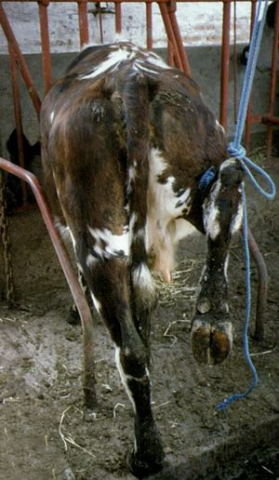 Animal secures in stanchion with hindlimb lifted with a rope.
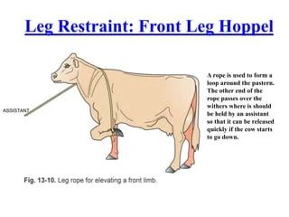

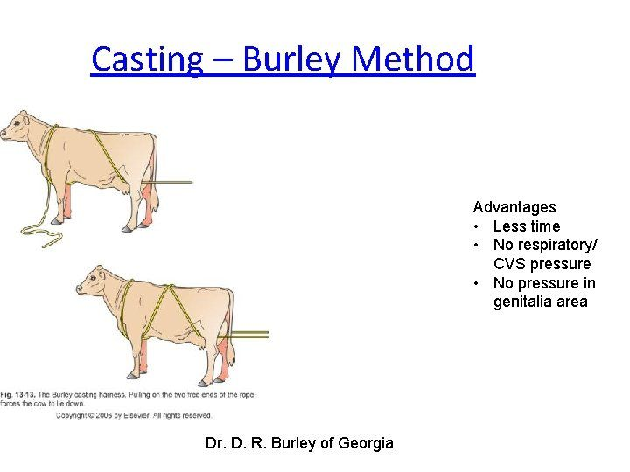
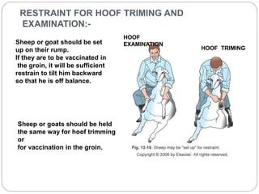
Hoof trimming restraint in sheep and goats.

