HOOF ANESTHESIA
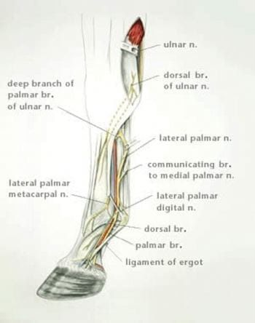
Intravenous limb regional anesthesia (IVRA) is commonly used for surgical procedures involving the foot such as, digital amputations or arthrodesis. To use this technique it is important to know the location of the associated veins to perform the regional block, which can be hard to see on an animal with a swollen limb. In the thoracic limb the dorsal metacarpal or radial veins are used. In the pelvic limb the lateral saphenous or lateral plantar digital veins.

Often done is the “Bier block” technique for surgeries of the foot.
- This technique involves the placing of a tourniquet proximal to the lesion requiring attention and to a suitable accessible large and superficial vein.
- Local analgesic solution is injected intravenously and the whole are of the limb distal to the tourniquet is analgesic. (20 guage needle 2.5-3.5cm, 20ml of 2% lidocaine for an average size cow)
- It remains in that state until the tourniquet is removed, with consideration that the tourniquet is placed correctly and is 100% efficient.
- This technique can be carried out on a standing animal but best done with the animal in lateral recumbency.
- The hair over the vein should be clipped and the skin swabbed and prepared.
- To increase efficiency a roll of bandage is placed.
- Digital pressure should be applied to injection site to prevent hematoma formation on removal of needle.
- Analgesia of the limb should develop in 5-10 minutes and be effective until the tourniquet is removed.
Presence of analgesia is tested by a needle prick in the interdigital area.
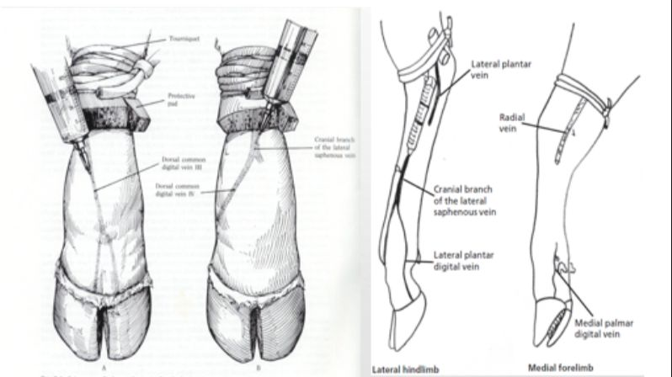
Advantages of this technique:
- Less time consuming than other techniques
- The presence of the tourniquet enables surgery to be more efficient due to less hemorrhage
- Requires only one needle stick

Other limb analgesic techniques: https://open.lib.umn.edu/largeanimalsurgery/chapter/nerve-and-joint-blocks-2/

