**RESTRAINT METHODS**

Proper restraint should be done for the safety of the animal and handlers to reduce the risks of injuries.

Postioning of animal for surgery:

Healthy cows tolerate standing surgery very well, many do not need sedation and will do just fine with local blocks. However, if the cow is hypocalcemic the cow may lie down therefore casting in lateral recumbency using double half hitch method, ensuring the animal is casted landing surgical site up. Casting in sternal recumbency by burley’s method for rectal prolapse with tail tucked or tied.

To administer anesthesia restraint methods such as use of rope and halter to tie the animal to a post, moving of the animal and manipulating the head. The use of stanchions or neck clamps can also assist in isolating the animal. Distraction restraint methods to help ease the administration of anesthesia include, tail jacking, nose pinch as well as use of chemical restraints for very fractious animals.

Restraint for surgery the animal if standing is placed in a chute to limit movement of the animal, can also be secured with a halter and tying to post of the chute. Anti-kicking knots of the hindlimbs to eliminate kicking of the animal as a response to any pain stimulants and movements during surgery. The use of drapes on the animal and covering the chutes is used to isolate the surgical field for surgery to ensure sterility. If the animal is casted the animal should be sedated to restrict activity, the limbs can be further restrained by tom’s fool knot or figure 8.

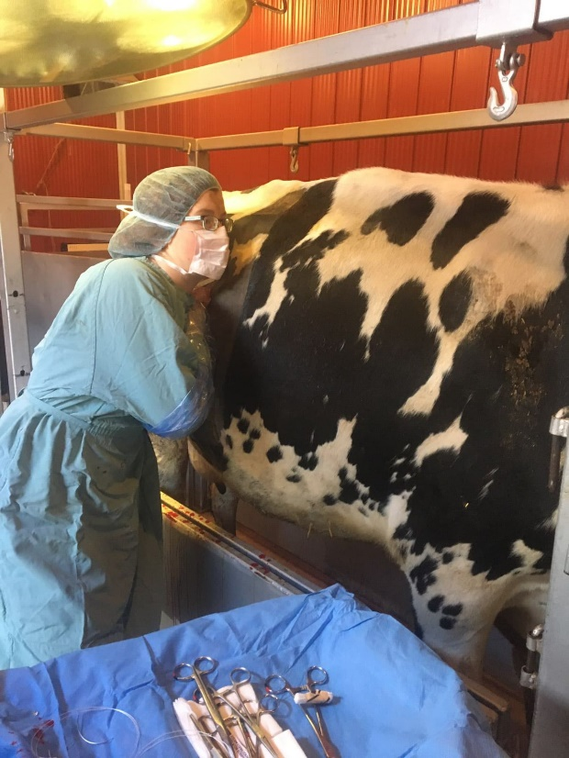

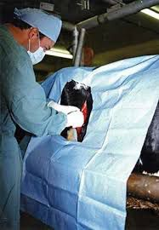

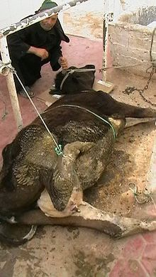

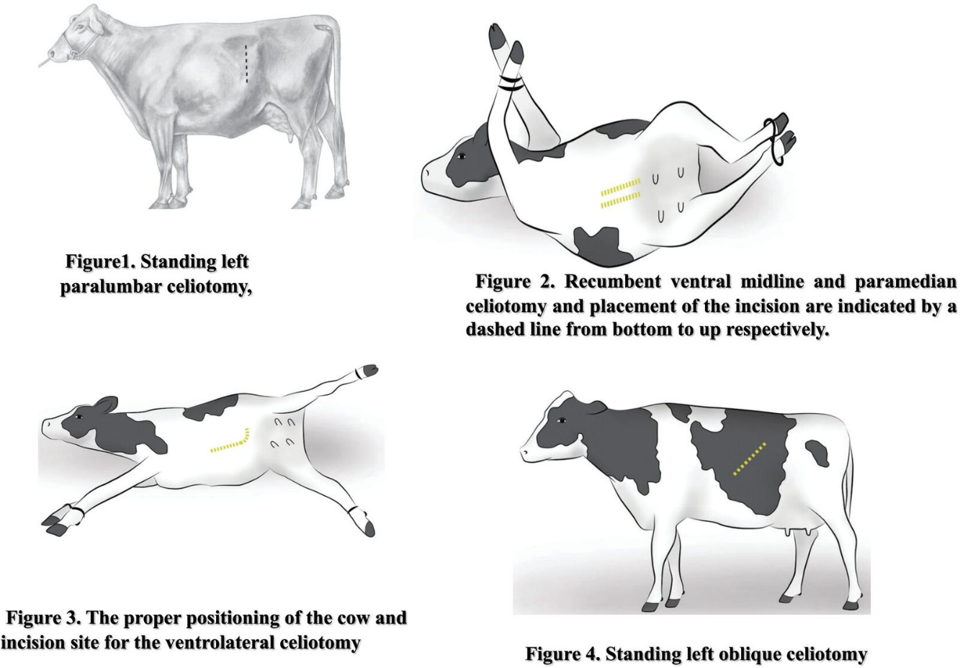

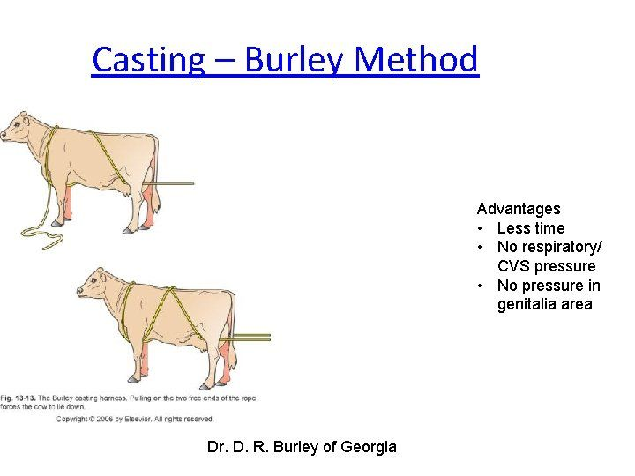

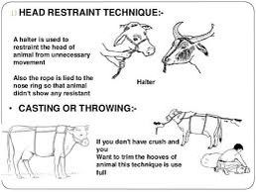

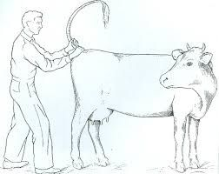 Picture showing tail restraint.