Equipment Table for Intestinal Surgery.
Equipment | Use
Scalpel blade and handle  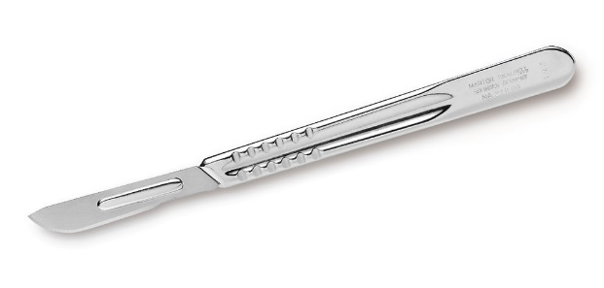 | - No 3 and No 4 handle  - 20 – 23 size blades
Doyen clamps  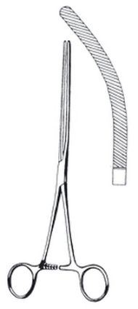 | - To grasp and clamp intestine  - Atraumatic
Mayo hegar needle holder  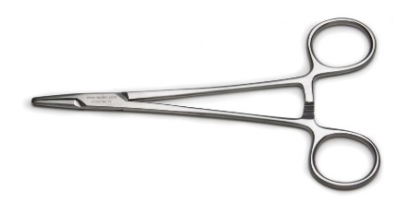 | - To hold and drive curved needles during surgeries
Metzenbaum scissors  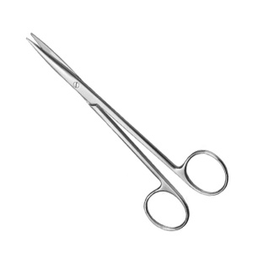 | - Used for cutting delicate tissues and structures
Surgical drapes  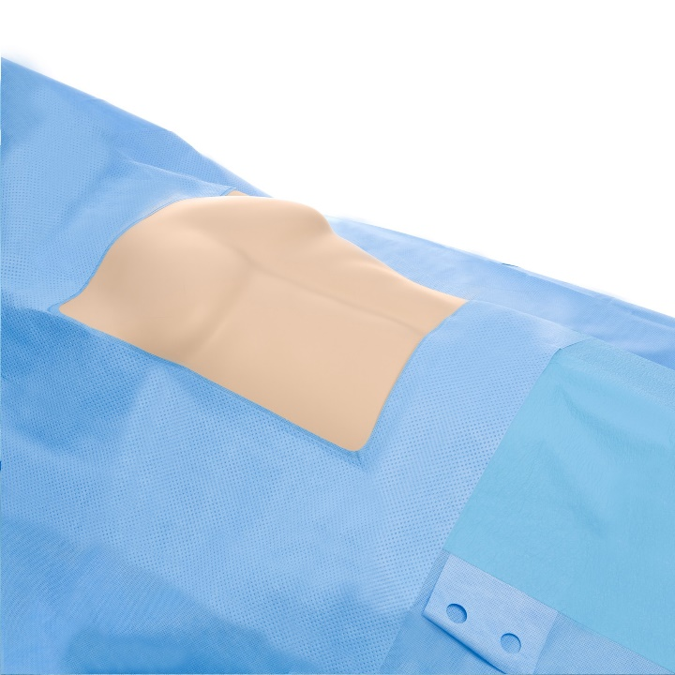 | - To provide physical barrier to protect surgical field from contamination
Profix rectal rings  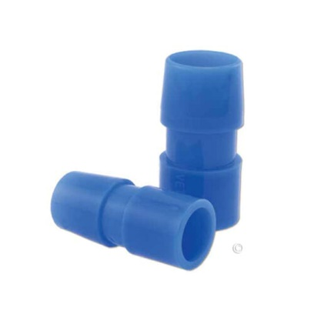 | - To repair rectal prolapses in calves, sheep and goats  - To use, insert the tube into the prolapse and tie offthe prolapse using an elastrator band or umbilical tape  - The prolapsed section should slough off after 5 days
Elastrator bands  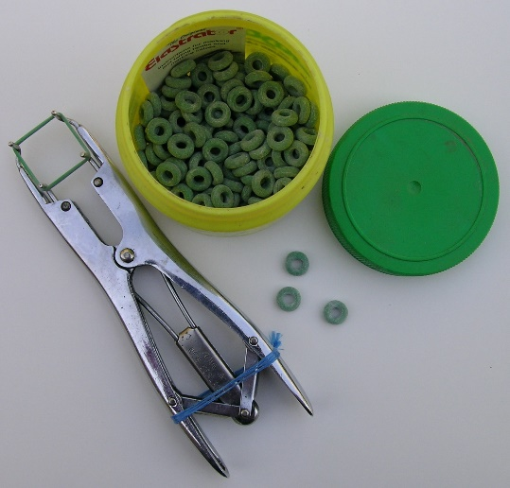 | - Used for rectal prolapse surgeries
Towel clamps  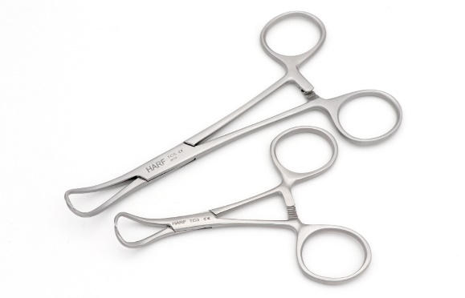  Laparotomy sponges  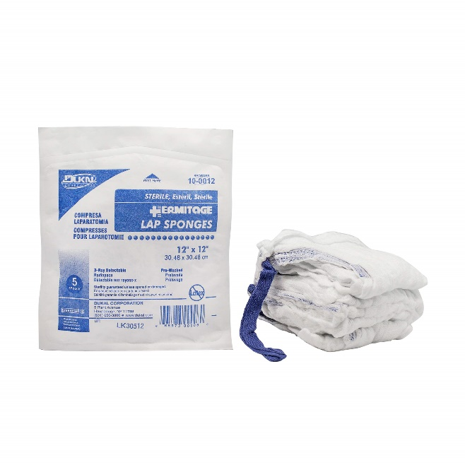 | - To hold surgical drapes in place and prevent movement  - An absorbent pad used during surgical procedures

