NERVE BLOCKING 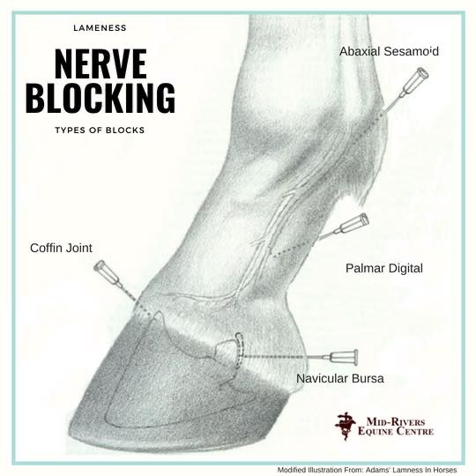

Nerve blocking of particular leg structures is a method used to help locate or confirm the location of pain associated with lameness. This is done by injecting local anesthetic to numb the nerves in the area of suspected to be the source of pain. It is usually done working from the lowest structure on the leg and then going up.

To locate the source of lameness using nerve blocking the horse is examined at the trot before, and the degree of lameness is determined. Then the suspected area is blocked and the horse is asked to trot again while the gait and transitions are evaluated. There should be an improvement in lameness, if not the process is continued on specific nerve progressing up the limb until the lameness is improved.

The onset of the local anesthetic usually is within 5 minutes, the results of the nerve blocks can be misinterpreted if assessed before the onset of LA.

When used for lameness investigation, an obvious pre-requisite is that the horse must be sufficiently lame for an improvement to be appreciated. In some cases, this may require you to observe the horse being lunged or even being ridden. Occasionally however, it may be necessary to ask an owner to return an unfit horse to work in the hope that will result in an increase in the severity of lameness. Diagnostic local analgesia is usually inappropriate in horses with a **sudden onset, severe lameness.** In these cases, local analgesic techniques should not be performed until a fracture or severe soft tissue injury has been ruled out as desensitisation could lead to increased weight bearing and catastrophic worsening of the injury. Mepivacaine (Intra-Epicaine™) is a commonly used local anaesthetic agent and rapidly results in desensitisation that is long lasting.